Life skills
WB 13.7.2020
Tie your shoelaces! See if you can learn to tie your shoelaces. If you don’t have any on your shoes, try doing it for your someone else in your house! Ctrl click on the image below to watch how to do it.

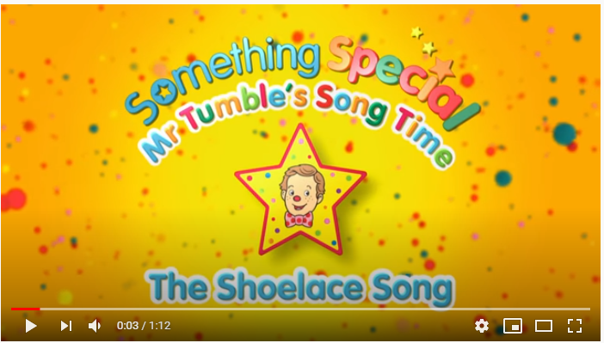

WB 20.7.2020
Have a go at making a tasty treat for you and your family! Remember to ask an adult to help you when heating the chocolate and cutting the tiffin.
