Life skills
WB 15.6.2020
Do some simple gardening jobs eg help clear weeds off your path. Make sure you wear gloves and are careful with the tools!

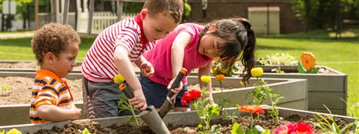

WB 22.6.2020
Help to write a shopping list for all the groceries you need.
