Paper plate hens

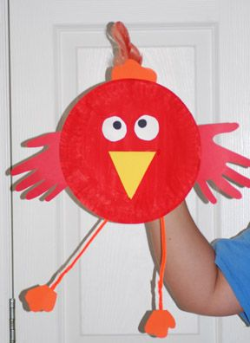
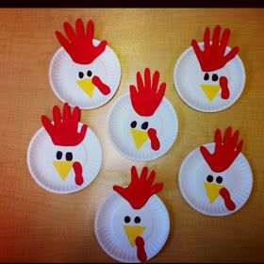
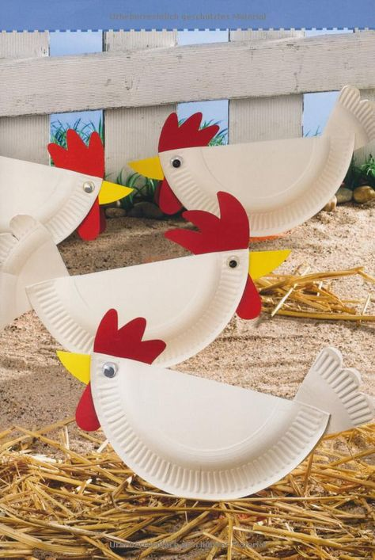
Using a paper plate (or a circle of paper), can you make one of these hens?
You may want to design your own and use other materials that you have at home.
We look forward to seeing your little hens!

