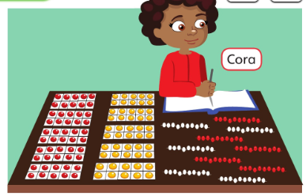

How many counters does Cora have? How many red counters? How many Yellow? Can you show the number of counters in different ways?
Does the number sentence remind you of something you already know? 5 + 5 = 10. 50 + 50 = 100
Can you use what you know about number bonds of 10 to make number bonds of 100? See if you can find all the ways to make 100 using multiples of 10!
10 + ? = 100
20 + ? = 100
30 + ? = 100

Which of these does not show a number bond of 100?
If you would like a harder challenge see if you can find some more number bonds of 100 like this!
15 + ? = 100
25 + ? = 100

