Practise these repeated additions!

Now can you write them as a multiplication sentence?

[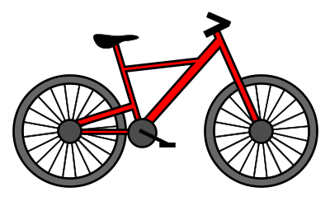](http://www.google.co.uk/url?sa=i&rct=j&q=&esrc=s&source=images&cd=&cad=rja&uact=8&ved=2ahUKEwiztrPFtLjhAhWhy4UKHbJfDYkQjRx6BAgBEAU&url=/url?sa%3Di%26rct%3Dj%26q%3D%26esrc%3Ds%26source%3Dimages%26cd%3D%26ved%3D%26url%3Dhttps://www.pinterest.com/pin/543457880004996909/%26psig%3DAOvVaw3F0uMUWX20bmvmyY4z77gk%26ust%3D1554534902669347&psig=AOvVaw3F0uMUWX20bmvmyY4z77gk&ust=1554534902669347)

2 + 2 + 2 + 2 = __

[](http://www.google.co.uk/url?sa=i&rct=j&q=&esrc=s&source=images&cd=&cad=rja&uact=8&ved=2ahUKEwiztrPFtLjhAhWhy4UKHbJfDYkQjRx6BAgBEAU&url=/url?sa%3Di%26rct%3Dj%26q%3D%26esrc%3Ds%26source%3Dimages%26cd%3D%26ved%3D%26url%3Dhttps://www.pinterest.com/pin/543457880004996909/%26psig%3DAOvVaw3F0uMUWX20bmvmyY4z77gk%26ust%3D1554534902669347&psig=AOvVaw3F0uMUWX20bmvmyY4z77gk&ust=1554534902669347)

[](https://www.google.co.uk/url?sa=i&rct=j&q=&esrc=s&source=images&cd=&cad=rja&uact=8&ved=2ahUKEwjXhd6QtrjhAhURWhoKHVkkDtQQjRx6BAgBEAU&url=https://www.vectorstock.com/royalty-free-vectors/hand-part-cartoon-vectors&psig=AOvVaw3FQMM7szGh0qgce25BLZtA&ust=1554535485534688)

2 + 2 + 2 + 2 + 2 + 2 = __

5 + 5 + 5 = __

[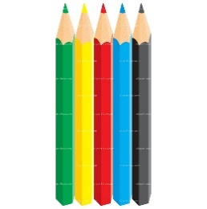](http://drprofile.co/color-pencils-clipart.html)

__ + __ + __ + __ = __

[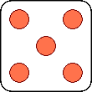](https://www.google.co.uk/url?sa=i&rct=j&q=&esrc=s&source=images&cd=&cad=rja&uact=8&ved=2ahUKEwjChdC2ubjhAhXO1eAKHQ_WC20QjRx6BAgBEAU&url=https://en.m.wikipedia.org/wiki/File:Dice-5.svg&psig=AOvVaw281qcik1aFUAqPIAPGUGNt&ust=1554536373518333)

__ + __ + __ + __ + __ = __

[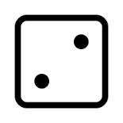](https://www.google.com/url?sa=i&rct=j&q=&esrc=s&source=images&cd=&cad=rja&uact=8&ved=2ahUKEwjWwvex1uXhAhVDXhoKHb_0BTsQjRx6BAgBEAU&url=https://thenounproject.com/term/dice-2/1194703/&psig=AOvVaw0Dug2tivfFaGdwR_nTOwtO&ust=1556090341104439)[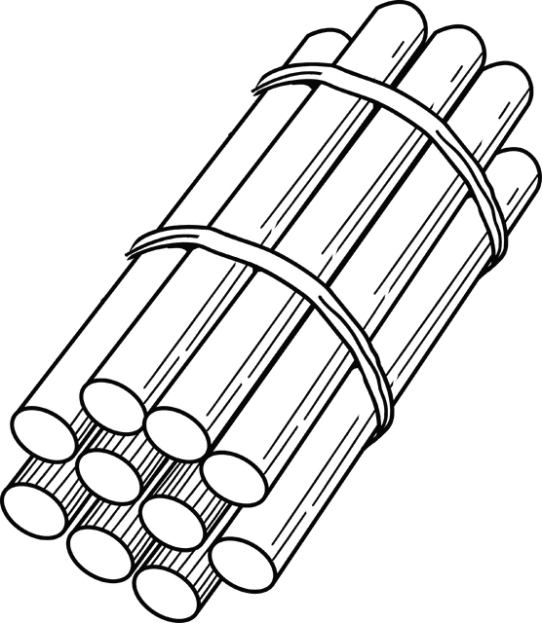](https://www.google.com/url?sa=i&rct=j&q=&esrc=s&source=images&cd=&cad=rja&uact=8&ved=2ahUKEwiI48r_1eXhAhUKx4UKHYKvB0IQjRx6BAgBEAU&url=https://etc.usf.edu/clipart/48800/48856/48856_b010_stick.htm&psig=AOvVaw07kP6KRr-yPAL9YwOXJu5P&ust=1556090228644813)[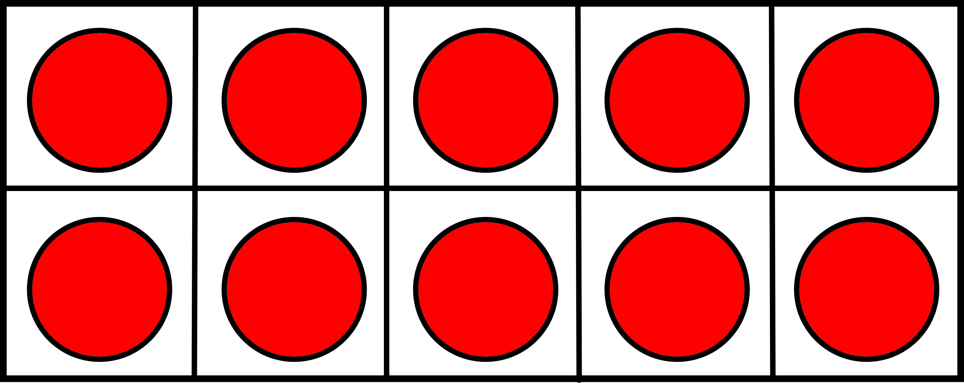](https://www.google.com/url?sa=i&rct=j&q=&esrc=s&source=images&cd=&cad=rja&uact=8&ved=2ahUKEwit_ZXO1eXhAhUFx4UKHcsDB4AQjRx6BAgBEAU&url=https://homeschoolclipart.com/math/free-ten-frame-clipart/&psig=AOvVaw3xg25qa_jBp-RM-EWIFh26&ust=1556090130627759)

__ + __ + __ = __