Teachers notes-  Continuing on from last week, our theme is still based around ‘All about me’. | Resources/ Activities
Life skills  We would love to hear about any life skills your child is developing. They are important in developing independence, resilience and confidence. | Have a conversation with a family member or friend over the phone. Can you ask them how they are? Or maybe what they have been doing? Can you share what you have been up to at home too?
Mindfulness  This activity should is designed to develop your child’s understanding of events and develop the skill of unpicking the finer details of a certain moment in time. | At the end of the day talk about 3 things you are grateful for. If you want to write them down you can or ask your grown up to help you do this – that way you could read them the next day.  Think about what has gone well in your day – did somebody do something nice for you? Did you achieve something you are proud of? Did you have a delicious lunch that made you happy?
Communication and Language Skills  Some of the best opportunities for developing language and communication is through social games – not only does it support the children’s understanding of social cues and turn taking but as the children are distracted by games, they will more often speak more freely. | Here are some activities you could try at home:  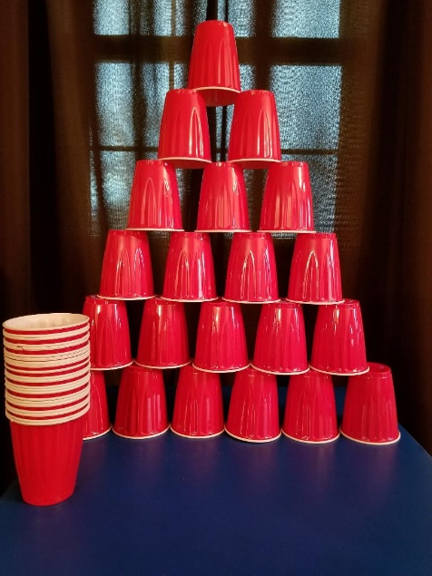  Stacking cups – this game works a little like jenga except for this time you are adding and not taking away. How high can you stack the cups? Take it in turn to stack the cups – if your cup is the cup to knock them all over then you have lost!  Target practice! – Using the same cups you could also have a game of target throwing – using a ball, soft toy, or bean bag, take it in turns to see how many cups you can knock down – the person who knocks the most down, wins!  Balloon herding – blow up a range of balloons and pretend they are like sheep in a field. Using a basket or box, turn this onto its side to make it appear like sheeps pen. Using a sweeping brush, can you sweep all of the balloons into the hoop – how quickly can you do it? Can you beat your last time? If the ‘sheep’ float back out of their pen you must quickly make sure you get them back to their pen!
Phonics  Language to use when discussing phonics with your child at home:  Phoneme: smallest unit of sound in a word, we teach the children which letter/s make these sounds.  Grapheme: the written letter/s that represent a sound.  Digraph: two letters that sit together to make one sound  Trigraph – three letters that sit together to make one sound. | Focus this week:  Phonemes: oi / ear  Watch the jolly phonics clip, you will need to scroll to find the digraph you are focusing on:  https://www.youtube.com/watch?v=W8Jp5MutVlQ  Practise the pure sound and sing the Jolly Phonics song together.  As well as saying the sound it is beneficial to write the sound – we would encourage writing the sounds in different ways, in difference colours, in different sizes – we have noticed that the more ways the children experience the sounds in, the more likely they are to remember them!  Phonics activities/games:  - Roll and Read – Phonics game for both of the new phonemes this week (see separate template). See how many you can read – maybe you could time it to challenge yourself.  - Boat race! – Using either corks or bottle tops, see if you can make some miniature boats – the name of the boats must be a word with the new graphemes in! Once you have made your boats place them in either the bath, paddling pool or tub of water. You could use a straw to blow the boats across the water – can you read the name of the winning boat? Which boat lost the race?  Tricky words Recap: the, to, I, no, go, into, he, she, we, me, be, you, all, are, they, was, her, my  Activity idea:  Using glitter or salt on a baking tray and a dry paint brush can you have a practice at writing the tricky words. After each word you may need to gently shake the try to make your ‘blank canvas’ again.
English-  Below are some links to some books and stories the children have enjoyed in school – these in particular are share important messages around self-positivity and the importance of friendships.  ‘Only one you’  https://www.youtube.com/watch?v=vu9capmEY5I  ‘The Paper Dolls’  https://www.youtube.com/watch?v=0BuURAo5f3k  ‘Ronald the Rhino’ – PowerPoint | Activities:  Super me! Can you draw yourself as a superhero? What could your power be? Maybe you are super kind, maybe you are an amazing writer or perhaps you want to save animals. Could you write down your powers? You could make a comic book of you using your special super powers for the greater good! We can’t wait to see what you come up with! We have given you a template that you can use if you would like or you can make your own.  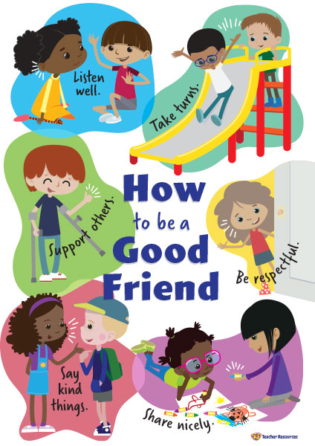  Ronald the Rhino:  Task 1 - Have a read through the story together and see if you can answer some questions. Why was the rhino upset? How did the other animals help? What did they make him realise? Have you ever helped a friend out before? Or maybe they have helped you? – Discuss the importance of being yourself and not trying to be anyone else. Can you think of the things you are good at?  Task 2 – Can you make a poster of what a good friend should be like? Make it bright and colourful! Think about the animals in the story, your own friends and how you demonstrate friendly behaviour to help you!  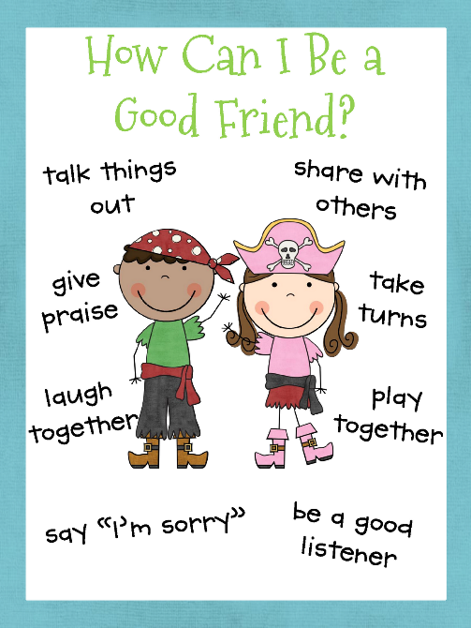
Maths  Here are some links to videos/games to support this weeks’ maths:  Money addition  https://www.topmarks.co.uk/money/toy-shop-money  Shape monsters:  https://www.topmarks.co.uk/early-years/shape-monsters | Money!  Not only do children learn about money in school but having a good understanding of money is also an essential life skill. This week we would like for you to have a look at the coins: 1p, 2p and 5p.  If you have the real coins available to look at and compare that will really help your child to develop a secure understanding of the differences. The children often presume that because the 2p is bigger than a 5p it should be worth more. It is essential to have conversations around this to iron out those misconceptions. We have also found that when children add the coins together, they sometimes forget the coins value, and they may see 3 physical coins and think this equals to 3p when actually it may have been 3 5p coins!  We have attached a coin addition sheet for your child to have a go at. A method we use is to draw dots underneath the coins to represent how much it is worth – you may find your child will benefit from this method or they may find it easier to lock an amount in their head and count on from that amount.  2D Shapes – Here are some further activities to have a go at to continue to embed and become secure in understanding the 2D shapes. We also find that shape is an area of maths the children engage with the most as they can become quite creative!  - Shape construction – using toothpicks/ sticks/ pipe cleaners and blue tack, can you construct a shape, pretend the blue tack is like your glue to stick all of the edges together!  - Shape crown – can you use the template provided to make your own crown – you will need to cut out all of the different shaped jewels to stick on it!
Arts and crafts  Getting creative and a little messy is a fun way to embed children’s learning. It also provides a hands on learning experience which is often very memorable for children! | 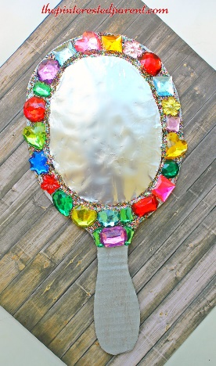  Magic mirror – can you make your own mirror using tin foil, card and collage pieces?  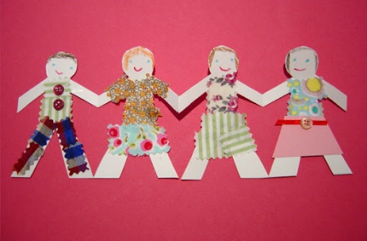  Can you make you and your friends/family as a paper doll chain? Fold your paper first into how many sections you need, draw the template of a person and then cut out. You can then decorate each person as your friends or family!  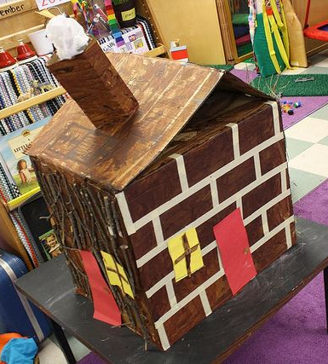  Can you make your home? What colour is it? How many windows does it have? What colour is your front door?
Physical  We try to get a mixture of gross motor and fine motor activities. | 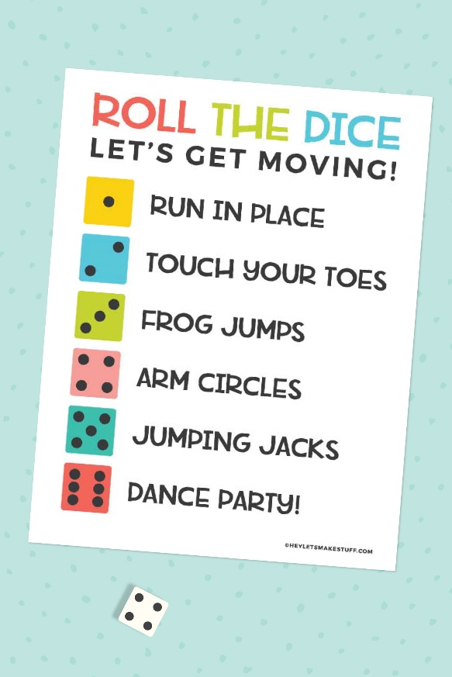  Together with your child you could create your own chart of ideas for the type of exercise to do for each number on the dice – we have provided an example but you could be creative and think of lots of other exercises to do!  Balancing – To develop children’s coordination and overall balance, children often need reminders to do things a little bit slower than they might like to. This activity will not only help to develop their control but also their patience as they will need to take their time to complete it successfully.  Option 1: Balancing an item on their heads when walking – you could start off with something easy such as a cushion and then progress onto something more tricky like a book.  Option 2: Moving an object from their foot into a bucket/tub. Place something like a bean bag or soft toy on the top of their foot. The children will then need to lift their foot slowly and with control in order to transfer that object into the bucket. The key point is that hands cannot be used!! That’s what makes it tricky.
Music  The activities this week are a little different for music – this week the children will be exploring different sounds in their environment. By having the hands on experiences and through them investigating the sounds themselves, this should help to strengthen their understanding. | 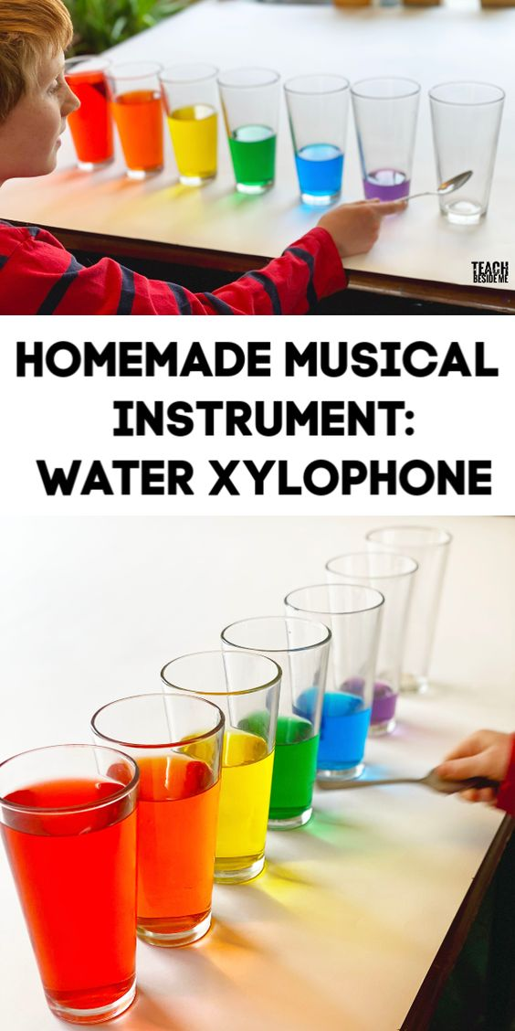  Exploring with sound is such a crucial element to a child’s progression in their phonics, reading and writing. This activity will help to develop their listening skills as they tune into the different pitches and volumes of sounds and also their scientific skills as they identify what happens as the liquid amount changes.  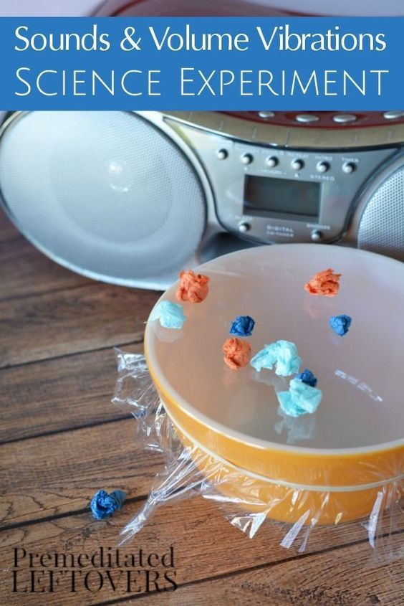  This second musical activity involves a bowl, cling film, tiny pieces of paper/tissue scrunched up and a CD player or set of speakers.  You can play any song that you like – you might want to investigate if different songs make different vibrations. Does the paper move when you turn on the speaker? How close do you need to put the bowl to the speaker to see it move?  You could also swap the paper for something light like rice or small dried pasta pieces.

