Teachers notes- Story of the week- What the lady bird heard | Resources/ Activities 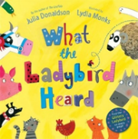
Life skills  We would love to hear about any life skills your child is developing. They are important in developing independence, resilience and confidence. | - Make a sandwich- talk about how to hold and use to use a knife safely- a useful tip is to put some butter in a little dish to limit how much they use. To begin with keep the toppings simple like jam or cheese spread.  - Use money to pay for the ingredients of their sandwich- introduce a few coins e.g. 1p for the butter, 2p for the bread and 5p for the toppings, for nursery it will be enough to identify the coins do not worry about adding them up to find the total.
Mindfulness  During this time you and your child may be feeling a lot of different emotions, it’s important to acknowledge, name and understand these emotions. Young children feel a range of emotions but have a limited vocabulary to process them.  It is important to talk about how even when emotions can feel all-consuming they will pass.  Then talk about what you can do to help it pass such as breathing techniques. | Emotions jar  Have bits of paper and a pen ready to record your emotions.  Either during a specific time frame or over the day write down how you are feeling, your child can draw their emotions if they want to. Don’t shy away from naming complicated emotions or letting your child know you are feeling that way. You might feel positive, productive, grateful, loved or tired, frustrated, annoyed, sad, lonely.  At the end of the time take the bits of paper out and talk about all the different emotions. You can talk about how it feels- negative emotions tend to make our bodies tense, our hearts beat faster, you can get a headache or a tummy ache or even feel sleepy and like you can’t move. Whereas positive emotions can make us feel floppy, taller, energetic etc.  Talk about how you have felt so many different emotions during that time and you haven’t just felt one emotion all day. Emotions change, sometimes because you have just got busy and moved on, sometimes because you made an effort to change how you are feeling. You could give examples of how the action of someone else helped change that emotion or what you did yourself to change it.  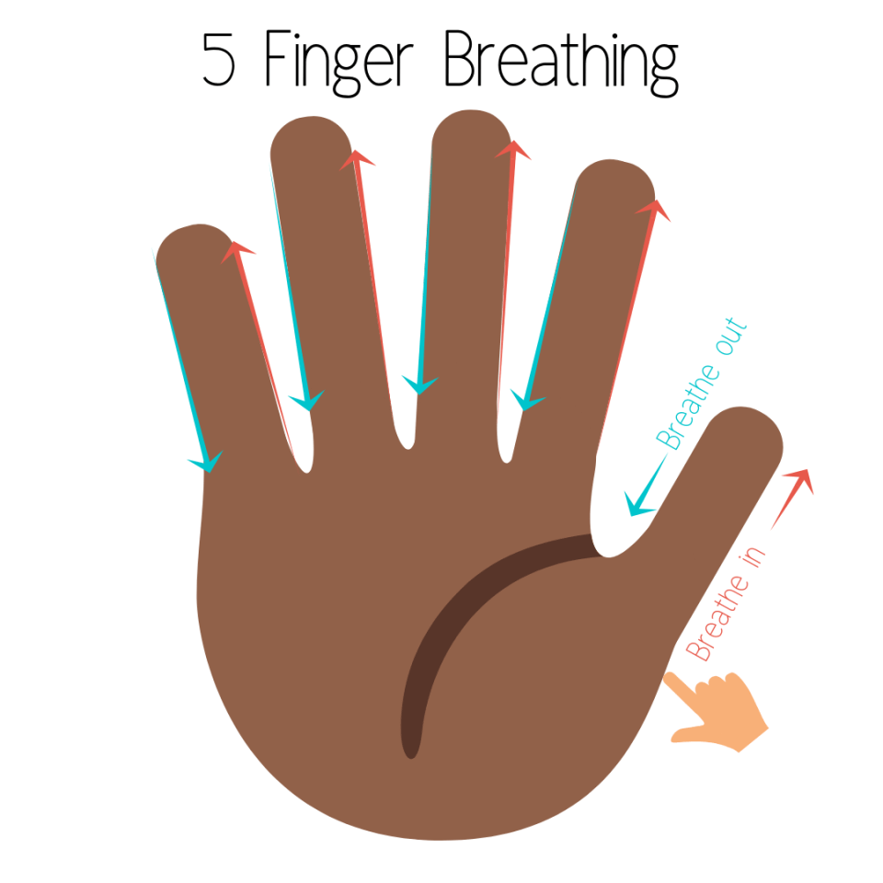  We use the 5 finger breathing technique as the physical action of running your fingers up and down really help distract the mind from what has upset the child. To introduce this you could draw around your hands and using different coloured pens draw the in breath and the out breath.
Social skills  A large part of early years is learning social skills.  Social skills are essential for children’s development as it incorporates a multitude of skills. The games suggested are things we have come across in school and the basis behind them are to support the development of patience, turn taking, resilience, perseverance and developing the sense of self pride and also feeling proud for others.  In addition to playing games, we know that having time to talk is also a positive way to develop understanding, emotional vocabulary and skills such as empathy, negotiating and problem solving.  These skills are often developed in day to day activities and conversations – but sometimes at school we find it particularly helpful to have a topic to discuss and explore in a more in- depth way.  We have provided a talking point idea that you may find useful. | Games you can play:  Name of the game You will need How to play  What am I ? 2 + players Linking with our story this week – play a game of guess who 1 player thinks of an animal and reveals 1 clue at a time – count how many clues it takes before the other player guesses it right! The person with the least clues needed wins!  Marble run! 2 + Players Marbles (or other small ball) Kitchen/Toilet roll tubes Line up a selction of kitchen/toilet roll tubes so that they are laying down flat to either the floor or table – decide together how many points each of the tubes are worth – maybe 1, 2, 5, 10! Create a starting line using either tape or string. Each player gets 3 marbles to shoot at the tubes – if the marble goes into the tube then the player gets that many points! Add up points after each round. Best out of 5!  Talking Time Idea/Activity:  In light of the current events and the changes that have been happening to daily routines and life, this activity is designed to refocus attention on the special and important things that we treasure and perhaps haven’t given a thought to recently.  Design and make a special box/bag/envelope – completely personalised to you – this is yours so make it exactly how you like – if you want to draw superheroes on it, then do it! If you want to draw animals on it, go ahead!  Whilst doing this activity you can have a chat about your favourite things and why you like them.  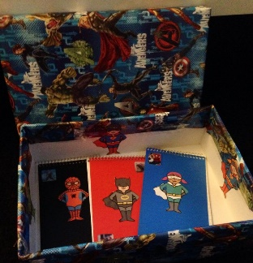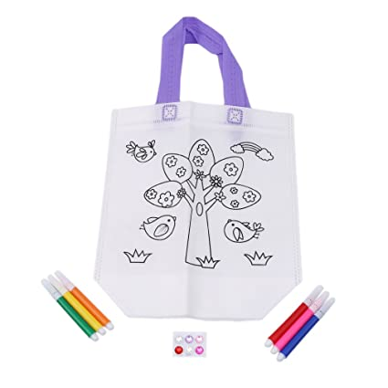  Once you have finished this, see if you can find some special things around your home to put inside – it may be a photo or a special little toy. This box/bag/envelope will be your happy space – you know that when you look at it and open it up, it will be full of the things you love.
Language skills  To help support your child’s communication and language development. Here are some activities you can do together which link to this weeks’ book ‘what the ladybird heard’ | - Create a character description for the 2 thieves in the story! Think of lots of adjectives to describe them – you could draw a picture then tell your grown up the words you would use to describe them and they could then write them down for you!  - In the story it gives you the sounds the animals make – can you make the sounds of any other animals – you could even think about the animals in the zoo! You might want to look in a mirror to see your facial expression – what shape does your mouth make when you create the sounds of each animal?  - Talk about your favourite and least favourite animals with someone in your family – see if you can extend your sentences with the words, ‘because’ ‘and’ ‘also’ to explain why you have that opinion.
Phonics  Language to use when discussing phonics with your child at home:  Phoneme: smallest unit of sound in a word, we teach the children which letter/s make these sounds.  Grapheme: the written letter/s that represent a sound.  Digraph: two letters that sit together to make one sound | Focus this week:  Tricky words: Practise last weeks: the, to, I, no, go, into (phase 2) Introduce: he, she, we, me (phase 3)  write all the tricky words out onto paper to use as flashcards, ask the children to read the words as you move through them, reminding the children these are tricky words and they can’t be segmented and blended to read If they are confident reading these challenge your child to try and write these words, you may use the look, cover, write, check attachment if you like or just a simple pen and paper.  Phonemes: ng / ai  Watch the jolly phonics clip, you will need to scroll to find the digraph you are focusing on:  https://www.youtube.com/watch?v=W8Jp5MutVlQ  Practise the pure sound and sing the Jolly Phonics song together.  Practise writing the grapheme in the air, in a plate of rice, in the soil or sandpit in the garden, painting it or using exciting coloured pens.  - I spy ‘ng’ activity – using a magnifying glass see how many words containing ‘ng’ the children can spot and read (attachment).  - Children to read the ‘ai’ word and then draw a picture of the object underneath. There are two blank spaces for the children to think of two of their own to write down and draw a picture of (attachment).  - Walk around your house to see how many items you can find together containing ‘ng’ or ‘ai’. Encourage your child to write a list as you move around the house supporting them to segment to hear the sounds they need to record.
English-reading &writing  (All the resources are on the website labelled English)  You can access the story here:  - Via the PowerPoint in the English Resources section.  - Via YouTube – This video shows the full story book including images and text  https://www.youtube.com/watch?v=Eu9mPX7DuLA  There is also a ‘What the Ladybird heard’ Song – the Lyrics to this are included in the English Resources section – this might be useful when finding some rhyming words. | Reading Activities:  Read the book together and spot the rhymes –  See if your child can pick out some of the rhyming words in this book – they may be able to tell you verbally or perhaps they can point them out directly in the book. Talk about why these words rhyme and show them how they’re often very similar spellings towards the end of the words. Ask them if they can think of another word to rhyme with one from the book.  Reading Non-fiction texts –  See if you can find out some information about ladybirds! There are lots of websites online such as: The National Geographic for Kids, Love The Garden, RSPB etc. You might even have some factual books at home that you can have a look at. If you don’t have access to these, in the English resources section there is also a Ladybird reading activity sheet that provides some facts about Ladybirds!  Writing Activities:  Sound walk –  Like the ladybird did in our story this week, see what you can hear as you go for a walk, it might be a walk around your garden, it might be a walk during your daily exercise – see if you can write down all of the things you can hear. You might hear things like birds tweeting, cars zooming by, maybe even the wind in the trees or perhaps you have music on at home! You might want to write it as a list, or you could turn it into a sentence and start it with, ‘I can hear…’ you could also use the word ‘and’ to connect your ideas!  Draw and label the farm –  See if you can draw the farm from the story, don’t miss out any animals! Once you have done this see if you can label the animals that live on the farm. Don’t forget to use your phonics!
Maths | Ladybird Doubling Numbers.  Show your child the “Practical Doubling Ladybird Spots” resource (ladybird body and black spots to cut out.) Talk about how doubling a number is adding the same number again - so however many spots is on one wing, the same number of spots is put on the other wing and then they are added together.  - To practice this, roll a dice and whatever number the dice lands on, count out that many spots onto one of the wings and then repeat for the other wing (to DOUBLE the number) and then add both together.  - Now complete the “Doubling Ladybird Spots” activity, continuing to use the ladybird cut out and movable spots if needed.  Number Ducks 1-20.  For some children in Foundation Stage 2, one of their targets is to recognise and order numbers 1-20. Cut out the number cards and use them as flashcards, for your child to tell you what the number is, and then ask your child to put the numbers in the correct order. If your child closes their eyes and you remove 1 or 2 numbers, can they tell you what numbers are missing?  100 Number Square.  We started work last term looking at the 100 number square. It would be useful for your child to revisit the number square and see what they can remember. The children looked at patterns in the rows and columns of the square, can they tell you any? We also practised counting in 2s, 5s and 10s and coloured these squares to look at the different patterns. Can you point to a number for your child to tell you what the number is or if you cover up a square, can your child tell you which number is missing? We’d love to hear about any other games you’ve been playing using the number square!
Arts and crafts  The children in the Foundation Stage always love a challenge with the box modelling! Can you make a farm animal using recyclable materials and items you can find at home? We look forward to seeing photographs of your creations!  Potato Print Ladybirds  - Cut a potato in half and using red paint, print some ladybirds onto paper.  - Use a carrot, your fingertip or anything else you can think of to print the black spots onto the ladybird.  - Can you make the ladybirds symmetrical? (Print the same amount of spots on each wing.) | Can you make a farm animal from materials you find around the house?  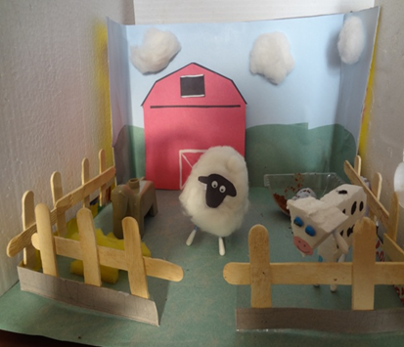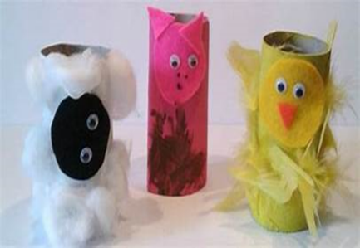  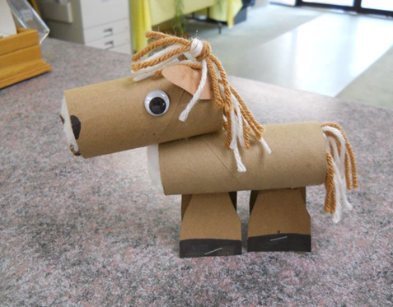  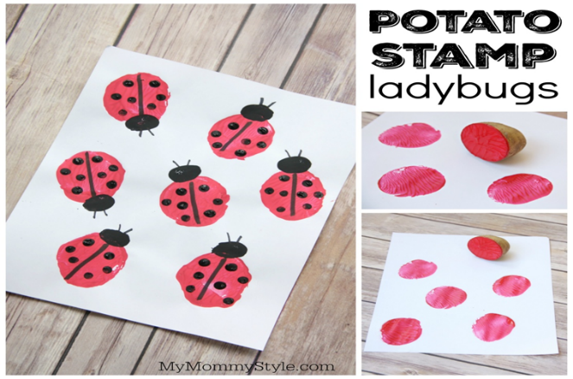  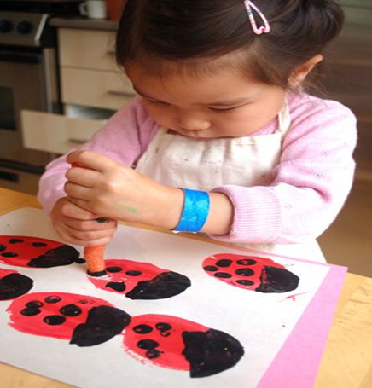
Physical  We try to get a mixture of gross motor and fine motor activities. | - Cosmic Kids – this week our yoga is all about Diggory the Dumptruck  https://www.youtube.com/watch?v=lppLh0FI3iw  If you are really enjoying yoga here are some more to have a go at:  Tiny the T-Rex  https://www.youtube.com/watch?v=rnlDBKD2S78  Tallulah the Owlet  https://www.youtube.com/watch?v=2aje33UPixE  Nelson the Pigeon  https://www.youtube.com/watch?v=kN1_qchKPnA  Cracker the Dragon of Wonder  https://www.youtube.com/watch?v=7NWzS2xziI4  - Create an assault course either inside or outside and see if you can complete the following challenges:  - Can you complete the assault course independently?  - Can you race someone else in your family? Who can do it the fastest?  - Can you improve on your own time completing the assault course?  - Can you complete the assault course with a blindfold on and someone else giving you instructions?  - Can you give someone else in your family instructions to safely make it around the assault course with a blindfold on?  - Farmyard bowling  Use any farm animal toys available or make your own using paper/card. Using a ball see who can knock down the most animals, careful to use 1:1 counting when counting totals. Encourage children to roll the bowl using the underarm technique and to think about where they are aiming, the force they need to use and the shape of their body.
Music | https://www.youtube.com/watch?v=7NbyiDpY6Ww  - -We have included the lyrics to the song ‘what the ladybird heard’, you could dress up as your favourite animal from the story and preform the song to other members of your family. We would love to see the videos!  - -You could think about representing different animals with different sounds, what can you find in your house that sounds like a bird or a cat? Think about the sounds are they loud, quiet, high or low?

