Home Learning Pack – Year 2 Week Beginning 18th May & 1st June
The Home Learning Pack consists of :
- 10 spellings to learn a week
- A story to read together
- A maths game to play together
- 5 creative activities to support our theme for the fortnight

Spellings :
Week beginning 18/5/20: too, two, to, their, they’re, there, here, hear, quite, quiet
Week beginning 1/6/20: blue, blew, one, won, be, bee, sea, see, knight, night
10 spellings to learn each week. Show your child how to write these words on day 1 and get them to write them correctly 2 or 3 times as appropriate for your child. Each day ask them to write them from memory and correct any they make mistakes on. As the days go on they should be able to increase the number of words they can remember correctly. If your child finds reading difficult then focus on the first 4 or 5 words only.
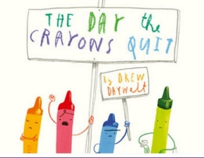
Story for the fortnight: The Day the Crayons Quit by Drew Daywalt (https://www.youtube.com/watch?v=489micE6eHU)

Maths game :
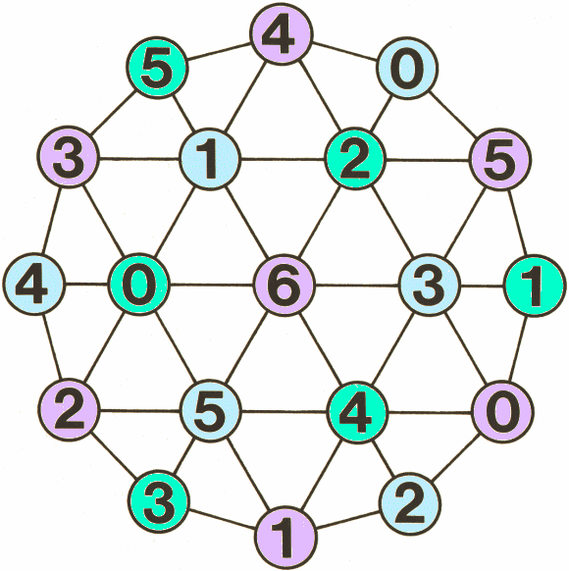
A Maths game to play together which will support your child with practising their important maths facts – this is known as fluency.
Our Maths game for this week is Totality.
You will need a game board (https://nrich.maths.org/1216) and a counter. A short video (with no sound) is also available on the website to demonstrate how to play.
The aim of the game:
Slide the shared counter across several adjacent numbers, adding them up as you go to make a 'running' total. Be the player to make the final slide so that the chosen target is reached exactly. Making the total go above the target loses you the game.
How to play:
1. Player 1 chooses a target to reach. This is the total both players try to make.
2. Player 2 places their counter on the game board over one of the numbers and says that number.
3. Player 1 moves the same counter in any direction along a line segment to a neighbouring number and announces the total of the two numbers.
4. Player 2 moves the same counter to cover a neighbouring number, adds on that number, and announces the 'running' total of the three numbers.
5. Players take it in turns to slide the counter to cover a neighbouring number and to add that number to the 'running' total.
6. Players must move when it is their turn.
7. No 'jumping' is allowed.

Creative Work
For the next 2 weeks we would like your child to complete a project related to the Year 2 Art curriculum and The Great Create. The Great Create has been formed by The Prince’s Trust to promote the importance of arts and craft to support wellbeing. We are going to join in with a lot of creating of our own! We would like them to email a photo of their learning to school (please email year2@totonbanksroad.notts.sch.uk & put your child’s class & name in the subject).
In Year 2 children are expected to:
- Use a range of materials creatively to design and make products
- To use drawing, painting and sculpture to develop and share ideas
- To develop a wide range of art techniques including colour, pattern, texture, line and shape
- To learn about the work of different artists and make links to their own work

Your 5 learning tasks for this project are:
- Create a piece of tree art
Before we finished school we all created a rainbow to put in our windows so that we could spot them on our daily walk with our families. Now you are going to create a tree to go in your window so that we can spot these too! There are some ideas of how you could do this below or you can choose a way of your own instead.

- Research a famous artist and recreate one of their famous artworks
Find out some facts about an artist and look at the art work they created. We have included some links to information about Andy Warhol, Gaudi and Van Gogh but you can choose a different artist if you like.
Choose your favourite piece and try to recreate it. You will need to think carefully about the shapes and colours they used. You might want to do it slightly differently, for example, if they used paint you could use a technique like crayons or chalk instead or if it was 3D or you could recreate it in 2D.
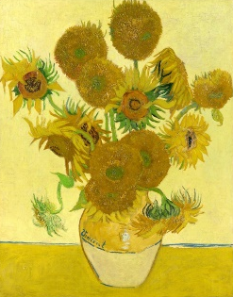

- Create a 3D model
We would like you to use your imagination to create anything you like in 3D. You could use box modelling, your D&T skills, playdough, plasticine, clay or any other materials you choose. You will need to think carefully about how you join your materials together and which materials you choose to make your model look like what it is supposed to be.
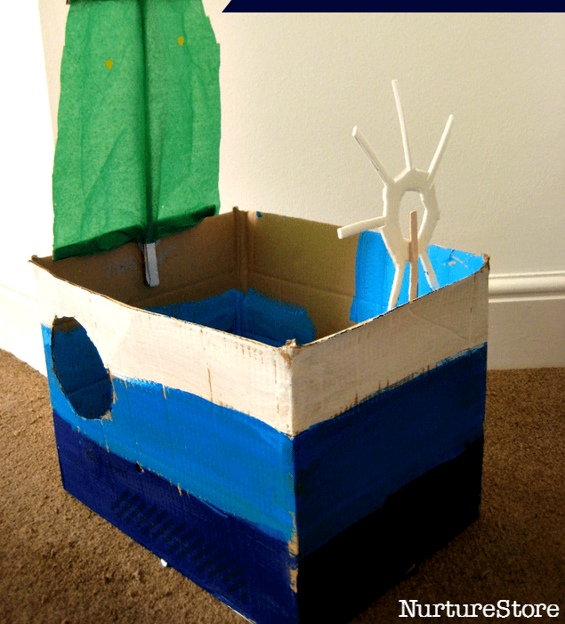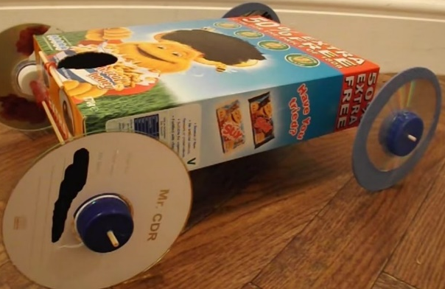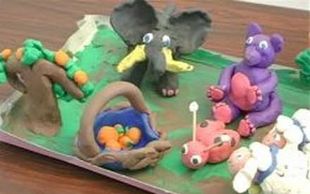

- Make a natural collage
Using natural materials from your garden or that you can safely collect on your daily walk, create a collage. You may want to do it in a pattern design or try to make it look like something in particular, for example an animal. Think about the textures and colours you are using. Can you take a photograph and send it to your teachers?

You could watch this video about Andy Goldsworthy. He creates amazing outdoor art using only materials he finds in the environment. https://www.youtube.com/watch?v=yqmUOk44A9M
- Practise improving your own artwork
In Art in Year 2 we think a lot about how we can improve our work. To do this we would like the children to watch ‘Austin’s Butterfly’ https://www.youtube.com/watch?v=hqh1MRWZjms and think about how they can draft and re-draft their art work, just like we do in writing. Once they have watched the clip we would like them to have a piece of paper split into 4 sections and in the first box draft a drawing of a butterfly. Then think carefully about what they have done well and what they could improve to re-draft in the second box and repeat in the remaining boxes.
