Teachers notes- Story of the week- The very hungry Caterpillar | 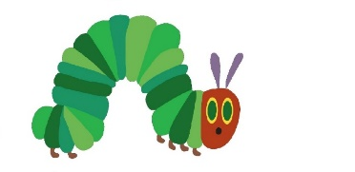  Resources/ Activities
Life skills  At school we don’t always have the opportunities to practice important life skills. We would love to hear about any life skills your child is developing. They are important in developing independence, resilience and confidence. | - Pick an outfit for the day (talk about what clothes are appropriate for the weather) and get dressed independently.  - Pair up clean socks and put the away in the right place.
Mindfulness  We use the stories and calmer from ‘meditation for mini’s’ by Debbie Wildi.  Begin with a calmer- these are techniques that we teach the children to use with us before a meditation (story) or by themselves when they need it. They can be used regularly to form good habits for dealing with different situations in life.  The meditation stories can be changed. I have put a link to some relaxing music to play in the background. Meditation takes practise and at first children find it hard to focus but just like any muscle the more your practise the better you get. Do not tell your child to sit still/stop fidgeting, simply gently rest your hand on the part of them until they still or use a blanket. You will know when your child has reach their limit, simply wrap the session up and make sure you come out of it slowly, move to the end of the story. Meditation can have a strong physical impact- take a minute to look around the room or garden and have a drink of water. | Calmer- The red balloon  Find a comfortable place and sit up straight, close your eyes…  Now place your hands on your tummy. Imagine there is a red balloon inside there. Take a long slow breath in, as you breathe in imagine the big red balloon fill with air and get bigger just as a balloon does when you blow it up. Feel your tummy grow, as the imaginary red balloon gets bigger.  Now slowly breathe out.  As you breathe out imagine the balloon is shrinking.  Feel your tummy go down and become smaller.  Keep on picturing the big red balloon in your tummy, becoming bigger and rounder each time you breathe in, and smaller and flatter each time you breathe out.  Do this for a few minutes. Your mind will feel nice and relaxed and you will feel happy, shiny and new….  When you have finished slowly open your eyes, do a big stretch and smile.  Meditation story-Happy butterfly  http://calmforkids.com/wp-content/uploads/2019/03/03-Drifting-River.mp3  Find your nice comfortable space, close your eyes and relax….  Imagine you are a butterfly sitting on a leaf in a wonderfully sunny garden.  Just spend a moment thinking about what colour you are. Maybe you are more than one colour, or even multi-coloured.  Just use whichever colours come into your mind. (Gentle pause)  Imagine that you are now fluttering across the garden. You decide that in a moment you will land on the prettiest yellow flower in the garden.  The flower seems very large because you are so small. You look down at the huge beautiful bloom as you hover above it.  Notice how bright it is. The bright sunny colour make you feel so happy.  You flutter onto the flower and sit and relax on the pretty petals.  This is the happiness flower. Whenever you touch the petals you will feel happy all day long. Imagine yourself reaching down and touching the yellow flower.  You feel the warm sun on your wings and hear your bird friends chirping in the distance. (Pause to listen, if you do this outside you could listen for birds around you)  You flutter down and land on a blue flower. Notice how soft the petals feel underneath your small butterfly feet.  A buzzy bumblebee stops to land on the same flower next to you. Buzz, buzz.  ‘Hello Mr Bumblebee’ you say.  ‘Good day butterfly’ he replies.  You both smell the pretty flower petals.  It smells so sweet and fresh. ‘mmmm’  This blue flower is the flower of calm and whosever smells it will feel calm and relaxed all day long. Take a big long sniff! (together take some deep breaths holding on the breath in and out)  You decide to set off again and flutter around the garden, enjoying the feeling of flying high. You see the blue flower and the bee below you. You also spy small worms in the mud, as well as a snail gliding along the garden path.  You are a happy, calm butterfly now as you fly in the warm sunshine. (gently pause to take some more breaths)  It is now time to come down to land again. This time you find yourself on the woody branch of a small tree.  As you look around the garden you feel happy about your journey today and know that you can come back here at anytime. All you need to do is close your eyes and imagine.  Remember, whenever you wish to feel happy just touch the yellow flower, and smelling a blue flower will always help you feel calm.  Now when you are ready wiggle your fingers and toes. Keep your eyes closed  Have a long stretch.  Take a breath to refresh you, and open your eyes very slowly.  Well done! How does it feel to be a human being again?
Social skills  A large part of early years is learning social skills. The games that are suggested will contribute to developing your child’s turn taking skills, building resilience (as they may lose a few games!) and their patience.  As well as playing games to develop social skills, having a specific topic or a talking point will also support children in developing their emotional vocabulary and how they respond to scenarios. See if your child can think of ways to help their teachers below! What advice would they give? How would they feel? | Shopping List Memory- 2 + players. ‘I went to the shop and I bought…’ – each player must repeat the shopping list, adding an item each time. If a player forgets an item the game has to start all over again!  What’s hiding? Memory Game 2 + players-You will need-  10 household objects. A blanket/sheet.  Have a selection of objects laid out in front of you – Give the player 10 seconds to look at what’s there before covering them up and removing an item – can the player guess which item is missing? Make this more challenging by increasing the amount of items.  Construction Competition 2 + players You will need Construction e.g. lego or wooden blocks. A dice.  Place the construction in the middle of the players. Each player takes it in turns to roll the dice and builds a tower using the amount on the dice. After 5 rounds, whoever has the tallest tower wins!  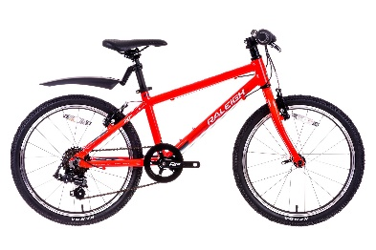  Miss James wants to play with the red bike outside, but so does Miss Buxton. The problem is there is only 1 red bike!  Miss James quickly runs to get on the bike leaving Miss Buxton feeling very sad sat on the bench.  How could you help to solve this problem?  Mrs Kiddie couldn’t find anyone to play with outside on the playground. Miss Freeman was playing lots of games with all of the other teachers.  Miss Freeman saw Mrs Kiddie standing alone.  Should Miss Freeman carry on playing with her other friends or should she go to Mrs Kiddie?  What would you do if that was you?
Language skills  To help support your child’s communication and language development. Here are some activities you can do together which link to this weeks’ book the Hungry Caterpillar. | - Retell the story of the Hungry Caterpillar – you may want to add in a stick puppet and resources like we sometimes do in school to make the story even more exciting and engaging!  - Say the days of the week in the right order – if you can do this then see if you can say a sentence for each day, such as, ‘On Monday I played in my garden. On Tuesday I went on my bike…’  - See if you can spot some of the food from the story in your home – can you describe what it’s like – you could talk about the colours, textures, and taste!
Phonics  we focus on the children being able to identify sounds, to add an element of challenge shake two socks behind your back or under a towel | Sound socks- This is a fun activity for those odd socks you have, the children love this game at nursery- we sing what’s in the sock, what’s in the sock, listen (being as dramatic as possible)  - Putting some objects in the socks such as lego, marbels, packets of crisps, small cars, teaspoons.  - Tie the end or use an elastic band/hair bobble.  - Shake the socks one at a time and talk about what they sound like- what material does it sound like, is it quiet or loud? Etc  - Either put them under a towel or behind your back and shake one at a time can your child identify what’s in the sock?  Tricky words- You will need to write the tricky words I, no, go, to and put around the garden they can be on pieces of paper, laminated or with chalk. And a water pistol or sprayer.  - Look at the words first to help remind your child and talk about how they are trying to trick us and can’t segment them.  - You shout the word and your child squirts it.
English-  The hungry caterpillar  If you do not have a copy of the book you can watch the story here- https://www.youtube.com/watch?v=75NQK-Sm1YY  Reading related texts –  As well as the story of the week, we would also encourage reading in lots of other contexts – you could read some non-fiction texts about caterpillars and how they transform into butterflies.  Read all about what cheeky monkey has been up to on his adventure at Miss James’ house. | -Read the very hungry caterpillar then come up with your own version- try to change just one element either the character or the pieces of food the caterpillar eats. You can record this either by scribing for your child their new story, recording your puppet show or drawing pictures.  -Using the sequencing sheet can you put the pictures in the right order as you tell the story?  -Take photos or draw pictures to write back to cheeky monkey what you have been doing at home. You can email this to us at nursery@totonbanksroad.notts.sch.uk
Maths  In nursery we focus on a number a week, understanding at a deeper level. This link has a nice explanation of different ways to support your child, this is a broad suggestion of ideas we will send specific activities weekly. https://www.bbc.co.uk/cbeebies/grownups/help-your-child-with-maths | - Number of the week is 3-  https://www.bbc.co.uk/iplayer/episode/b08bzh11/numberblocks-series-1-one-two-three  https://www.bbc.co.uk/iplayer/episode/b08cqtk0/numberblocks-series-1-three-little-pigs  - Think about the different ways you can represent 3, Can you find 3 different objects from the garden? Can you find two that are the same and 1 different thing? When you put them together they still make 3- What other ways can you make 3?  -Can you complete the hungry Caterpillar addition sheet?  -Can you colour all the pieces of fruit on the roll and colour sheet?
Arts and crafts  There are so many different Hungry caterpillar crafts you can make, we have chosen two that we hope you will enjoy but feel free to make your own. | 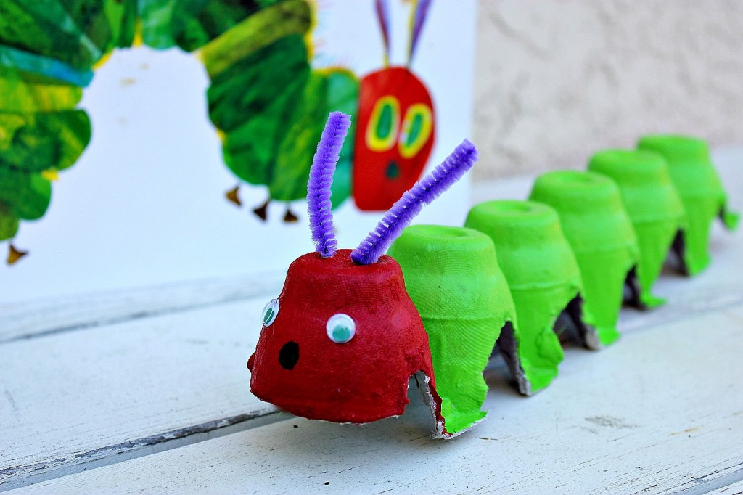  Can you make an egg box caterpillar?  - Cut along the middle of an egg box to make the segments of the caterpillar body OR cut each section of the egg box and then join them together with wool, string or treasury tags to allow movement between the segments.  - Paint or colour the caterpillar’s head and body.  - Stick on googly eyes or draw on eyes and a nose.  - Use pipe cleaners/straws/matchsticks for the caterpillar’s antennae.  We look forward to seeing photographs of your crawling caterpillars!  Can you make a very hungry caterpillar handprint?  We have put a link to the instructions on our website.
Physical  We try to get a mixture of gross motor and fine motor activities. | - Cosmic Yoga – The Hungry Caterpillar: https://www.youtube.com/watch?v=xhWDiQRrC1Y  - Ask the children if they can use their bodies to create the following shapes from the story:  Egg  Caterpillar  Chrysalis  Butterfly  Can they add movements to any of these shapes? Would all of them move? Why did they choose that movement?  - Using pipe cleaners or straws and beads or pasta can the children create their own hungry caterpillar? Encourage the children to thread the beads or pasta onto the body of the caterpillar (straw or pipe cleaner). Create a face for the caterpillar using card or paper. You could also create the foods the Hungry Caterpillar ate in the story and use a hole punch to make the bite marks as he eats through the foods!
Music  Listen to the Flight of the bumblebee by Nikolai Rimsky-Korsakov. The first time you listen encourage your child to close their eyes to help them focus on the music, you can talk about how it makes you feel- is it a relaxing piece of music or energetic? Do you think it sounds like a bumblebee? The children love watching the orchestra, you could try and identify the different instruments and talk about why they sit in groups or families. | https://www.youtube.com/watch?v=t3splSJ4Jp0  -Whilst listening to the music you could take your pen for a walk to the music and then colour it in.  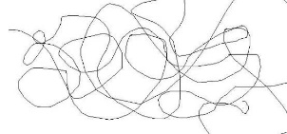  -Make your own Kazoo (we think this sounds very similar to a bee) https://www.bbc.co.uk/teach/bring-the-noise/found-sounds/zvfynrd

