Can you finish off these frog themed sentences with a word?

If I was a frog I would jump to
I would make sure I ate lots of
My best friend would be a
My home would look like a
My favourite activity would be
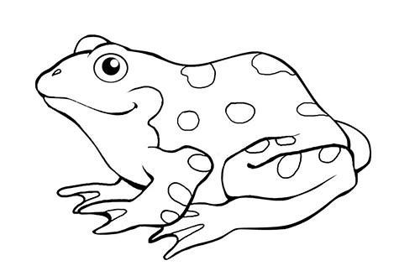
I could jump as high as a

