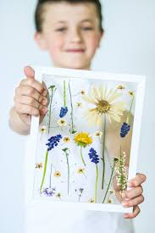 Flower Pressing

- Find a flower head and carefully cut just one from the plant and make sure it is dry.
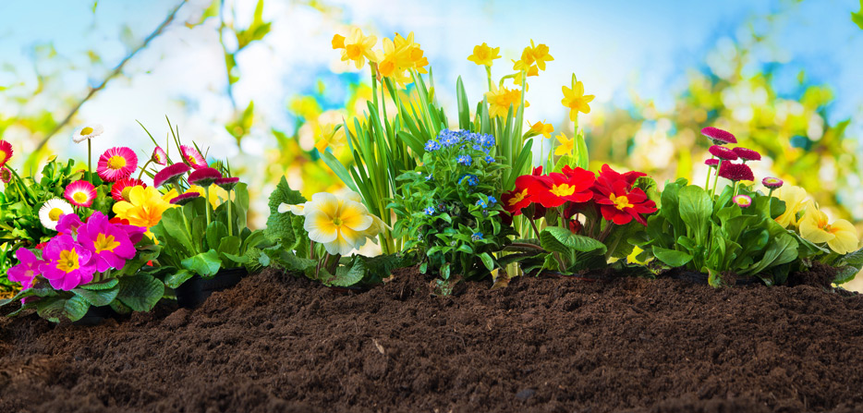
- Use 2 sheets of paper and a piece of tissue then place the flower on one piece of paper, add the sheet of tissue, and then another piece of paper on top.
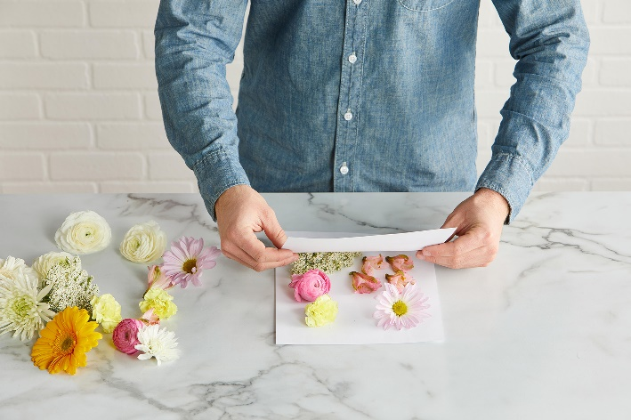
- Place the papers on a hard surface and add a piece of wood/hardback book large enough to cover the whole paper on top of the papers.
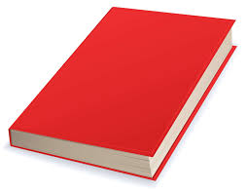
- Then add more books or a heavy box on top.
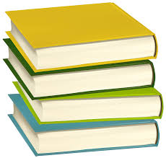

- Be patient and leave the flower to press for at least 3 or 4 days.
- You can then stick your flower onto a picture or into a card as a lovely surprise! If you press more flowers you can put them in a frame and make them into a different picture like the cat one below.
