Easter activities
If you take photos we would love to see them, the nursery email address is nursery@totonbanksroad.notts.sch.uk please only send emails showing your child’s learning, any questions should be directed to the school office address.
Mindfulness
- Take a minute to focus on your breathing, we have been practising sitting with our legs crossed, hands rested on our knees and eyes closed to help us focus. We take short sharp breaths in and long slow breaths out, holding for a count of 3 in-between. We have been using our inner eye (our imagination) to picture a safe place that makes you happy, this can be a beach or sitting in a boat at sea, a treehouse or a rocket in space. We then think about how that place feels- for example at the beach imagine how the sun feels on your skin, how does the sand feel under your feet, what does the sea smell like, what colour fish can you see swimming, what sounds can you hear? The children are encouraged not to answer these questions but simply
Physical (for rainy days)
- Learn body parts with https://www.youtube.com/watch?v=1cqLp1RqHl8
- Our afternoon wake and shake song https://www.youtube.com/watch?v=1gUbdNbu6ak&list=RD1gUbdNbu6ak&start_radio=1
- https://www.youtube.com/watch?v=KVE-T2_vLpY&list=RD1gUbdNbu6ak&index=3
- https://www.youtube.com/watch?v=A1vdKfXlB_g&list=RD1gUbdNbu6ak&index=4

Number
- Count and sort different coloured eggs found on your Easter egg hunt.
- Draw your own Easter egg design and make repeating patterns on it this can be different colours, shapes or handwriting patterns (we expect nursery children to be able to finish a AB pattern that an adult starts e.g. blue, yellow, blue yellow)
- Use an egg box to collect Easter themed objects, talk about how many you will have altogether when it is full, Where to start filling, and then working by going across the rows, how many do you have when a row is full?
- Using the numicon Easter eggs resources to do an Easter egg hunt.
English
- https://www.bbc.co.uk/cbeebies/watch/lets-celebrate-easter?collection=lets-celebrate-celebrations Watch Toby as he prepares for Easter, together you could write down how/if you celebrate Easter. Do not expect your child to be able to spell words or know which letters represent sounds. Get your child to draw pictures of the Easter story, think about the beginning, middle and end.
- You could do a tricky word hunt on eggs- we have been learning I, no, go, to
- You could write the tricky words in chalk and use a water sprayer to wash the word you say out.
- Using objects around the house as instruments you could make up your own Easter song, think about the different sounds you are representing- how would a bunnies hop sound, is it a high sound or low, is it quiet or loud?
- Lay down and close your eyes what sounds can you hear? What sounds would you normally be able to hear e.g. children playing in the playground, airplanes etc.
Creative
- Easter painted rocks 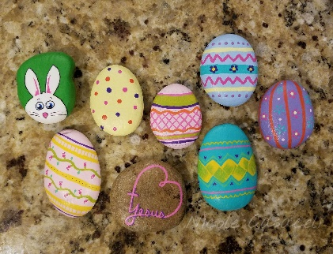
- Make an Easter Bonnet
- Make a sun catcher 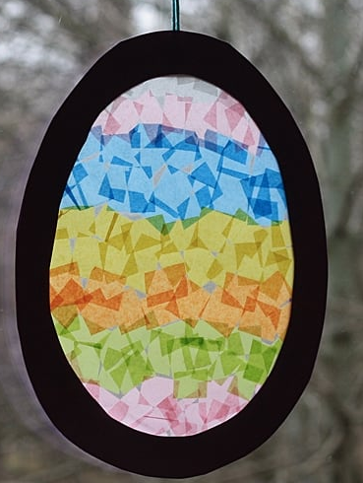
- Create your own Easter bunny story, draw pictures to show what happens on his adventures

