Phonics bug- on-line reading scheme support sheet
Phonics bug can be accessed from any device that connects to the internet simply enter the web address www.activelearnprimary.co.uk
You will need to enter your child’s login details- we have spoken to the children about keeping these details private.
Username: please see class teacher for these details
Password: please see class teacher for these details
School code: please see class teacher for these details
When you log on you will be taken to your child’s homepage. To access your child’s reading books please click on the tab ‘my stuff’.
The class teacher will allocate your child a couple of books and review regularly. Please encourage your child to re-read books as this is the most effective method to build up pace, expression and comprehension.
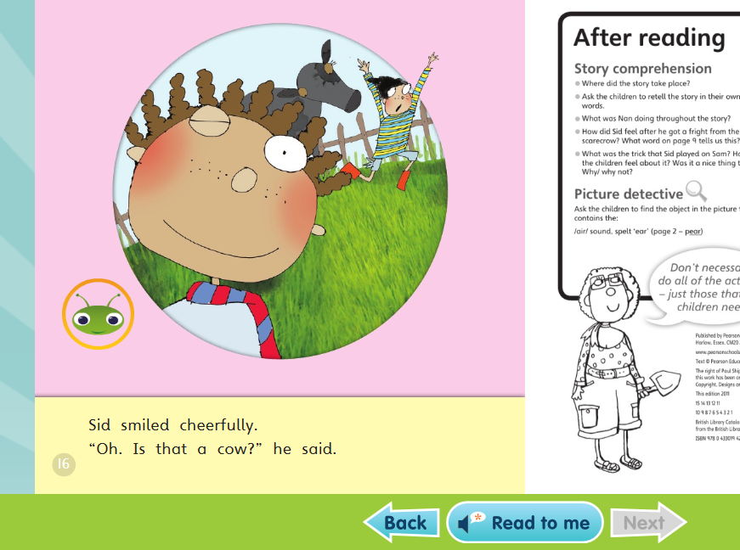
- Click on the book you would like to read, if you are using a tablet device you may need to turn this on its side.
- On some of the pages you will find a green bug if you click on this you will find comprehension activities. Please encourage your child to complete it independently as the teacher will be able to see the results and assess where to support further.
- Once the comprehension activities have been completed the book will move into the my library tab so please encourage your child to read the book a couple of times before answering questions this will ensure they can answer fully.
The more your child engages with the texts the more rewards they earn to spend in the reward section. This area can be found if you click on the ‘my rewards’ tab.

