[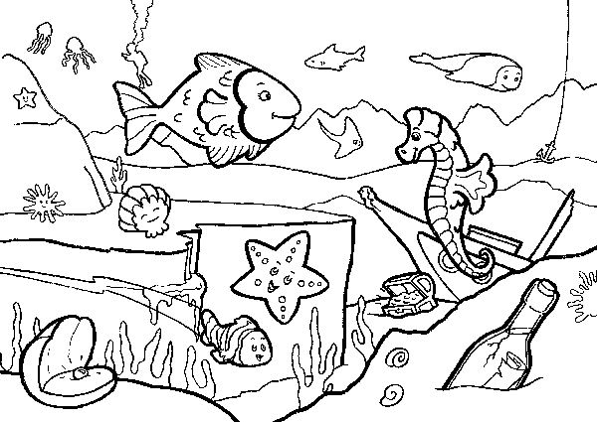](https://www.kiddycharts.com/assets/seaside-colouring-in-designs-child-sea-JPG.pdf)

[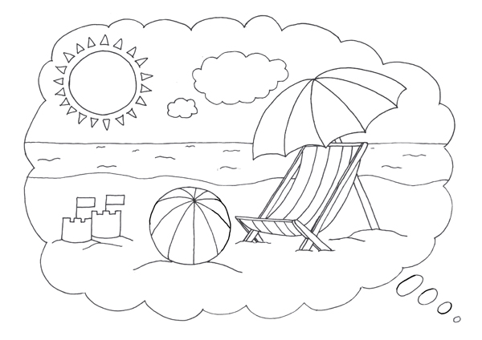](https://www.google.co.uk/url?sa=i&url=http%3A%2F%2Fwww.getcoloringpages.com%2Fbeach-scene-coloring-pages&psig=AOvVaw2avHRD8zfJPehXCyFJApYA&ust=1594205415234000&source=images&cd=vfe&ved=0CAIQjRxqFwoTCPCC7KL9uuoCFQAAAAAdAAAAABAa)