Do flowers drink water?

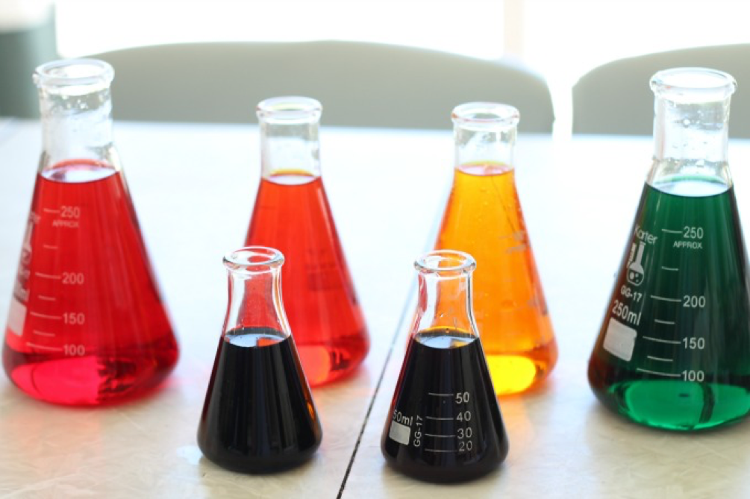
Have you ever wondered where the water goes when a plant is watered? Place the stem in coloured water and you’ll see how your flower “drinks” up the water.
With this experiment, your child will see how important the functions of the stem are to keep plants growing. They will be able to see how water travels up stems of plants, into the leaves and flowers to make food which helps keep the plant rigid.
You will need – Clear containers, white flowers (carnations work best), food colouring, scissors.

Instructions
Step 1: Add 10 drops of food colouring into each clear container.
Step 2: Fill with water. Add more drops if necessary to achieve a nice dark colour.

Step 3: Cut each stem of your flowers on an angle and place inside each container.

Step 4: Wait and watch! Within a few hours, you’ll begin to see the flowers change color. As the flower “drinks” the water, it runs through the stem as well as all of the petals.

