My Weather Diary
Can you write a weather diary for each day this week? Maybe if you have a thermometer at home you could measure the temperature too!
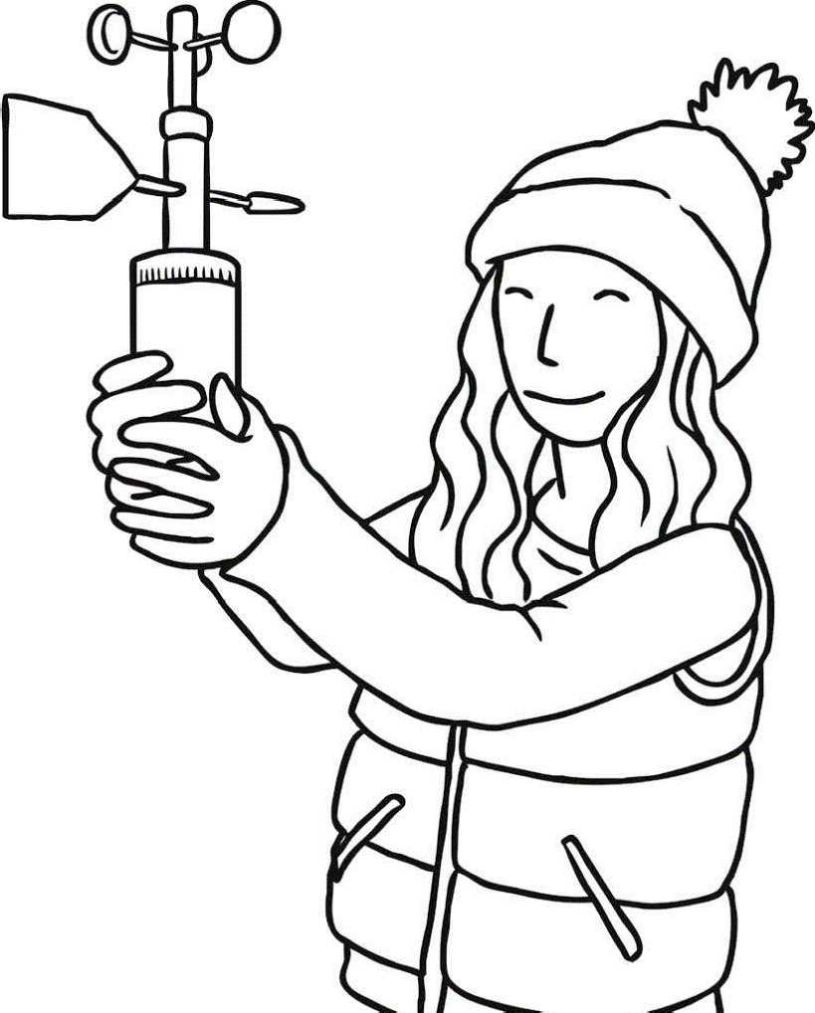

Use the weather word mat to help you!

Day | Describe the weather | Draw the weather
Monday
Tuesday
Wednesday
Thursday
Friday
Saturday
Sunday

This chart is an example you could use to record the weather for the week. You can also do it as a booklet/draw your own chart with the temperature on. Have fun and please show us on the year 1 email!

