Teachers notes-  The theme for the next couple of weeks is ‘All about me’ – this is a great opportunity to reflect on themselves – their likes/dislikes, their family, their friends, their feelings. | Resources/ Activities
Life skills  We would love to hear about any life skills your child is developing. They are important in developing independence, resilience and confidence. | - Can you help to fold some of the washing in your house?  - Can you help to make your bed?
Mindfulness  This activity should is designed to develop your child’s understanding of events and develop the skill of unpicking the finer details of a certain moment in time. | Have a look through some family photos – can you remember where you were in the photos?  Can you remember how you felt in those pictures? Who can you see? Can you imagine yourself back in that place that you see?  Can you make a senses handprint – draw around your hand and label each one of your fingers/thumb as – Touch, Taste, Smell, Hear, See – can you draw or write in each section of your hand something that relates to that photo. E.g. if you were on a beach, what did you smell? What did you hear? What did you taste? Etc.
Communication and Language Skills  Some of the best opportunities for developing language and communication is through social games – not only does it support the children’s understanding of social cues and turn taking but as the children are distracted by games, they will more often speak more freely. | Here are some activities you could try at home:  Can you make a large scale ‘three-in-a-row’ game? Instead of using noughts and crosses, use two types of fruit or vegetable! You could use real ones (if you’ve got enough), make pictures, or even paint pebbles. Your fruit/vegetables could sit on plates instead of in squares/a grid  Play the shopping game. Sit in a circle with your family or take it in turns with one other person. The first person starts by saying….’I went shopping and I bought a…..(pear)’, the next person says….’I went shopping and I bought a pear and a…..(banana). Keep it going as long as your memory lasts!  You could choose to only use healthy foods or if you have been learning about food groups, perhaps you could choose one of these to make it even harder!
Phonics  Language to use when discussing phonics with your child at home:  Phoneme: smallest unit of sound in a word, we teach the children which letter/s make these sounds.  Grapheme: the written letter/s that represent a sound.  Digraph: two letters that sit together to make one sound  Trigraph – three letters that sit together to make one sound. | Focus this week:  Phonemes: ur / ow  Watch the jolly phonics clip, you will need to scroll to find the digraph you are focusing on:  https://www.youtube.com/watch?v=W8Jp5MutVlQ  Practise the pure sound and sing the Jolly Phonics song together.  As well as saying the sound it is beneficial to write the sound – we would encourage writing the sounds in different ways, in difference colours, in different sizes – we have noticed that the more ways the children experience the sounds in, the more likely they are to remember them!  Phonics activities/games:  - Water balloons – fill up balloons with water and label them with words that contain the new phonemes - put them into a big box – one at a time pull out a balloon and segment and blend the word – if you get it right you can pop it!  - Kitchen roll towers – cut up a kitchen roll into smaller tubes – write on words that contain this week’s phoneme in. Take it in turns to pick up one of the small rolls and read the word. Each time you pick one up see if you can stack them to make a tower, you can only add it to your tower if you read it correctly!– the person with the biggest tower wins.  Tricky words Recap: the, to, I, no, go, into, he, she, we, me, be, you, all, are, they, was, her, my  Activity idea: can you write the tricky words using at least 3 colour pens – write a tricky word in one colour, then on top of that write the same tricky word again in another colour, repeat this as many times as you like to make rainbow tricky words.  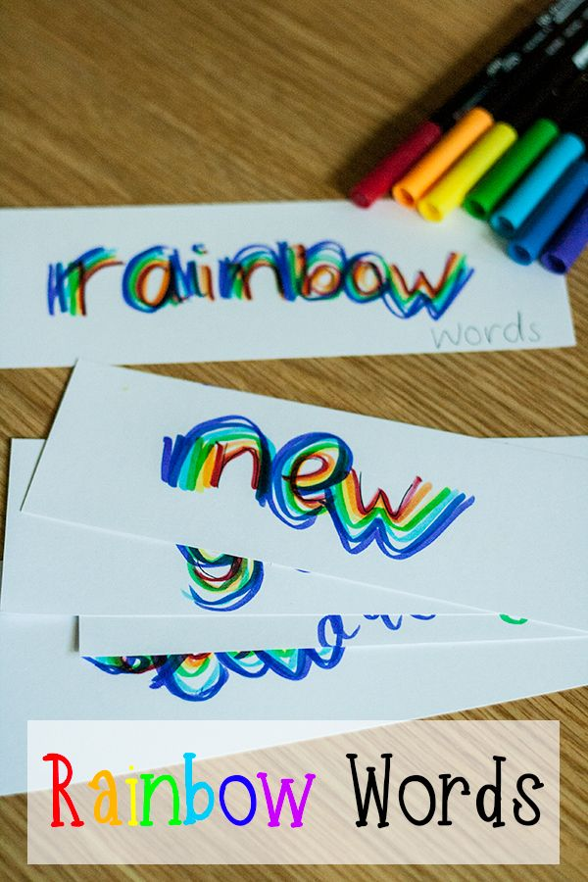
English-  As the theme for the next couple of weeks is ‘all about me’ this is a great opportunity for you and your child to read a range of your favourite books and texts.  The book review activity is a great way for children to develop their comprehension skills – you could ask questions about why they like it, who are their favourite characters, what was their favourite scene from their book etc. It’s also a good opportunity to develop their emotional vocabulary as they express their views. | Activities:  Positivity rainbow – using the template provided can you think of all of ways to describe yourself – talk about everything you are amazing at doing, you can write in what you say on each colour of the rainbow and then you can colour it in. All of those amazing things make up your own pot of gold at the end of the rainbow.  Book review – do you think you could tell us all about your favourite book? Maybe it is one we could share in school. You might know books your teachers have never heard of! Can you tell us all about it – we have a book review template that you can use for ideas – there are parts you can draw in and other parts to write in.  My 5 senses – can you do some research into your 5 senses? Do you know what they are? What do we need them for? Could you draw and label a picture of yourself and point out where we could find our 5 senses?
Maths  Here are some links to videos/games to support this weeks’ maths:  Subtraction (to help consolidate previous weeks learning)  https://www.topmarks.co.uk/Flash.aspx?f=TakeAway  100 square (interactive so you can splat different numbers and represent patterns in numbers)  https://www.topmarks.co.uk/learning-to-count/paint-the-squares | Place value –  To ensure children have a strong sense of the value of numbers here are some activities you could try at home:  - Missing numbers worksheet – can your child identify the numbers that come before or after a given number? See if they can fill in the blanks on the sheet.  - 100 square – we looked at what the 100 square was, what it showed us and how we could use it to help our maths. Could you challenge your child to colour in the boxes that show: multiples of 2, multiples of 10, all of the numbers that have a 3, all of the numbers that have 6 etc – by doing this they are becoming familiar with the position of numbers and where they belong amongst all of the other numbers.  Repeating Patterns – to continue our learning about shapes, we would love to see what patterns you could make with them. Can you do a 2 shape pattern, or even a 3 or 4 shape pattern? You could draw the pattern, you might want to paint a pattern, or stamp a pattern!
Arts and crafts  Getting creative and a little messy is a fun way to embed children’s learning. It also provides a hands on learning experience which is often very memorable for children! | 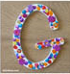  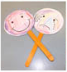  What’s the first letter of your name? Can you draw round a template, and cut it out? Decorate your name however you like!  Make some feelings lollies! Use card circles to draw your expressions on and lolly sticks to hold them up. How many feelings can you think of?  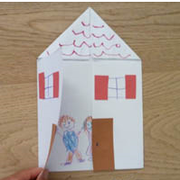  Make a folding house with windows and doors. Can you draw your family inside?
Physical  We try to get a mixture of gross motor and fine motor activities. | Leaf prints – This activity is something the children absolutely loved in our Forest schools garden. It is also something you can incorporate into daily exercise too. First you need to gather a selection of leaves – we encourage children to get a range of colours and to also get the leaves with the biggest veins as they will create the best art work – this might be a nice opportunity to stretch your legs and go to the local park.  The only other equipment you will need is white paper or an old white sheet/pillow case and a hammer.  *Please note – this activity is designed to be completed with adult supervision*  Sandwich the leaf in between 2 bits of paper or the material – and use your hammer to tap the leaf below – you will slowly see the colours disperse from the leaf – repeat with others to create art work!  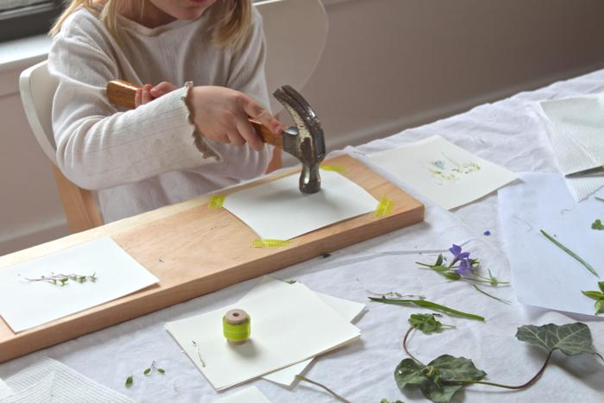  Here are some links to some other active videos which the children have loved in school – they are great 5 minute exercises!  Shake your sillies out:  https://www.youtube.com/watch?v=NwT5oX_mqS0  Head, shoulders, knees and toes:  https://www.youtube.com/watch?v=TSdeIhmv6v0
Music  As the theme is ‘all about me’ this week we have sourced some ideas which will engage the children in thinking about themselves physically using the body percussions and how to make their own sounds. It will also allow the children to think about their feelings towards music and how to match a feeling to a sound. | 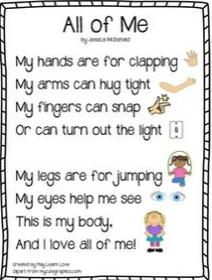  Have fun with this rhyme – can you make up a tune to go with it? Can you make up some actions? You could change the words to different parts of the body.  Body Percussion!  Explore all the different sounds your body can make! Finger snapping, feet stamping, hair swishing, tongue clicking….. You could even make a repeating pattern with your body percussion – have fun!  Explore the sounds your voice can make. Can you hum, sing, whisper…. make your voice high or low, loud and quiet?  Sing a song in different ways, using your voice differently each time.  How does it make you feel?  Listen to these pieces of music and decide how they make you feel. Can you name the feeling?  Gustav Holst – Jupiter  Beethoven – Fur Elise  Saint Seans – The carnival of the animals X111

