Teachers notes-  Continuing on from last week, our theme is still based around ‘All about me’. | Resources/ Activities
Life skills  We would love to hear about any life skills your child is developing. They are important in developing independence, resilience and confidence. | Have a conversation with a family member or friend over the phone. Can you ask them how they are? Or maybe what they have been doing? Can you share what you have been up to at home too?
Mindfulness  This activity should is designed to develop your child’s understanding of events and develop the skill of unpicking the finer details of a certain moment in time. | At the end of the day talk about 3 things you are grateful for. If you want to write them down you can or ask your grown up to help you do this – that way you could read them the next day.  Think about what has gone well in your day – did somebody do something nice for you? Did you achieve something you are proud of? Did you have a delicious lunch that made you happy?
Communication and Language Skills  Some of the best opportunities for developing language and communication is through social games – not only does it support the children’s understanding of social cues and turn taking but as the children are distracted by games, they will more often speak more freely. | Here are some activities you could try at home:  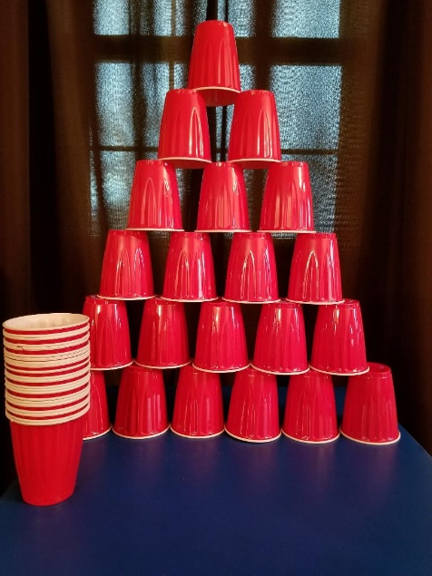  Stacking cups – this game works a little like jenga except for this time you are adding and not taking away. How high can you stack the cups? Take it in turn to stack the cups – if your cup is the cup to knock them all over then you have lost!  Target practice! – Using the same cups you could also have a game of target throwing – using a ball, soft toy, or bean bag, take it in turns to see how many cups you can knock down – the person who knocks the most down, wins!  Balloon herding – blow up a range of balloons and pretend they are like sheep in a field. Using a basket or box, turn this onto its side to make it appear like sheeps pen. Using a sweeping brush, can you sweep all of the balloons into the hoop – how quickly can you do it? Can you beat your last time? If the ‘sheep’ float back out of their pen you must quickly make sure you get them back to their pen!
Phonics  Here are some games that the children know and love from Nursery to practice their phonics skills. We particularly focus on sound discrimination, rhymes, alliteration, oral segmenting and blending, and body percussions. | Focus this week:  - Singing nursery rhymes – although it may not seem like direct teaching, singing songs, particularly nursery songs, helps children to understand rhymes, rhythms and beats which is a huge part of phonics. We find it particularly useful to point out the rhyming words to children and ask them if they can then think of others to rhyme with them.  - Take an ‘adjective’ walk – whilst you are out on a daily walk, see if you can focus on describing what you see in the environment, try and model alliteration for the children to pick up on hearing for initial sounds e.g. fantastic flowers, tall trees, colourful car etc.  - What am I? – Fill a bag with either toy animals or pictures of animals – the person with the bag chooses an animal and makes the sound of that animal – can you guess what it is?
English-  Below are some links to some books and stories the children have enjoyed in school – these in particular are share important messages around self-positivity and the importance of friendships.  ‘Only one you’  https://www.youtube.com/watch?v=vu9capmEY5I  ‘The Paper Dolls’  https://www.youtube.com/watch?v=0BuURAo5f3k  ‘Ronald the Rhino’ – PowerPoint | Activities:  Super me! Can you draw yourself as a superhero? What could your power be? Maybe you are super kind, maybe you are an amazing writer or perhaps you want to save animals. Could you write down your powers? You could make a comic book of you using your special super powers for the greater good! We can’t wait to see what you come up with! We have given you a template that you can use if you would like, you could draw the pictures in each scene and your grown up can write down what is happening!  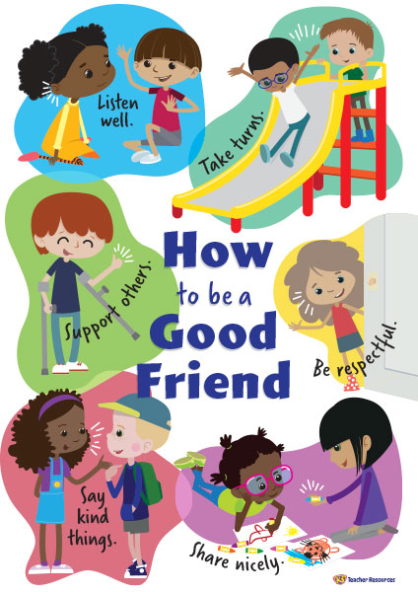  Ronald the Rhino:  Task 1 - Have a read through the story together and see if you can answer some questions. Why was the rhino upset? How did the other animals help? What did they make him realise? Have you ever helped a friend out before? Or maybe they have helped you? – Discuss the importance of being yourself and not trying to be anyone else. Can you think of the things you are good at?  Task 2 – Can you make a poster of what a good friend should be like? Make it bright and colourful! Think about the animals in the story, your own friends and how you demonstrate friendly behaviour to help you!  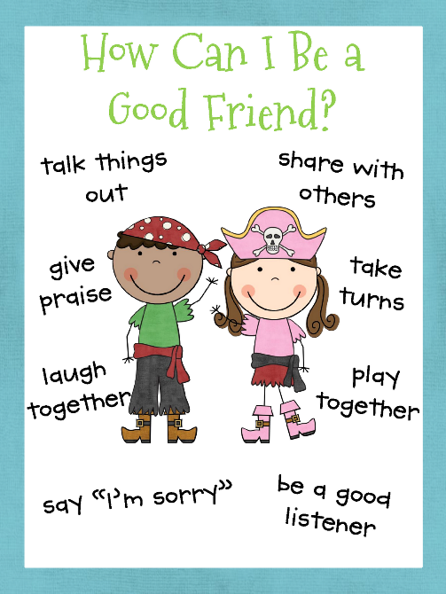
Maths  Here are some links to videos/games to support this weeks’ maths:  Shape monsters:  https://www.topmarks.co.uk/early-years/shape-monsters | 2D Shapes –  This week we are recapping our knowledge of shape.  Here are some activities you could do to embed the learning:  - Shape picture – can you draw a picture using different shapes?  - Shape construction – using toothpicks/ sticks/ pipe cleaners and blue tack, can you construct a shape, pretend the blue tack is like your glue to stick all of the edges together!  - Shape crown – can you use the template provided to make your own crown – you will need to cut out all of the different shaped jewels to stick on it!
Arts and crafts  Getting creative and a little messy is a fun way to embed children’s learning. It also provides a hands on learning experience which is often very memorable for children! | 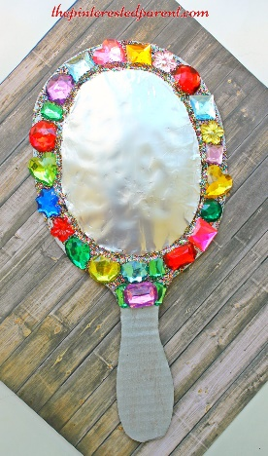  Magic mirror – can you make your own mirror using tin foil, card and collage pieces?  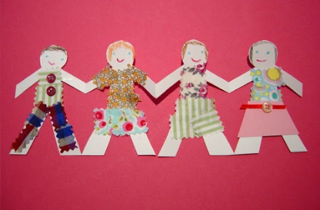  Can you make you and your friends/family as a paper doll chain? Fold your paper first into how many sections you need, draw the template of a person and then cut out. You can then decorate each person as your friends or family!  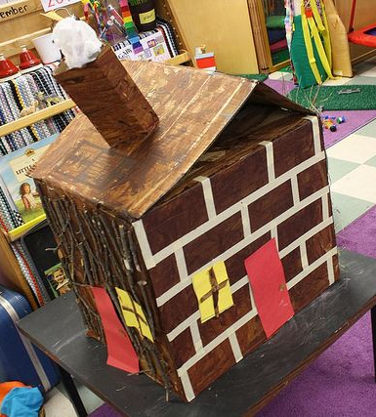  Can you make your home? What colour is it? How many windows does it have? What colour is your front door?
Physical  We try to get a mixture of gross motor and fine motor activities. | 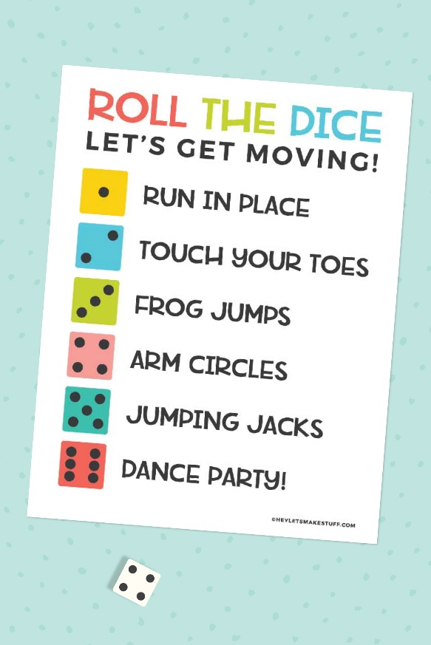  Together with your child you could create your own chart of ideas for the type of exercise to do for each number on the dice – we have provided an example but you could be creative and think of lots of other exercises to do!  Balancing – To develop children’s coordination and overall balance, children often need reminders to do things a little bit slower than they might like to. This activity will not only help to develop their control but also their patience as they will need to take their time to complete it successfully.  Option 1: Balancing an item on their heads when walking – you could start off with something easy such as a cushion and then progress onto something more tricky like a book.  Option 2: Moving an object from their foot into a bucket/tub. Place something like a bean bag or soft toy on the top of their foot. The children will then need to lift their foot slowly and with control in order to transfer that object into the bucket. The key point is that hands cannot be used!! That’s what makes it tricky.
Music  The activities this week are a little different for music – this week the children will be exploring different sounds in their environment. By having the hands on experiences and through them investigating the sounds themselves, this should help to strengthen their understanding. | 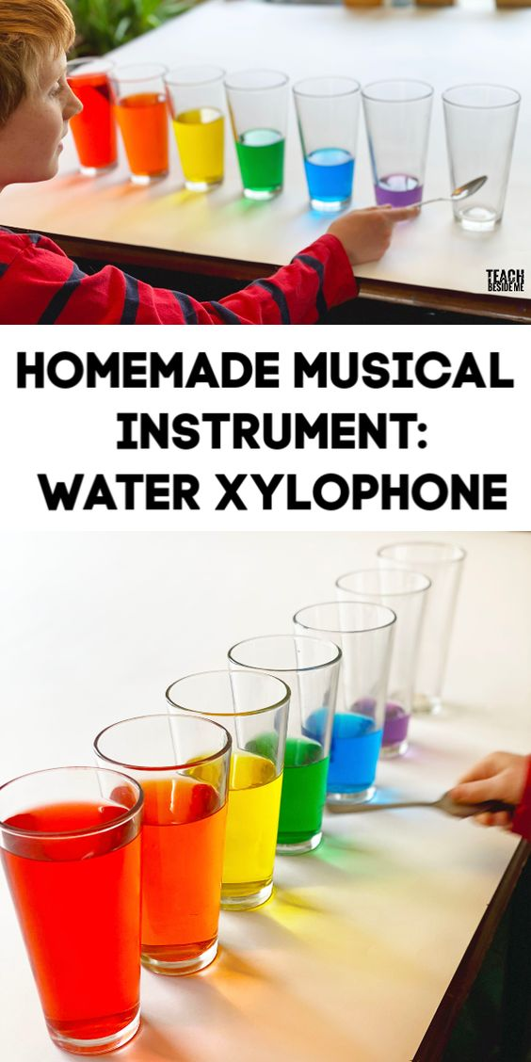  Exploring with sound is such a crucial element to a child’s progression in their phonics, reading and writing. This activity will help to develop their listening skills as they tune into the different pitches and volumes of sounds and also their scientific skills as they identify what happens as the liquid amount changes.  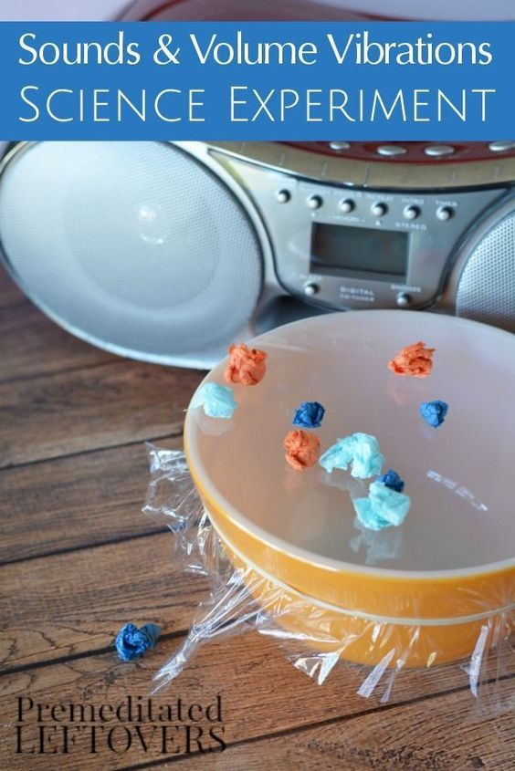  This second musical activity involves a bowl, cling film, tiny pieces of paper/tissue scrunched up and a CD player or set of speakers.  You can play any song that you like – you might want to investigate if different songs make different vibrations. Does the paper move when you turn on the speaker? How close do you need to put the bowl to the speaker to see it move?  You could also swap the paper for something light like rice or small dried pasta pieces.

