Teachers notes- Story of the week- Little red hen | Resources/ Activities
Life skills  At school we don’t always have the opportunities to practice important life skills. We would love to hear about any life skills your child is developing. They are important in developing independence, resilience and confidence. | - Clear the table after a meal  - Loading the dishwasher or helping to wash the pots. (please make sure the pots are not too big for your child or easily broken if dropped by accident)
Mindfulness  Cosmic kids have guided meditations in their zen den, one that your child may be familiar with is the candle of concentration There is a link to this or could try our shorter version if you like. | https://youtu.be/yx_8bnRYL08  At school we sometimes use the candle of concentration- we start by talking about the safety rules around matches and fire, reminding them what the firefighters taught us. Ask your child to get comfortable, a sitting position is preferable so they can open their lungs up when deep breathing. We talk about how meditation is like exercise for the mind, the more you practise the stronger your mind becomes.  Light the candle and place it between you.  Ask your child to focus on the candle (in between asking questions take a few seconds pause to focus on deep breathing, modelling to your child opening your chest, breathing in through your nose and out through your mouth) your questions are not meant to be answered but for your child to think about. Looking at the colours they can see, thinking about the way the candle moves dancing and flickering, what does this remind you of?  Can you feel the warmth from the candle? Just like the warmth of the sun or the warmth of a love one as you hug them. Warmth that makes us feel happy….safe…secure.  To finish we work as a team to blow the candle out without moving from the sitting position. The breathing techniques make our lungs stronger and by working with others our breath will be more powerful. If when you blow the candle out it does not extinguish we talk about how we are not strong enough YET and by keep practising we will.
Social skills  A large part of early years is learning social skills. The games that are suggested will contribute to developing your child’s turn taking skills, building resilience (as they may lose a few games!) and their patience.  As well as playing games to develop social skills, having a specific topic or a talking point will also support children in developing their emotional vocabulary and how they respond to scenarios. | Name of the game What you will need How to play  Hide and Seek with Clues! 2 + players. A teddy/toy. Pen and Paper (optional). Like a traditional game of hide and seek but this time use a toy/teddy to hide. The player who is on must hide the teddy in a room in the house – the player guessing must ask questions about where it could be, for example is there a mirror in the room where it is hiding? If the player guessing gets a question right they can move on to another room and ask another question, if they get it wrong they must stay in the room they’re in until they get a question right!  Bowling 2 + players Bottles (they do not have to be the same size) or Kitchen roll tubes covered in a sock (for extra strength). A ball. Play this game like a traditional game of bowling – whoever knocks down the most wins – best out of 5 rounds! Get your child involved in the preparation of this game too – this will add to the experience of them finding resources they could use as the skittles!  Monster! 2 + players Paper, Pen/Pencil, Dice The aim of this game is to have drawn a complete monster on your paper before your opponent. With each roll of the dice, that is how many features of the monster you can draw e.g. if you roll a 2, you can draw 1 arm and 1 leg. The criteria for a completed monster is: - 1 head - 1 body - 3 arms - 4 legs - 2 ears - 4 eyes - 1 mouth - 1 nose  Talking Point:  Minion was hungry one day. Not just a bit hungry…VERY hungry. He had no food left at home. Poor minion!  He decided to go for a walk to take his mind off it and he knew the fresh air would do him good.  As he walked by his neighbour’s house he saw a giant fruit bowl filled with yummy bananas. The window was also open…  His neighbour was such a lovely person, she was always kind and helpful, and she always helped the Minions when she could.  Minion was drooling at the sight of the delicious bananas – he just had to have one! He thought about it for a moment, then he snuck across the front garden and reached into the open window and took 2 before running home again.  Was this the right thing to do? If he really was that hungry was there something else he could’ve done instead? How do you think his neighbour felt?
Language skills  To help support your child’s communication and language development. Here are some activities you can do together which link to this weeks’ book The little red hen’ | - Read the story aloud – adding expression for each of the characters – perhaps the people in your family could each play the part of one of the characters and turn it into a live action story – you could even make masks to really ‘become’ each of the characters!  - You could do some home baking and talk through the recipe together – using words such as First, Second, Third, Next, Then, After etc will help to develop understanding of sequencing and order. Even if you don’t have real ingredients you could always pretend to make some delicious bread and say what the Hen did in the right order!  - Use the story sequencing cards to verbally talk through the story – you might want to use this as an opportunity to ask questions such as: How do you think the hen was feeling? If you were the dog would you have helped? This will help to strengthen comprehension skills.
Phonics  Language to use when discussing phonics with your child at home:  Phoneme: smallest unit of sound in a word, we teach the children which letter/s make these sounds.  Grapheme: the written letter/s that represent a sound.  Digraph: two letters that sit together to make one sound | Focus this week:  Phonemes: sh / th  Tricky words: the, to, I, no, go, into (phase 2)  Watch the jolly phonics clip, you will need to scroll to find the digraph you are focusing on:  https://www.youtube.com/watch?v=W8Jp5MutVlQ  Practise the pure sound and sing the Jolly Phonics song together.  Practise writing the grapheme in the air, in a plate of rice, in the soil or sandpit in the garden, painting it or using exciting coloured pens.  - Play ‘Sorting Sounds’ using the PowerPoint attachment. As well as sorting the sounds for this week’s phonemes you could also have a go at sorting the sounds for last week phonemes!  - Write and colour activity identifying ‘sh’ (attachment)  - Draw a label something with the sound ‘th’ in it (attachment)  Tricky words: write the tricky words above out onto paper to use as flashcards, ask the children to read the words as you move through them, reminding the children these are tricky words and they can’t be segmented and blended. If they are confident reading these challenge your child to try and write these words, you may use the look, cover, write, check attachment if you like or just a simple pen and paper.
English-reading &writing  Read the story of the week- ‘The little red hen’ | Read the book together –  As there are key phrases that are repeated in this book you might find your child can pick up on these and begin to read this unsupported – as they will then be focusing less on how words are spelt and more on the patterns of words, this is a good opportunity to then talk about adding some pace and expression to make it sound more exciting!  Reading a recipe –  See if you can find a recipe for baking something of your choice – it doesn’t have to be bread but that would be great if you could link it to the book! As recipes are written in a completely different format to a story book ask your child what they notice – look at the numbers, the ordering, the type of vocabulary they use – talk to your child about how recipes are a bit bossy and are telling you to do something!  Reading simple sentences:  You might want to write the following sentences bigger to see them better – after reading them you could then cut up the sentences to see if you can put them back together again!  - The red hen was not happy.  - She had so much to do.  - The dog, cat and duck did not help at all!  - Little Red Hen must have been sleepy after all of her work.  Writing a sorry letter from one of the characters!  Pretend you are either the dog, cat or duck. You’ve thought about what you have done and now you feel very sorry about not helping the hen with all of her work. Can you write a letter to the hen to apologise? You might want to add in a question such as, can I help you with anything in future? You also might want to draw the hen a picture to cheer her up or make her something to make her smile – I’ve heard she loves anything pink and blue!  Speech bubbles for the characters –  Draw the key sections of the story to make it look like a comic book- you might want to make your paper look like it has square boxes in for this – then you could cut out or draw some speech bubbles and write in what the characters said at different points of the story. If you’re feeling super clever you might even add in some thought bubbles to show how the characters were feeling too!
Maths  This link has a nice explanation of different ways to support your child, this is a broad suggestion of ideas we will send specific activities weekly. https://www.bbc.co.uk/cbeebies/grownups/help-your-child-with-maths | -Look at the ‘I spy and count numbers to 20 sheet’, using the ‘I spy checklist’ count how many of each object you can spy. Your child may need you to model forming the numbers correctly.  -Little red addition sheet- You can extend your child by encouraging them to come up with their own number sentence, you could use items from the kitchen.
Arts and crafts  Paper plate hens. | 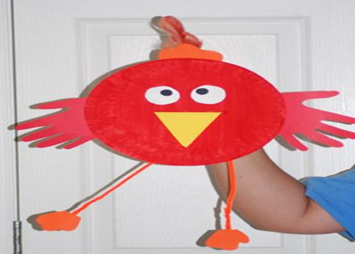  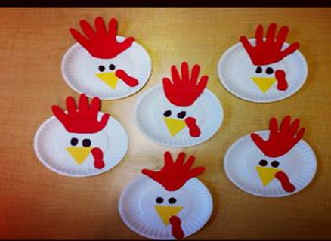  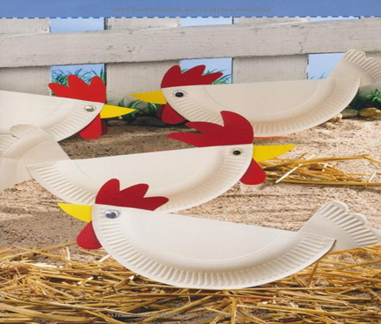  Using a paper plate (or a circle of paper), can you make one of these hens?  You may want to design your own and use other materials that you have at home.  We look forward to seeing your little hens!  We have also attached a split pin hen to colour and make. If don’t have any spilt pins at home you could attach with wool or string to make the parts moveable.
Physical  We try to get a mixture of gross motor and fine motor activities. | Yoga Time – This week our yoga is all about being on the farm.  Yoga Time on the Farm  https://www.youtube.com/watch?v=YKmRB2Z3g2s  If you are really enjoying yoga here are some more to have a go at:  Squish the Fish  https://www.youtube.com/watch?v=LhYtcadR9nw  Coco the Butterfly  https://www.youtube.com/watch?v=pT-s1-phgxs  Parsnip the Cat  https://www.youtube.com/watch?v=Nfd6e4wBQho  Arnold the Ant  https://www.youtube.com/watch?v=iWowDC3x0hE  Talk about and make bread rolls together. Talk about the ingredients and where they come from. Make and knead the dough together and then shape into rolls and bake in the oven. Simple recipe included in the attachments or you can use your own. We would love to see pictures of your finished rolls!  Alternatively you could make pretend bread rolls using our playdough recipe. Please see attachments for recipe.  Milk a cow!  You will need:  Container  Clean rubber glove  Water  Needle  What to do:  Prick the end of one finger of the rubber glove with the needle. Depending on the thickness of your gloves, you may need to stretch the hole with the needle.  Fill the glove with water and tie the open end of the glove so that it holds the liquid without spilling.  Now the fun can begin! Allow the child to grasp and squeeze the finger downward to simulate milking a cow. You can attempt to fill a small glass with the “milk.”
Music  Sing up is a web site that supports schools bringing songs into the classroom. | https://www.singup.org/singupathome/songs-for-learning/4-7  Digging in the garden song.  - What could you find in the garden that makes a sound? Can you use these garden instruments to create your own gardening/growing song?  - You may spot some other songs that we sing at nursery on there.  - We have attached the little red hen song, you could learn this or come up with your own version to a different nursery rhyme

