Hello,

As you may be aware we will be holding our “ Family Fun Day” again this year .

This is an event which helps raise funds for many groups , charities , schools and individuals who need our support .

Please could you display our posters and put them in your newsletter if possible .

A lot of local children were on the stage last year as we have local dance schools , scouts etc taking part during the day .

I would be most grateful for any support you could give in this matter .

Please feel free to join us on the day .

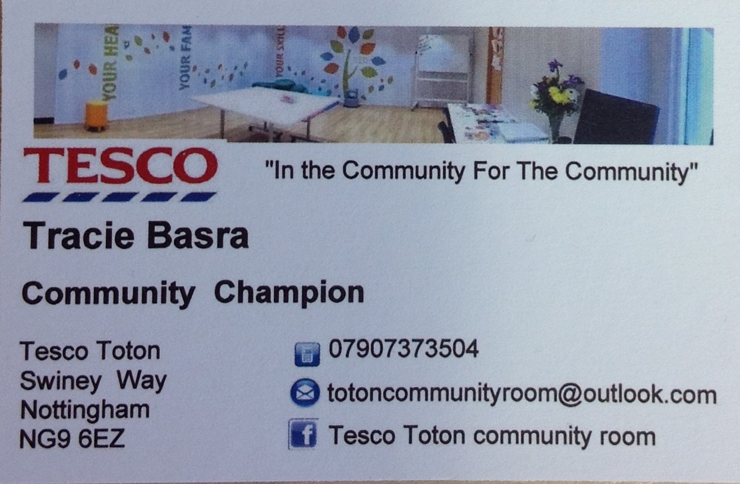
We are sure you will enjoy it .

Please feel free to contact me if you need anymore information .

