WB 6.7.20
Transitions and Feelings
This week we would like you to talk to your child about their feelings.
With a lot of changes in recent events and the news of moving into their new classes in September, we understand that the children are probably feeling a whole range of emotions. Some children may be able to express their feelings verbally, whereas some may show their feelings in different ways.
We find it is important to have the opportunities to talk and share how one another are feeling in these ever-changing times. It not only will enhance emotional language but will also develop general understanding of reactions and feelings towards events and during different periods of time.
This week’s task is to create a journal – this can be filled in throughout the week, you might want to choose a couple of sections to do a day.
On each page there is a different question or task for your child to complete about their feelings. Your child can draw, write or simply talk about the questions provided.
If you prefer you could represent your journal in a different way. Perhaps you’d prefer to write more in the style of a diary.

My Feelings Journal

WB 06.07.20

Name: …………………………….

Picture of me

How do I feel today?
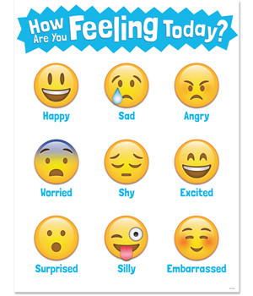

What am I going to do today or have I done already?

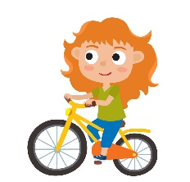

What’s on my mind? What am I thinking about?

Has something made me smile today, if so, what was it?

I can’t wait for…

I’m not quite sure about…

How do I currently feel about moving into a new class in September?

I am most excited for…

I feel a little nervous about…

Here are the things that make me happy when I feel nervous…

Who can I ask if I feel worried about something?

If my friend was feeling worried, how could I help them?

I am so good at…

I’d love to get better at…

These are the things that are most important to me and what I am most grateful for…

