Teachers notes-  The theme for the next few weeks is growing and life cycles.  This week we have planned activities based on the life cycle of a frog! | Resources/ Activities
Life skills  We would love to hear about any life skills your child is developing. They are important in developing independence, resilience and confidence. | - Take my coat on and off independently and hang it up in the correct place.  - Fasten my coat – whether it is zips or buttons independently. Offer to help others who may be struggling.  - Use my manners when asking for something or receiving something from another person.
Mindfulness  Amongst all the changes in routines and the added uncertainties, it is important to take time for yourself and to take time out of the busy day. | This week we have provided some mindfulness colouring for your child to complete – when completing this at school we would often play music quietly in the background to make this a calming experience and we find the children enjoy having this time to relax and simply enjoy the activity.  In the past we have used music such as Classical Disney Songs on YouTube or instrumental versions of modern day songs.  The time taken to complete the colouring varies between each child, the more the children practice the longer they can sustain their concentration on the task.
Communication and Language Skills  Language development is a fundamental aspect to a child’s learning.  Although language is developed every day through incidental and unplanned activities, sometimes having allocated time for this type of learning is beneficial so that you can pinpoint and focus in on the specific areas you may feel your child needs to work on. It might be their organisation of ideas, it could be how they extend their sentences or it may be the vocabulary they use when describing something. | Here are some activities you could try at home:  - Talk through the life cycle of the frog. Can you use words such as firstly, then, next, finally? You could use pictures to support you and to make sure you get it in the right order! (organising ideas and thoughts into the right order is a key part to a child’s communication development!)  - Guess what? – This game is just like the famous ‘Guess Who?’ game but this time, instead of people it will be objects from around the home. Each player could have a box or a screen to hide their selection of objects – each player takes it in turns to ask questions about the other players objects – can you narrow it down and guess what they’re hiding? You could also do this in a slightly different way where the player reveals 1 detail at a time about their object, they could use describing words – the player who guesses correctly with the least amount of clues wins!
Phonics  Language to use when discussing phonics with your child at home:  Phoneme: smallest unit of sound in a word, we teach the children which letter/s make these sounds.  Grapheme: the written letter/s that represent a sound.  Digraph: two letters that sit together to make one sound  Trigraph – three letters that sit together to make one sound.  Picnic on Pluto Game – Obb and Bob  The children love this game in school – it helps the children to practice their segmenting and blending and at the same time ensures they understand what they have read as they will need to decide if the words are real or nonsense!  https://www.phonicsplay.co.uk/PicnicOnPluto.html | Focus this week:  Phonemes: oa / oo  Tricky words Recap: the, to, I, no, go, into, he, she, we, me, be, you, all, are  Introduce tricky words: they, was  Watch the jolly phonics clip, you will need to scroll to find the digraph you are focusing on:  https://www.youtube.com/watch?v=W8Jp5MutVlQ  Practise the pure sound and sing the Jolly Phonics song together.  As well as saying the sound it is beneficial to write the sound – we would encourage writing the sounds in different ways, in difference colours, in different sizes – we have noticed that the more ways the children experience the sounds in, the more likely they are to remember them!  - Target game - Write words which contain the new phonemes in on separate sheets of paper or post it notes. Spread them out all over the floor and take it in turns to thrown either a bean bag or soft toy at the words – whichever word it lands on, that’s the word you segment and blend to read!  - Lily Pad Jumps – Linking with the theme this week, create individual lily pads – you could use paper plates for this or draw them using chalk on the pavement. In each lily pad add in a phoneme – can you jump on at least 3 phonemes to build a word?! Incorporating the new phonemes from this week would help to consolidate the learning.  - Snap – together, make some snap cards that contain the new phonemes, this simple yet effective game is useful for both the reading and writing elements of phonics.
English-reading &writing  Although there is not a particular story or text this week to share, here are some of the books/stories we would have shared in school with a link of where to view them:  Oi Frog!  https://www.youtube.com/watch?v=J2sAgbs-ebU (this link is the full story book read aloud)  https://www.bbc.co.uk/bitesize/topics/zvyc7nb/articles/zkpn92p (this link has an audio version of the book plus a video version which has key words clearly visible for you to see as you listen)  Teeny Weeny Tadpole  https://www.youtube.com/watch?v=dJTNcE1qO6g  The Frog Prince – PowerPoint Story | Reading Activities:  Frog Facts  Can you find out some facts about frogs. How does a tadpole turn into a frog? Do tadpoles eat what frogs eat? You could read about it in a non-fiction book or perhaps find some information out online! We have also found a PowerPoint of facts which you may find useful! (See separate resources).  Oi Frog –  Using the video link to bbc bitesize – open the video which contains the key words from the story. After listening to the story once, watch the story again – can you read the words – practice oral segmenting and blending. Ask your grown up to write down some of the key words – you could even turn it into a game – if you can turn the word over and read them you keep it! Whoever has the most by the end wins! You could even make a snap game out of the key words!  Writing Activities:  Rhyming string – How many words can you write that rhyme with the following words:  - Frog  - Cat  - Mug  See if you can write a list! Which word did you get the most rhyming words for?!  Finish the sentences!  Sometimes, thinking of full sentences can be tricky, so this time we have given you the first part of a sentence and all you need to do is finish it off! We hope that you give some creative answers! We would love to see what you come up with! (see separate sheet).
Maths  Here are some links to videos/games to support this weeks’ maths:  Sharing Video – Sesame Street - https://www.youtube.com/watch?v=KTFJ9gjfAXg  Addition to 10 game: https://www.topmarks.co.uk/addition/addition-to-10 | Sharing –  Continuing our theme of sharing we would like to see if you can make equal groups this week.  You might want to draw or cut out your very own lily pads or wooden logs. Start with 2 lily pads/ logs then add more if you’re finding it easy! You could then gather flowers or make your own little frogs to share out equally between the lily pads/logs.  Talk about making it fair – what does this mean? If I have 2 frogs on this lily pad and 3 on the other, is this fair? How could I make it fair?  Frog addition –  We know that you are great with counting when completing addition sentences, particularly counting accurately by pointing at each individual object. Your next challenge is to see if you can represent the addition sentences given as a part, part, whole model – for example, 2 + 2 = 4 is the same as saying ‘2 is a part, 2 is a part and the whole is 4’ – do you think you could draw a part, part, whole model to represent the addition sentences? Remember you will need 3 circles (2 parts and a whole) – see if you can then say the stem sentences to match!  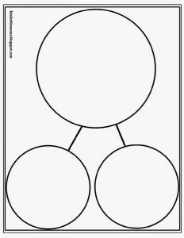
Arts and crafts  Getting creative and a little messy is a fun way to embed children’s learning. It also provides a hands on learning experience which is often very memorable for children! | Frog Life Cycle –  Using household resources or natural resources from the garden such as empty egg cartons or boxes from food packaging or pebbles, see if your child can make the 4 step process of a frog life cycle!  Bubble wrap works great for frogspawn but could also be created using clingfilm scrunched up or cellotape!  Below are 3 different ways you could represent the life cycle.  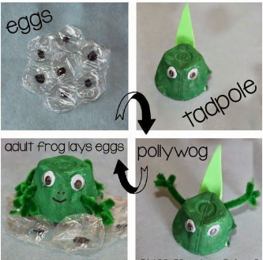  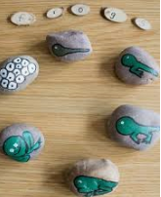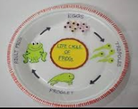  Concertina frog legs!  See if you can make your very own friendly frog!  Like when we have made fans in school, see if you can use the same zig-zag folding method to make legs that look like they bounce on your frog!  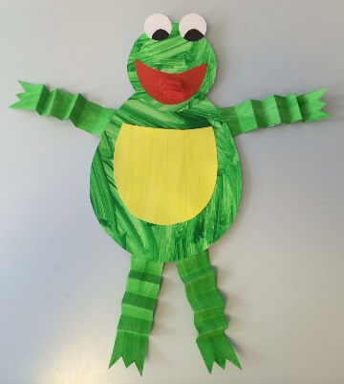
Physical  We try to get a mixture of gross motor and fine motor activities. | Jumping task!  Linking with this weeks’ theme of frogs, we would love to see if you can have a go at some jumping just like frogs do – you might want to practice simple bunny hop jumps to begin with and then progress onto big leaps from a crouched position. If you feel really brave you might be able to leap frog over the top of something like a cushion! Can you do it?! What about over the top of 2 cushions?!  Frank the Frog Yoga  Cosmic Kids yoga video -  https://www.youtube.com/watch?v=TY8xx7c6_z0  Pencil control frog leaps – (see separate sheet).  This activity is designed to provide an opportunity for some quiet focus time which will also increase dexterity and overall fine motor control.
Music  The children know this song well as they have sung it previously in school. It is a great opportunity to blend maths skills into something fun and light- hearted.  To enhance your child’s listening skills and rhythm you could also make a beat for the song using wooden utensils or natural resources. You could even try and make the sound of the frog if you find a bumpy surface to run a stick over!  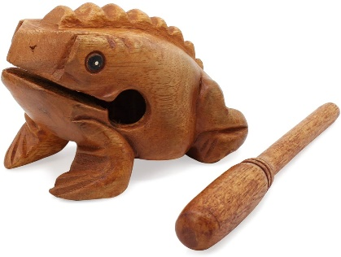 | Sing the 5 little speckled frogs song together:  Five little speckled frogs  Sat on a speckled log  Eating some most delicious bugs, yum, yum  One jumped into the pool  Where it was nice and cool  Now there are four more speckled frogs, glub, glub  Four little speckled frogs  Sat on a speckled log  Eating some most delicious bugs, yum, yum  One jumped into the pool  Where it was nice and cool  Now there are three more speckled frogs, glub, glub  Three little speckled frogs  Sat on a speckled log  Eating some most delicious bugs, yum, yum  One jumped into the pool  Where it was nice and cool  Now there are two more speckled frogs, glub, glub  Two little speckled frogs  Sat on a speckled log  Eating some most delicious bugs, yum, yum…  One jumped into the pool  Where it was nice and cool  Now there is one more speckled frog, glub, glub  One little speckled frog  Sat on a speckled log  Eating some most delicious bugs, yum, yum  One jumped into the pool  Where it was nice and cool  Now there are no more speckled frogs, glub, glub

