Home Learning Pack – Year 2 Week Beginning 6th & 13th July
The Home Learning Pack consists of :
- 10 spellings to learn a week
- A story to read together
- A maths game to play together
- 5 creative activities to support our theme for the fortnight

Spellings :
Week beginning 6/7/20: moon, blue, blew, fruit, soup, tube, June, use, chew, flute
Week beginning 13/7/20: complete, these, theme, dream, read, each, made, came, same, eight
10 spellings to learn each week. Show your child how to write these words on day 1 and get them to write them correctly 2 or 3 times as appropriate for your child. Each day ask them to write them from memory and correct any they make mistakes on. As the days go on they should be able to increase the number of words they can remember correctly. If your child finds reading difficult then focus on the first 4 or 5 words only.
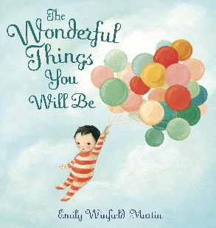
Story for the fortnight:
The Wonderful Things You Will Be by Emily Winfield Martin
You can watch this on youtube - https://www.youtube.com/watch?v=gYqEsoAfhPQ

Maths game :
A Maths game to play together which will support your child with practising their important maths facts – this is known as fluency.
Our game for this week is Dotty Six
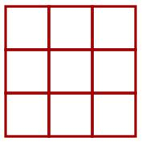
You will need:
- a partner
- a 1-6 dice
- a grid like this

How to play:
Take turns to throw the dice and draw that number of dots in one of the boxes on the grid.
Put all of your dots in one of the boxes. You can't split them up and you can't have more than six dots in a box.
When a box is full, you could put a tick in the corner like this:
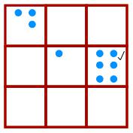
Keep going until there are three ticks in a row or column or diagonal. The winner is the person who puts the last tick.
There is a video of how to play here: https://nrich.maths.org/7337

Creative Work - Celebrations
At this time of year we would usually be celebrating the children’s time at Banks Road.
For the next 2 weeks we would like your child to complete a project related to the Year 2 RE and PSHE curriculum as well as celebrating their time at Banks Road.
By the end of Year 2 the children are expected to show understanding of:
- different beliefs and practices including festivals, worship, rituals and ways of life.
- what communities do, and why, so they can identify what difference belonging to a community can make

Your 5 learning tasks for this project are:
- What do you celebrate?
Think about the things that you celebrate and why. You might think about birthdays, special events, religious celebrations, holidays etc. You could display your celebrations any way you choose.
You could make:
- Poster
- Timeline
- Mindmap
- Picture

- Celebrate your time at Banks Road
Think about all the lovely times you’ve had at Banks Road, your memories, your friends, your teachers and your learning. Create a celebration of these. You could have a tea party, make a memory book, create a memory jar, make a little video or anything else you choose.
There are some nice ideas at the bottom of this web page https://www.hobbycraft.co.uk/ideas/kids/6-kids-memory-making-ideas
Please send us photos, we would love to see how you’re remembering and celebrating.

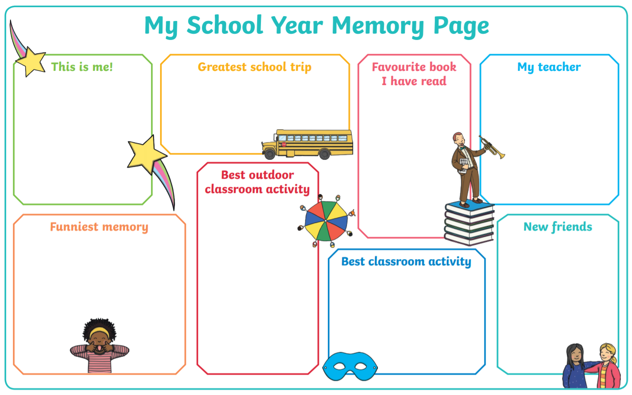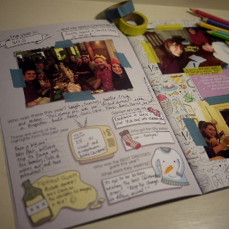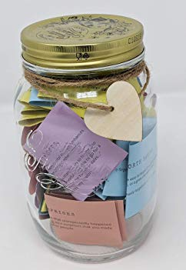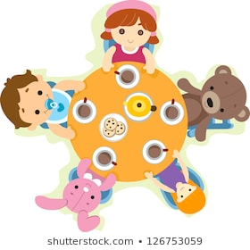

- Bake a celebration food
We often have special food at celebrations and festivals. We would like you to work with your grown ups to bake a special celebration food. You could eat it at your celebration party! You might want to make Hot Cross Buns, Christmas cookies, Birthday cake. See if you can show your grown ups how good your measuring skills are.
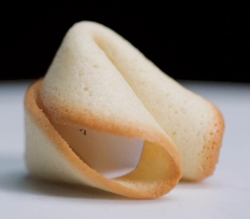
We have put some recipes that you could use on our website.

- Make a decoration
Choose a festival or celebration and make a traditional decoration that people would use to help them celebrate. We often decorate our homes around special celebrations. We would like you to choose a celebration or festival and make a decoration that we use to help us celebrate.
You could make salt-dough decorations, paper chains, paper lanterns or anything else you can think of. See if you can practise you Art and D&T skills that we have learned, particularly cutting, joining and presentation.

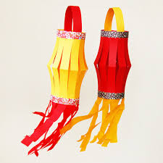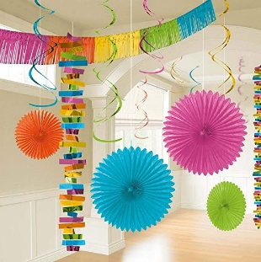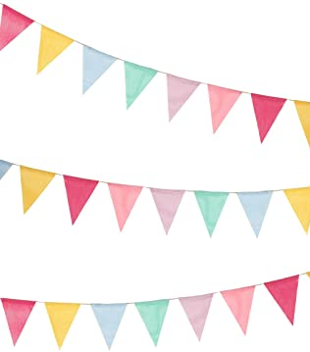

- Learn about a celebration or festival that you don’t know much about yet
Research a celebration. You can pick any celebration at all. It may be a religious celebration, a festival or something in the past that you can ask someone in your family about.
You can show what you have learned in any way. You could write in your project book, draw a picture, write us an email, make a model etc.
You can find lots of information about different celebrations here https://www.bbc.co.uk/cbeebies/shows/lets-celebrate
