[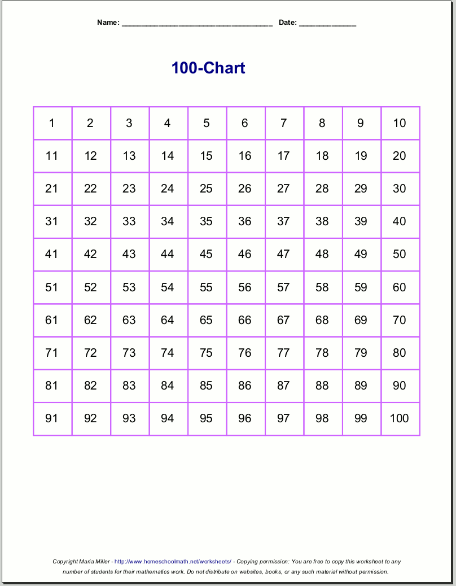](https://www.google.co.uk/url?sa=i&url=https%3A%2F%2Fwww.homeschoolmath.net%2Fworksheets%2Fnumber-charts.php&psig=AOvVaw1RsfvpzaCqT1oyB5JgorVV&ust=1591532276418000&source=images&cd=vfe&ved=0CAIQjRxqFwoTCJCev-uW7ekCFQAAAAAdAAAAABAJ)