Teachers notes-  This week all of our learning is based around growing – flowers, vegetables and fruit etc. There is not a set story for this week as it is open for you to explore – you may have some stories at home which explores this topic such as The Enormous Turnip or Oliver’s vegetables. You may even have some non-fiction books! There are also lots of resources online. | Resources/ Activities
Life skills  We would love to hear about any life skills your child is developing. They are important in developing independence, resilience and confidence. | - Sweep up a mess using either a broom or dustpan and brush. This can be something they have made themselves or sweeping up the patio or drive.  - Help to dust around the house.  - Learn your home address.
Mindfulness  Movement has close links to mental health, it can be hard to motivate yourself or your child so finding something you both like can really help. | Dance to your favourite song, teach your child some cheesy dances like ‘superman’ or ‘Agadoo’. You could learn some new moves from boogie Beebies - https://www.bbc.co.uk/programmes/b006mvsc  Or go noodle - https://family.gonoodle.com/  Going for a walk in nature can be very beneficial, try encouraging your child to be in the moment by talking about what you can see, hear, small and feel.
Social skills  A large part of early years is learning social skills.  Whilst a game of Snap seems very easy, it encompasses a lot of elements to support your child’s development. For example, attention and concentration to notice when a pair of cards are the same; resilience, if the other players win that round; determination to win at the next round; perseverance to keep going and lastly compassion to feel pride for others if they themselves have lost the game.  Using a tennis ball and a racket is not something you might want inside of your home (better saved for outdoor open spaces!), so to avoid some unwanted accidents, this is an alternative tennis game which is good for a rainy day. The children can get involved in making the bats/ball using household resources (lightweight!).  Self - reflection opportunity – This activity is designed for the children to take a moment to think about themselves – what things they really need to help them physically grow and to stay healthy and for them to also grow personally with their knowledge and social aspects. | Games you can play:  Name of the game You will need How to play  Snap! 2 + players Snap Cards OR paper and pens to make your own. If you have a set of snap cards already then great, you’re good to go! If not, you could design your own using paper and pens – perhaps your child could draw their favourite animals on cards (remembering to do each twice!) or maybe they’d like to draw their favourite foods. The first to spot a pair wins that round! Continue until somebody has used up all of their cards.  Balloon Tennis 2 + Players Paper plates/Lolly sticks. Balloon. (Alternative option is to use cardboard to cut out the bat template and scrunched up foil for the ‘ball’. A game of tennis is a fun and active way to enhance social skills. You could play this 1 on 1 or perhaps get other members of the family involved for a team game. You might want to have the rule of the first team to drop the ball/balloon lose that round. Or you may want to see if you can reach up to 10 hits of the bat without dropping it for a win! This game can be adapted and the children can introduce their own rules.  Thinking and Talking Time Idea/Activity:  Linking with the growing theme this week – think about the things that make you grow as a person – you might want to draw a picture of yourself and around the outside you could draw or write about everything that helps you to grow. Just like a plant needs water, what do you need? Perhaps you need your family and friends, you might think about your learning, you may also think about what foods you eat.
Language skills  To help support your child’s communication and language development. Here are some activities you can do together.  Sometimes your child may not feel like talking a lot and we appreciate that they can be distracted by the things around them, the first activity containing the cards are quick fire talking cards which can be turned into a game. It might even make them giggle with some of the answers they may give when put on the spot! You could give them a timer to motivate them to complete it within an allotted amount of time. | Task 1 – Quick Fire Talking  Task 2 – Becoming a professional gardener!  Using the theme this week of growing, see if you can talk through the stages of how to grow and care for a plant. You could even video record it like the gardeners on the TV – it doesn’t have to be a particular plant, you can choose your own, maybe it is one you have spotted on your walk or in your garden. You might need to ask a grown up to help you with some research before you talk through each stage! If you’re brave enough you could even email over the video of you talking to your teachers (you might teach them a thing or 2 about looking after plants!).
Phonics  Language to use when discussing phonics with your child at home:  Phoneme: smallest unit of sound in a word, we teach the children which letter/s make these sounds.  Grapheme: the written letter/s that represent a sound.  Digraph: two letters that sit together to make one sound  Trigraph – three letters that sit together to make one sound. | Focus this week:  Phonemes: ee / igh  Tricky words: Practise: the, to, I, no, go, into, he, she, we, me Introduce: be, you, all, are  Watch the jolly phonics clip, you will need to scroll to find the digraph you are focusing on:  https://www.youtube.com/watch?v=W8Jp5MutVlQ  Practise the pure sound and sing the Jolly Phonics song together.  Practise writing the grapheme in the air, in a plate of rice, in the soil or sandpit in the garden, painting it or using exciting coloured pens.  - Squirting phonemes with a water pistol: hang up the phonemes learnt so far in the garden (these can be written on paper with pen and hung on a washing line or a fence or wall) and as you call out a phoneme your children needs to find it and squirt it with the water gun. You can take this activity indoors by placing the phonemes in a room or around the house and as you call out the phoneme your child needs to find it and bring it back to you. You can add a timer if this is something your child would enjoy!  - Use outdoor chalks to practice writing phonemes on different surfaces. You can extend this activity at a later date by playing a version of musical statues using the phonemes already drawn, play some music let the children dance when the music stops you call out a phoneme and they must find it and stand on it or near it.  - Go on a nature hunt for sticks/stones etc in your garden or on your daily walk and then use them to make large scale phonemes.  - Collect and mix up a variety of objects from around the house and play I Spy: put all the objects in the centre and take turns saying “I Spy with my little eye something beginning with….” the other person playing then needs to find the object.  Tricky words: write all the tricky words out onto paper to use as flashcards, ask the children to read the words as you move through them, reminding the children these are tricky words and they can’t be segmented and blended to read If they are confident reading these challenge your child to try and write these words, you may use the look, cover, write, check method if you like or instead of squirting the phoneme try squirting the tricky words.
English-reading &writing  Although there is not a particular story or text this week to share, here are some of the books/stories we would have shared in school with a link of where to view them:  The Enormous Turnip (story) –  https://www.slideshare.net/marlcliffeprimary/the-enormous-turnip-story-book-5645523 (This is a slideshow version)  https://www.youtube.com/watch?v=mGw5yTOPTSQ  Oliver’s vegetables (story) - https://www.youtube.com/watch?v=2yvllKqyVUc  Christopher Nibble (story) -  https://www.youtube.com/watch?v=h4PjZlXB74Q  Sam’s seeds (power point) – See links on the school website for this.  Radio Programme –  https://www.bbc.co.uk/cbeebies/radio/radio-mr-bloom-under-the-soil  There is a child friendly radio programme hosted by ‘Mr Bloom’ – there are several other links and podcasts on this website which are all based around growing plants. | Reading Activities:  Reading Non-fiction texts –  This topic lends itself well to information texts – you could read the information on packets of seeds, or perhaps an article in a magazine or newspaper about plants or gardens. You may also find some information online in places such as: https://www.bbc.co.uk/cbeebies/grownups/how-does-your-garden-grow  https://www.youtube.com/watch?v=ZDjFZVqiLvY  Writing Activities:  Create your own poster!  See if you can use what you know about plants to create a poster for a garden centre which tells the customers of what they will need to take care of their plants. Make sure it is nice and clear for customers to read! You could use numbers to help people remember how many things they need to do. You might want to draw a picture of what the plant or flower will look like if they manage to follow all of the steps!  Nature walk -  When you nip out for some daily exercise or perhaps in your garden – see how many different type of plants or flowers you spot – you could write down the names of them – see if you can aim for at least 5! If you can find even more that would be brilliant!
Maths  Halving and Sharing  Stories on YouTube:  “Learn to Half - Halving Story - Sharing Story - Maths Story”  https://www.youtube.com/watch?v=663FhDCwhkY  “Numberjacks “NUMBERJACKS | Half Time | S2E10”  https://www.youtube.com/watch?v=azVL530KCgA  Measuring  Game on “Topmarks” Website about measuring in centimetres:  https://www.topmarks.co.uk/maths-games/measuring-in-cm | Halving and Sharing  Last week we worked on doubling numbers, this week we are practising halving and sharing. Please find the activities sheet of practical problems for you to halve and share a number of objects.  As the activities suggest, you can draw some of the questions in a picture to help you or use the actual objects or similar things that you have at home to find out the answers.  Measuring  We introduced Measuring last term at school and thought it would be an ideal opportunity to revisit and reinforce what we learned previously in our “Growing” topic.  You could think about the equipment that you use to measure things at home, for example, weighing scales to measure ingredients for baking and a ruler to measure how tall you have grown! Can you remember how to use the equipment and the vocabulary? We talked in particular about a metre ruler, using language such as centimetres and then for weighing we discussed heavy, light and introduced grams.  We also held objects in our hands and made predictions about which we thought were the heaviest/lightest so that we could order them. We also ordered objects by length using our measuring equipment to check if we were correct.  Tasks:  - Can you pick three objects at home and do this? Predict which you think is the heaviest and lightest and put them in order, and then use your scales to check.  -Do you have weighing scales at home that you and your grown ups could stand on to see how much you weigh? (Sorry grown ups)  - Measure some plants in your garden using a ruler or tape measure. Can you say which is taller by looking at them and then use your ruler to check? Remember fair measuring and to start right at the 0 on the ruler holding it against the end of the object to measure correctly!  Think about how you could record your activities. You could take a photograph or draw a picture!
Arts and crafts  Alongside choosing their own resources that they think will be best suited for the art job, it is important that children build up that perseverance with art tasks and take time. We often talk about how they can reflect on what they have done and where they can improve on. | Observational Drawings and Paintings  Can you find some flowers or an interesting plant in your garden and do an observational drawing or painting of them? This means you sit and concentrate (can you remember what that word means?), and you look very closely at the shapes and colours of the flowers/plant and try to repeat these on your picture to try to make your drawing or painting look just like the real article!  We look forward to seeing your fabulous pictures! 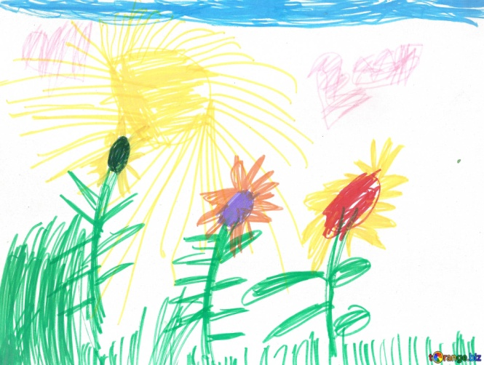  Collage Flowers  Using the different materials and resources that you have at home (e.g, tissue paper, wrapping paper, buttons, ribbon, etc) can you make some beautiful collage flowers? Think about the shapes and colours that you are using – you might have to cut, tear or fold your resources to make them the shape and size that you need. Maybe you can make one large colourful flower or a pretty bunch of flowers.  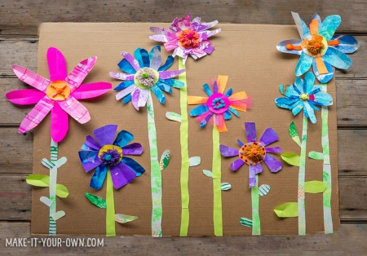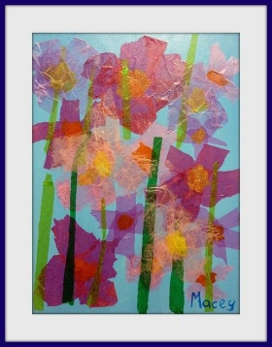
Physical  We try to get a mixture of gross motor and fine motor activities.  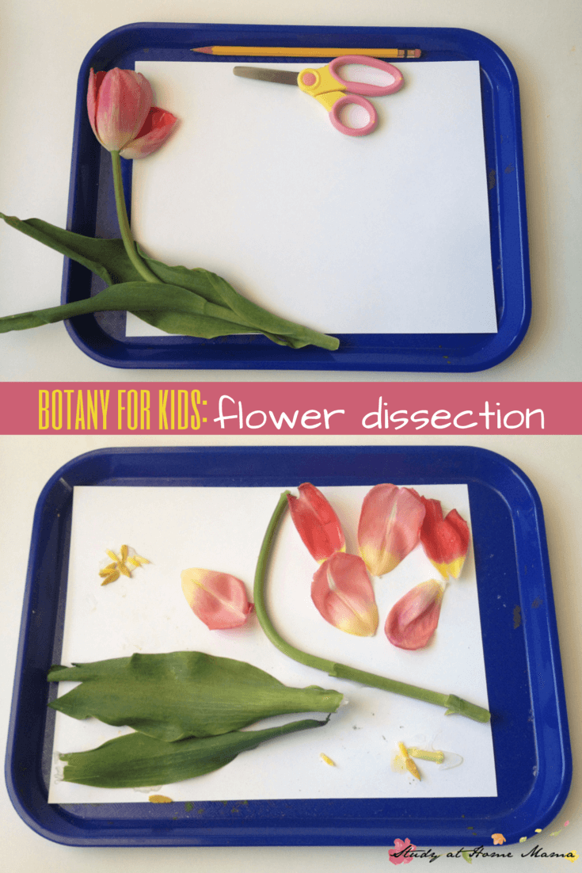 | https://www.youtube.com/watch?v=bG4ValU7TmI  This week we have included a mixture of yoga and guided meditation for you to have a go at:  Flower Power Guided Meditation (5 minutes)  https://www.youtube.com/watch?v=wlsG4ZqHVDE  Refresh your Senses Guided Meditation (9 minutes)  https://www.youtube.com/watch?v=qRoN8xdsVX0  We’re Going on a Bear Hunt – Yoga Story  https://www.youtube.com/watch?v=KAT5NiWHFIU  Pokemon - Yoga Story (can be broken into 2 sessions)  https://www.youtube.com/watch?v=tbCjkPlsaes  Trolls – Yoga Story (can be broken into 2 sessions)  https://www.youtube.com/watch?v=U9Q6FKF12Qs  - Ask your child to sort their toys into colour groups and challenge them to make a rainbow with them. Please send any pictures of your rainbows, we would love to see them!  - Using tape/scarves/ropes (or whatever you have available!) create different lines on the ground and ask your child to jump/hop/skip to the line from a starting place and count how many it takes. To challenge further first ask them to estimate how many they THINK it will take before they complete.  - Dissect a flower and look carefully at each part. When dissecting the plant encourage your child to carefully pull apart or cut off each part of the flower, this is great practice for self-control and fine motor control. As each part is removed, stick it onto a piece of paper and have a go at labelling each part of the flower together using phonics to support.
Music | The parts of the plant  (sung to ‘the wheels on the bus’)  The roots on a plant grow underground,  underground, underground  The roots on the plant grow underground  All day long  The stems on the plant hold up the leaves,  up the leaves, up the leaves  The stems on a plant hold up the leaves  All day long  The leaves on a plant are making food  Making food, making food  The leaves on a plant are making food  All day long  The flowers on a plant are growing seeds, growing seeds, growing seeds  The flowers on a plant are growing seeds  All day long.  You can make your own shaker to shake out the beat as you sing the song.  You could use old seeds, dried beans or lentils in old yoghurt pots with paper or tissue paper over the top.

