[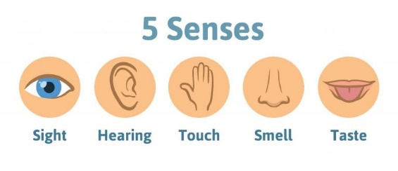](https://www.google.co.uk/url?sa=i&url=https%3A%2F%2Fwww.harleystreetent.com%2Fblog%2Fthe-five-senses-and-why-they-are-important&psig=AOvVaw3Wp9yAIGwKbvvONFeBVm5Q&ust=1594200199916000&source=images&cd=vfe&ved=0CAIQjRxqFwoTCNDT9urpuuoCFQAAAAAdAAAAABAD)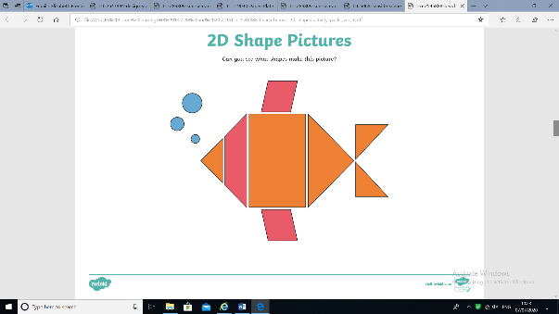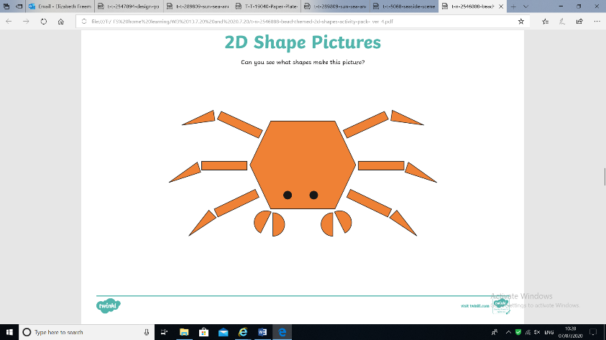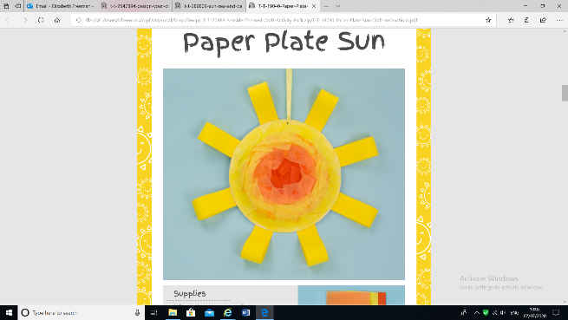

**Our 5 senses**

Imagine you are on a beach.

Can you write or talk about what you can…

See,

Smell,

Touch,

Hear,

Taste!

If you haven’t been to a beach, think of somewhere you have been on warm day, maybe a park or your garden and you could write about those 5 senses in your special place.

**Shape sea creatures!**

Can you make a picture of a sea creature using shapes we have learnt in school? What shapes can you see in the pictures above?

Can you think of what shapes you would need to make a shark!?

**Paper plate sunshine!**

Can you transform a paper plate into a beautiful sunshine. You could paint it, collage it, colour it! You could even add a piece of ribbon or string to hang it from somewhere.

These are the last 2 weeks of school! We cannot believe the summer has come around so quickly.

We have a range of activities for you to try over the new 2 weeks. The activities are based around the theme of summer time.

**Additional craft activity ideas!**

[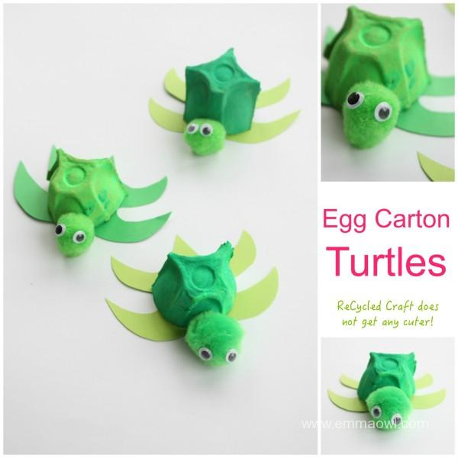](https://www.google.co.uk/url?sa=i&url=https%3A%2F%2Femmaowl.com%2Fegg-carton-turtle-recycled-kids-craft%2F&psig=AOvVaw2QA5kbkZDqLzRODIxpbpqX&ust=1594200631586000&source=images&cd=vfe&ved=0CAIQjRxqFwoTCPir-LjruuoCFQAAAAAdAAAAABAD)

[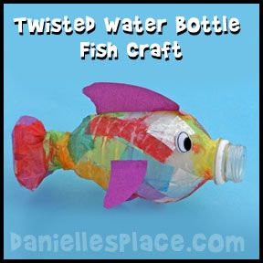](https://www.google.co.uk/url?sa=i&url=https%3A%2F%2Fwww.pinterest.com%2Fpin%2F255720085064659956%2F&psig=AOvVaw2-sLi45j0XT5RZKjTTPbSA&ust=1594200750730000&source=images&cd=vfe&ved=0CAIQjRxqFwoTCJjo2_bruuoCFQAAAAAdAAAAABAJ)

**Water bottle collage fish.**

**Tiny egg box turtles!**

[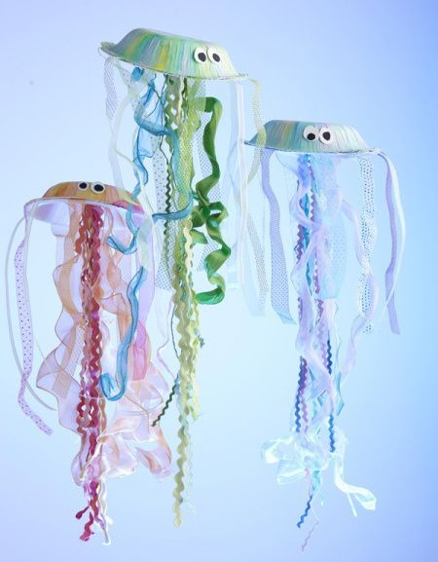](https://www.google.co.uk/url?sa=i&url=https%3A%2F%2Faskbirthday.com%2F2018%2F05%2F31%2Fbirthday-party-22-under-the-sea-craft-creations-birthday-party-kids-crafts%2F&psig=AOvVaw2-sLi45j0XT5RZKjTTPbSA&ust=1594200750730000&source=images&cd=vfe&ved=0CAIQjRxqFwoTCJjo2_bruuoCFQAAAAAdAAAAABAP)

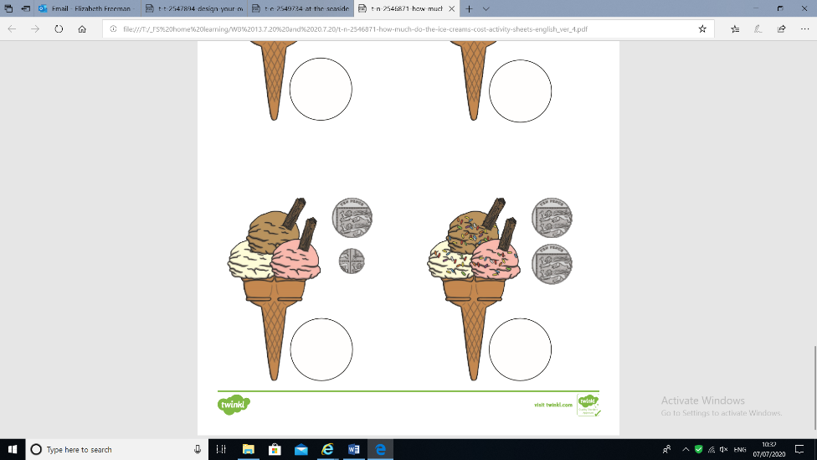[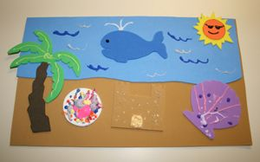](https://www.google.co.uk/url?sa=i&url=https%3A%2F%2Fwww.pinterest.com%2Fpin%2F223913412693543036%2F&psig=AOvVaw0XGoJYNx4RBo9j7wSlvQ9l&ust=1594201087661000&source=images&cd=vfe&ved=0CAIQjRxqFwoTCLCH75LtuuoCFQAAAAAdAAAAABAD)

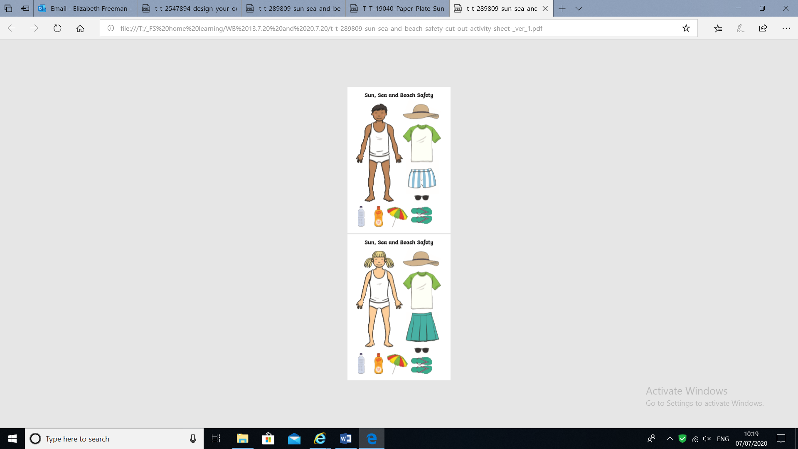

[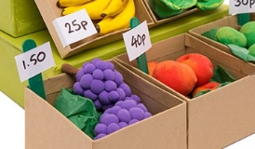](https://www.google.co.uk/url?sa=i&url=https%3A%2F%2Fwww.bakerross.co.uk%2Fcraft-ideas%2Fteachers%2Fmake-a-market-stall%2F&psig=AOvVaw36XvV5F9vjUj_8k6PC_1Nu&ust=1594200865033000&source=images&cd=vfe&ved=0CAIQjRxqFwoTCIi-vKbsuuoCFQAAAAAdAAAAABAK)

**Sun Safety**

July and August can become quite hot and sunny!

We want to see if you can find out all of the ways to keep sun safe.

You could make a poster of how to keep safe. What do you need to remember?

In this pack we have included a cut and stick activity – can you make the children sun safe and ready for a day at the beach?

[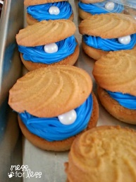](https://www.google.co.uk/url?sa=i&url=https%3A%2F%2Fwww.pinterest.com%2Fpin%2F125749014572915371%2F&psig=AOvVaw3XmJ9360PHKk3mBOpO3Qe-&ust=1594201287730000&source=images&cd=vfe&ved=0CAIQjRxqFwoTCJiZmfPtuuoCFQAAAAAdAAAAABAD)

**Beach themed baking.**

We know you all loved baking at school.

Fingers crossed the shops have stocked up a little better now and you could maybe do some baking at home

You could make some shell shaped biscuits or maybe you could cut some into the shape of a fish. Maybe make some triangles for fins and circles for the body.

[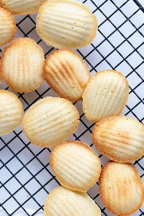](https://www.google.co.uk/url?sa=i&url=https%3A%2F%2Fmomsdish.com%2Frecipe%2F16%2Fmadeleine-cookies&psig=AOvVaw3XmJ9360PHKk3mBOpO3Qe-&ust=1594201287730000&source=images&cd=vfe&ved=0CAIQjRxqFwoTCJiZmfPtuuoCFQAAAAAdAAAAABAP)

**Plan your own holiday!**

You can be as adventurous and creative as you like. How will you travel, will it be on a bus, a bike, a space ship, a jet pack or a rocket? Will your destination even be on planet earth? What will you need to take with you?

**Extra short tasks!**

We appreciate that in the last couple of weeks of term the children are getting tired and may lose focus more quickly. We have added in just a few additional worksheets that you could pull out in those times where you need 10 minutes of focus time!

**Beach Stall!**

Can you make your own beach stall or market?

You could make your own toys to sell or pretend ice creams and ice lollies!

You could add in some price tags so people know how much your items cost.

We have also added in a worksheet that you could have a go at – can you work out what the coins represent and how much each ice cream costs?

**Beach scene collage.**

**Paper plate and tissue paper jellyfish.**