Where My Food Comes From!
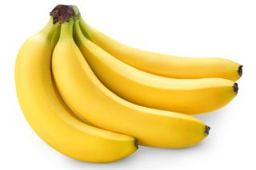
My bananas came all the way from Brazil. Bananas do not grow on trees but actually come from a herb plant. They need to grow in hot and humid places. Most banana plants are grown in countries near the equator.

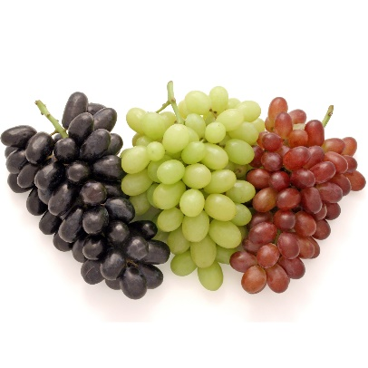
My grapes came from spain. Spain is one of the top grape producing countries of the world. Grapes grow on vines. Grapes are one of my favourite fruits!

