Year 1 Phonics Activities Weeks 5 and 6 – 15.6.20 & 22.6.20
Use post it notes to write the graphemes from your child’s phonics group on. See how many different words they can make and write in 3 minutes!
Make a phonics garden using the template. Put a grapheme in the centre of the flower, then use the petals to write as many words as you can think of containing that grapheme. Use the phase 3, 4 and 5 charts and choose which graphemes you think your child needs to practice. 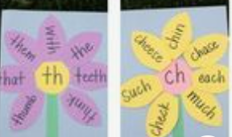

Have a go at the different phases of word search, or you can try and make your own wordsearch using some tricky words. Make sure you check the spellings of people won’t be able to find them!

