Life skills
WB 29.6.2020
Tidy your bedroom and organise your toys.

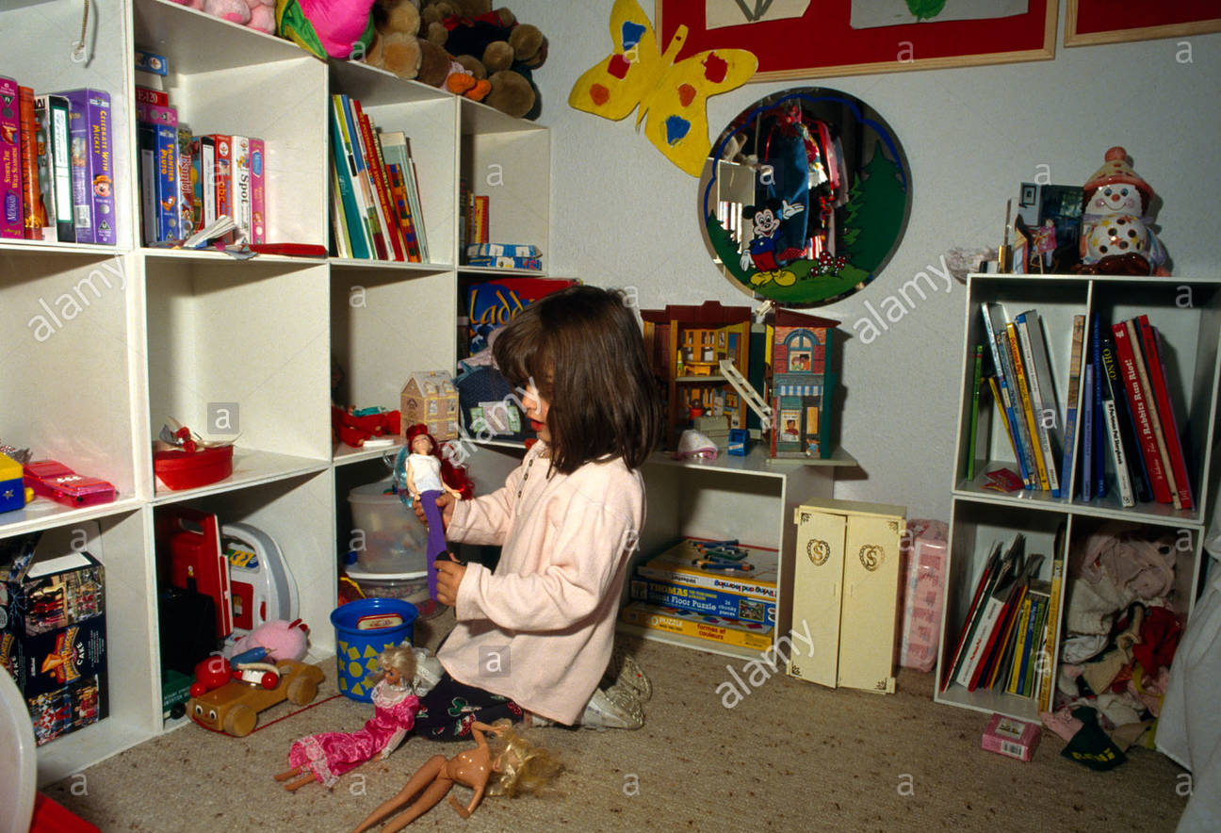

WB 6.7.2020
Help to sort the rubbish into the correct bins!

