Foundation Stage 2 Parents’ Handbook

Starting School


Banks Road Infant and Nursery School

This handbook is designed to provide information to parents about Reception. We hope that you will find this information of use and of interest, and that it will answer any questions you may have. We also hope it will help your child to settle successfully into School.

If after reading it you still have some queries, please do not hesitate to ask either the class teacher, the administrative staff in the school office or the head teacher. We are here to help!

WELCOME TO FOUNDATION STAGE 2

You and your child are about to take yet another big step in their short life; starting school. We hope you are looking forward to it. Our aim is to make the transition as stress-free as possible for both you and your child.

Before entering Foundation Stage 2, all the children will have visited their new class and met their teacher and class-mates. Children transferring from our Nursery have had their story read in the Nursery by their new teacher. They have visited their new classroom and outdoor area during play sessions and ‘mix-up’ days.

Children transferring from other preschool providers will have been visited in their nursery by one of the FS2 teachers. Their teacher will have also met with their key worker to ensure your child makes a smooth transition into school. We hope your child will have been to some or all of our school visits and you were able to attend the parents’ information evening.

The Foundation 2 year is the second year of the Foundation Stage and follows the same curriculum goals as the Nursery/Foundation 1. Foundation 1 and 2 teachers plan together to ensure that the children receive a balanced and progressive curriculum whenever they transfer from Nursery to school.

In the Foundation 2 year, the children are working on the Early Learning Goals prior to beginning the National Curriculum in Year 1. The Early Learning Goals are not subject specific, but cover 7 areas of learning and development:

Prime Areas

- Personal, social and emotional development
- Communication and language
- Physical Development

Specific Areas

- Literacy
- Mathematics
- Understanding of the world
- Expressive art and design

Over the first few weeks in school, we will be focusing on settling the children in to their new environment. You will receive a ‘certificate’ to let you know how your child has settled at the end of this period. However, if the teacher has any concerns, she will talk to you about them as soon as possible. Likewise, if you have any problems or questions, do come in and speak to the teacher, or if that is difficult because of work commitments, you can have a chat with her over the telephone.

We hope that you and your child will be happy at Banks Road, and that we can work in close partnership with you throughout their stay with us. If any problems or concerns arise, do come and discuss them with either the class teacher or the head teacher. If we don’t know that you or your child are unhappy, we cannot begin to address the issue; and unhappy children do not enjoy learning. That is not what any of us want for the children.

School Times

8.45 a.m. to 3.15 p.m.

School does not have the variable start to the day that the Nursery operates. Please make every effort to arrive at school punctually as a calm start to the day is very important for young children.

Arrival at school

When arriving at school before a session begins, take your child to their classroom door in the playground. The teacher will then let the children in at the appropriate time. Please do not let your child go into the classroom if the teacher is not there.

The welfare and behaviour of the children before school is the responsibility of the parents/carers, so please do not leave your child unattended in the playground and watch what they are doing.

A particular hazard is the slope between the main gate and the playground. Both in the morning and at home time, ensure your child stays on the path, not on the grass. Please do not allow your child to run ahead of you or to play on the railings or steps down to the office.

Coming into the classroom

Each child has a peg for their coat, clearly marked with their name and a picture, so that all children can quickly become independent in the morning. We also ask parents to provide a small towel (a flannel is ideal) with a hanging loop and clearly named, which the child will use throughout the day when they wash their hands. As our cloakrooms are very small and cramped, we ask that children do not bring large backpacks and bags. You are welcome to come into the classroom with your child in the morning when they first start school. As they become more settled and confident, we encourage the children to come in independently and hope you will support us in this.

Lateness

Children will be marked as late if they arrive after 8.50am. If you do arrive late, please come in through the main entrance and sign your child in. It is important for safety reasons that we know how many children are in school at all times.

Our Curriculum

Our learning and provision is planned from the Early Years Foundation Stage Curriculum. Work is planned collaboratively by the teachers to ensure:

- coverage of all the requirements of the Foundation Stage for each child
- appropriate progression for each child
- continuity in acquiring basic skills
- delivery of a balanced and varied curriculum for the children

Our indoor and outdoor classrooms are zoned into areas of learning, for example, construction, creative, role play, maths, investigation, physical, sand and water. Children are taught how to access, use and put away resources in these zones to encourage independence and responsibility right from the beginning.

Every day, the children will have an extended period of time to enable them to become absorbed in and develop their learning through play. There will also be times where the children are expected to listen, think and contribute ideas within a whole class and smaller group settings.

While your child is at Banks Road, we will be assessing their progress in many ways:

We assess children’s learning
- To find out where pupils are in terms of their acquisition of knowledge, skills, concepts and attitudes
- To provide information on which to base future planning
- To involve the pupil in self-assessment to motivate and target set
- To give feedback to the school on the effectiveness of teaching
- To provide evidence and information for reporting progress and attainment

We use this information
- To inform planning and teaching methods
- To ensure progression and consolidation as appropriate in all subjects
- To set individual targets
- To inform marking of the children’s work
- To forecast end of Key Stage attainments, both at individual and school levels

On entry to Foundation 2, we continue to compile evidence of learning towards the Foundation Stage Profile on each child. This is on-going throughout Foundation 1 and 2, tracking the child’s progress towards the Early Learning Goals, via the Development Matters, and building up an accurate picture of the child as a learner.

Assessment is done through observation of the child at play, and enables the Foundation Stage staff to ascertain each child’s skills. They are then able to plan appropriate experiences for the child, so that maximum progress can be made.

Children who have not attended our Nursery should have similar records from the Nursery they have been attending, and we ask parents to bring them to school so that we can take a copy for the child’s file. The Foundation Stage Profile is completed at the end of Foundation 2. This is a statutory requirement for all children.
Outdoor Play

We spend a great deal of time learning in our outdoor classroom. Being outside gives us opportunities to do things that we can’t do inside, such as large scale den building, camping, car washes and many other stimulating role play and construction activities. We enjoy appreciating our natural environment and spend time learning about using our senses to investigate patterns in nature and exploring natural materials through our play.

As we learn in an active way in Foundation Stage, the children don’t have a ‘playtime’ in the morning and the afternoon as the Key Stage 1 children do, but do join them at lunchtimes in the larger KS1 playground.

Welly Wednesday

We pride ourselves on the opportunities we offer your child to learn outdoors. Every Wednesday, our curriculum takes all 60 children outside, working in smaller groups of 20 to undertake activities on and off-site in most weathers.

As part of Welly Wednesday we commit sessions to Forest Schools where children learn an appreciation of nature and care for the environment, bush craft skills and collaborative play and games outdoors. Please see appendix 1 for more information about Forest School.

To make the most of our play and learning in all weathers every day we need to be equipped with suitable clothing. Please ensure that your child always has a pair of wellies and a waterproof coat (to leave in school if possible).

Curriculum Enrichment

We believe it is important to enrich the curriculum to promote learning. We do this through organising special themed days and trips to places of special interest linked with the curriculum. We also arrange visits from providers with specialist subject or cultural expertise; these include dancers, theatre groups, local ministers and followers of other faiths.

On some of these occasions we ask parents to make a contribution to cover the costs. This is voluntary, but if costs are not recouped the event may have to be cancelled.

Library Visits

Every class will get the opportunity to visit Toton Library at least a couple of times per year. We ask parents to complete a registration form for the library, which allows the children to borrow a book to take home. We ask that parents return the book to the library, as it might be a long time before we get to go again as a class.

Special Educational Needs & Disability

We treat all our pupils as individuals, and plan their learning experiences according to their needs. Careful records are kept of each child’s progress, which are available to parents who wish to see them. In this way we identify special needs at an early stage in the child’s school career.

Initially the class teacher provides a variety of approaches and experiences to help the child overcome areas of difficulty, and will always inform parents of any special arrangements being made. If this support does not overcome the difficulty, then the special needs co-ordinator will be consulted who may suggest other. She will also initiate and consult with the child’s parents.

If necessary, additional support will be sought from external special needs support services, but only after consultation with parents.

Please see appendix 2 for further information about Special Educational Needs.

More Able Children

Through the procedures that enable us to identify children with Special Educational Needs at an early stage, we are also able to identify those children who are most able. We monitor the curricular experiences being offered to them and tracks their progress to ensure their needs are met and their full potential is reached.

As planning is differentiated, the curriculum can be modified as necessary within the normal classroom situation.

The school has a detailed policy for teaching Able Children which is available in school and on the school website.

Homework

All schools are required to set homework. We try to make the work we send home enjoyable for both the child and the parent, as well as consolidating and extending learning. We want homework to promote the learning partnership between home and school.

Your child will get homework every Friday. One week this will be an activity to complete in their learning log and one week this will be a phonics activity in their reading folder. Homework should be completed and returned to school by the following Friday.

Pupil Premium

If you have a low income or are in receipt of certain benefits the school may be able to apply for additional funding to enable us to provide additional financial and educational support to your child. This is vital funding to our school and enables us to enhance the experience for your child. Please see the letter at appendix 3 for further details.

Communication with Parents

We try to inform parents of events, routines and the curriculum in a variety of ways. The most reliable way to receive information is via email. Please ensure that you let the office know your email address.

All sorts of information can also be found on our school website, so please look at this regularly, too at www.banksroadschool.co.uk

Letters and information may be sent home as paper copies and will be put into your child’s reading folder, so please check it regularly. The Friday newsletters give predominantly whole school information, including dates for diaries. Class teachers will send home a half termly newsletter that lets you know of any important dates and outlines the learning for the half term. Please also check the school website regularly as this is updated with photographs and information about your child’s learning.

Parents’ evenings are held in the Autumn and Spring terms when you will have the opportunity to discuss your child’s progress and development with the class teacher. However, do not feel that this is the only time to talk to the teacher. If you want to discuss any aspect of schooling, do make an appointment with them as concerns or questions arise.

In the summer term, you will receive a written report on your child’s progress, attainments and development.

Sending money to school

There are a variety of occasions when money needs to be sent to school, e.g. money for trips and enrichment activities.

Whenever you send money to school, please help us by putting it in a sealed envelope with your child’s name and class, the amount of money enclosed and what it is for clearly written on the front.

Security

The safety of all our pupils is of paramount importance. We ask all adults coming to school during the school day to come via the main entrance and register their presence.

Please also let us know if someone different is collecting your child. We will not allow children to leave with strangers or unaccompanied. If you change your collection arrangements during the day, you should call the School office to advise of the new arrangements. You will receive a call back on the number we hold for you to confirm the arrangements. If we cannot get hold of you (because your number is incorrect or unavailable) we may not be able to release your child at the end of the day. It is therefore of utmost importance that you keep us up to date of any change to your contact details.

If you are going to be late, we will keep your child until you arrive. If possible let us know if you have been delayed and we will then reassure your child.

Being a volunteer/visitor/parent helper in school

Parent helpers and volunteers at our school bring with them a wealth of skills and experience that can enhance the learning opportunities of the children. Banks Road welcomes and encourages them. Parent helpers are always welcome in school – regularly or occasionally. Activities may include playing a board game with a small group of children, reading stories and sharing books or sharing a skill or craft you enjoy.

If you would like to help at school or nursery AT ANY TIME (including on trips) you will be required to attend an induction meeting with the head teacher, Mrs Clemens. During this meeting you will be guided through the policy and procedures for any volunteer in school. This is our duty of care to you and your child. At the end of this meeting you will be asked to sign an agreement form which outlines the expectations of all stakeholders in order to actively support our school aims and values. You will only have to go through the induction process once during the time your child is at Banks Road.

There are only two induction meetings scheduled: Wednesday 26th September at 6pm and Thursday 27th September at 9am. Please try to attend one of these sessions. We know from experience that parents find it very frustrating later in the year if they have not attended these and want to join in with activities.

Travel to school

Children are welcome to come to school on their scooters. Scooters can be stored in the scooter park by the main gate at parents’ own risk. A padlock is required to secure the scooter throughout the day. The security of your child’s scooter is your responsibility. The School cannot guarantee the safety of unlocked scooters. This facility is not suitable for bicycles; if you allow your child to ride their bicycle to school, you must push it home when they have gone into class.

Park & Stride

Many parents use cars to bring and fetch children from school. Whilst we prefer children to walk to school, we understand that this is not always possible.

In order to minimise risk to our children and inconvenience to neighbouring residents, we have a ‘Park & Stride’ ethos which is supported by members of the local community, the Local Authority and Nottinghamshire Police.

We hope all parents will support this ethos by parking at the Greenwood Community Centre, which is accessed via Chester Green, and is free, and then striding from there to school (and reversing the process at home time.)

Thank you for your cooperation in keeping all members of our school safe

Breakfast Club

Our breakfast club is open to children who attend Banks Road Infant & Nursery School and their siblings who attend Bispham Drive Junior School. Breakfast club is open each day during term time (except Inset days). There is no need to book a place at Breakfast club.

Children can arrive between 7.30am and 8.15am. The breakfast provided will consist of cereals, fruit juice, toast with a variety of spreads, fresh fruit, yoghurts and hot drinks. Unfortunately we cannot accommodate children who arrive after 8.15am.

We provide childcare and breakfast at a cost of £4.50 per day. Payment can be made by cash or cheque, and will be collected at Breakfast Club, either on the first day of attendance each week or on a daily basis. Childcare vouchers are also accepted in payment for Breakfast Club.

After School Club

We offer an after school club for children in school and nursery. This runs in the school hall from 3.15pm to 6pm. Children get a light healthy tea for example sandwiches, beans on toast, soup, fruits, yoghurt etc. They have time to relax and play with their friends. There are craft activities and outdoor play as well as a range of toys for the children to enjoy.

The cost is £10 per session, and bookings for this need to be made a term in advance for the full term. Payment can be made by cash, cheque or childcare vouchers. Please contact the school office if you think this is a service you may require.

WE LIKE TO KEEP HEALTHY!


Milk and snacks

Milk is available in school daily and is free to all children under the age of five. We will register your child for free milk on your behalf by providing your child’s name and date of birth to our supplier, Cool Milk. Shortly before their fifth birthday you will be offered the opportunity to pay a subsidise rate for your child to continue receiving a milk drink in school. Please advise the school office if you do not wish us to register your child.

The school is a participant in the National Fruit Scheme. This ensures that every child receives a free piece of fruit each day.

No other snacks should be brought into school.

Drinks throughout the day

It is important that children drink enough water during the school day as dehydration affects concentration and learning as well as their general well-being. It is school policy that only water is drunk throughout the day. This is for health and dental reasons, but also, sugary drinks attract unwanted creatures such as ants. Your child should bring a water bottle to school on Monday’s to leave in school for the week; this will be filled and refreshed as necessary with chilled mains water. Water bottles should be taken home for washing each week. School logo water bottles are available to purchase £2.

School meals

We view lunchtime as an important part of the day, and strive to make it a pleasant and sociable occasion. We encourage children to try different foods so that they can make informed choices when the meal is being served. We emphasise the need for good manners and the correct use of cutlery.

Midday meals are prepared by our own cook in the school kitchen according to Healthy Eating guidelines. Vegetarians are catered for, and we can also cater for special diets upon receipt of a doctor’s letter. If this is the case, we will arrange an appointment for you to meet with the Cook to discuss the dietary needs of your child.

You may be aware that from September 2014 all infant aged children (reception, year 1 and Year 2) receive their midday meal free of charge (Universal Infant Free School Meals).

Packed Lunches


Alternatively, children may bring a packed lunch. As a holder of the Healthy School’s Gold Award, we are anxious that packed lunches should be balanced and healthy. Please ensure that your child has healthy choices such as wholemeal/ best of both bread, salads and fruits. Crisps, chocolate and cakes should be kept to a minimum. We are a nut free school and ask that you do not send nuts or nut spread in your child’s packed lunch. Children bringing packed lunches will be served with water to drink, just as pupils taking hot lunches are. No other drinks should be brought in.
All packed lunches should be in a secure and named container.

What You Will Need

Uniform
Whilst our school uniform is not compulsory, in practice all our children do wear the following:

Grey skirt, trousers or shorts White or red tee-shirt for P.E
White or red polo shirt or blouse Red, white or black shorts for P.E
Red sweatshirt or cardigan Winter hat
Red/White Gingham cotton dress Sun-hat

Uniform is available to buy with the Banks Road School logo embroidered on from Just-School Wear at www.just-schoolwear.co.uk or from their store in Long Eaton, and Morleys Schoolwear, Bramcote Avenue, Chilwell.

Footwear
Shoes should be appropriate for the range of activities the children undertake. They should not have heels or open-toes. Strappy sandals or flip-flops, however hot the weather, are not allowed.

Reading folders and PE bags
These are available from the school office priced at £4 each.

Lost property
There is a Lost Property trolley outside the office which is emptied termly. Avoid having to rummage through by naming everything your child may remove (including shoes)!

Please make sure that all clothing is clearly marked with your child’s name

Jewellery

We do not allow children to wear jewellery for safety reasons. If your child already has pierced ears, plain stud earrings only may be worn. Even these will need to be removed for PE by the child.

Toys


We do not permit toys to be brought into school, to avoid breakages and losses, which are upsetting for the child. School provides toys for playtimes, and the toys and equipment used for play activities in the classroom are carefully chosen to fulfil a specific curriculum requirement.

Absence


If your child is absent please telephone school as soon as possible on the first day of absence. An answer-phone operates when the office is unattended so that parents can leave messages prior to leaving for work etc.
It is our policy to follow up any unexplained absence by telephoning parents who have not contacted us by 30 minutes after the start of school.

If you know in advance that your child will be absent (e.g. for a medical appointment) please let the class teacher know.

Medicines

Many children are fit to return to school before they have completed their courses of medication. When a child is taking prescribed medicines, we will administer them during the school day if necessary. We ask that medicine is named and brought to the school office daily along with a suitable spoon or syringe. The parent/carer will be asked to complete an information authorisation sheet. We will then keep the medicine in the refrigerator if necessary. We will not administer non-prescription medicines.

Illness during the day

If your child is taken ill or has an accident at school, every effort will be made to contact you. Please help us by ensuring that we have at least two contact numbers which are up to date.

Infectious illnesses

In the cases of infectious illnesses the following apply

Illness | Appropriate action
Sickness or diarrhoea bug | Wait 48 hours after the last bout of illness before your child returns to school. They must be well and eating and drinking normally.
Conjunctivitis | Do not bring your child to school if their eyes are ‘gunky’.  Wait until 24 hours after treatment has been started.
Chicken pox | Do not bring your child to school until the last spot has scabbed.
Hand, foot & mouth | Do not bring your child to school until the last blister has dried up.
Scarlett Fever | Your child can return 24 hours after starting antibiotic treatment.
Impetigo | Do not bring your child to school until the lesions have scabbed, or 48 hours after antibiotic treatment is started.

Asthma

We ask parents to complete an annual ‘Asthma plan’ if their child suffers with asthma so that we can be aware of the likelihood and any possible triggers of an attack. Your child’s asthma inhaler will be kept in school and administered by the teacher as outlined in your child’s Asthma plan.
Head Lice

Head lice, or nits, are sadly a fact of school life. Please check your child’s hair regularly and let us know if you find either louse or nits (the egg of the louse). We can then remind other parents to check their children’s hair and so prevent them reaching epidemic proportions!

Sun Safety

Banks Road is a Sun Safe school. We actively promote the use of sun screen, hats and sunglasses during the summer months. We ask that you apply a once daily, high factor, sun screen to your child before they come to school in the morning, and that you provide a tube of cream for them to reapply if you feel it necessary during the day. The staff are unable to apply cream to the children.

Behaviour

Banks Road School we aim to achieve a calm and orderly school environment based on mutual respect and trusts with high standards of behaviour. Our school website has lots of information about behaviour expectations including our behaviour policy, please visit: www.banksroadschool.co.uk Appendix 4 also provides some further information for parents about our anti-bullying strategies.


The Friends of Banks Road Infant School is the school’s Parent Teacher Association and a registered charity. The Friends Committee is made up of parents and teachers who share an interest in raising funds for the benefit of the school, through organising fun and exciting events for the children and the parents.

The aim of the Friends Committee is to raise money for the school to spend on extra facilities and equipment to help your child have a fun and exciting time at school, they also organise social events for the children and parents. When your child starts at Banks Road you automatically become a ‘Friend’.

Every year they hold a Christmas and Spring disco for the children, plus a number of events for parents such as quiz nights and a Ladies Pamper night. The main annual event is the Summer BBQ, which is held in the Summer term.

The Friends raise over £5,000 each year which pays for a Christmas tree for the school hall, a Christmas present and an Easter egg for every child. Over the past couple of years they have also funded the establishment of the Forest School area, a large interactive screen for the school hall, iPads, playground equipment, toys and games.

The meetings are quite informal, but the job gets done, and the Committee has fun doing so! There are also a couple of committee members’ social evenings each year too. We hope you will become an active Friend whilst your child is at Banks Road. New committee members are always welcome, and the AGM meeting will be held on 26th September at 6.30pm. For more information please visit the school website.

Additional Information

We hope this booklet has provided some useful information. If there is anything else you would like to know or require more detailed information about any aspect of school life, please don’t hesitate to ask either the class teacher, the administrative staff or the head teacher. You can also visit our website at www.banksroadschool.co.uk to read news, events, policies and procedures. The following policies are just some of those available on our website:

Attendance Equality
Behaviour Gifted and Talented
Child Protection Privacy Notice
Complaints School Mission Statement
Special Needs

Dates for your diary

MacMillan coffee morning Friday 28th September (8.50am)
Meet the Teacher – settling into school meeting Tuesday 2nd October (2.45pm)
Phonics – parents information meeting Monday 17th October (6.15pm)

Appendix 1
Banks Road Infant and Nursery School

Forest School – Information for Parents

What is Forest School?

Forest school is an exciting opportunity for your child to experience nature and learn outdoors. At forest school the children learn through first-hand experience and develop skills like perseverance, independence and responsibility. These are all skills which will help them to achieve more when they are back in the classroom.

Where and when does Forest school take place?

Most sessions will take place in our small forest school area at the back and side of Nursery. The children will be able to access toilets in the Nursery or school. Some weeks we may go off site and walk to the public woodland space near Greenwood Community Centre. If we are going out of school we will endeavour to let parents know 24 hours in advance.

Forest school sessions last 2 hours and take place weekly within the normal nursery session times.

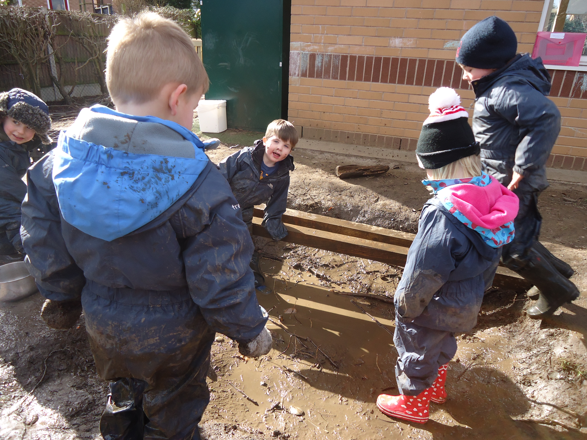
How will we keep the children safe?

The site has been carefully assessed and the children will be given detailed training for all the activities.

Part of forest school is teaching children about risks and how to evaluate them. So the children will be taught about how to add fuel to a fire, cook and make drinks using a fire, climb trees and use tools. These activities will be introduced as the children in the group are ready for them and will be carefully supervised by an adult. By allowing children to take these measured risks, we help to prepare them for making choices when they are older and teach them to be actively responsible for themselves, their choices and actions.

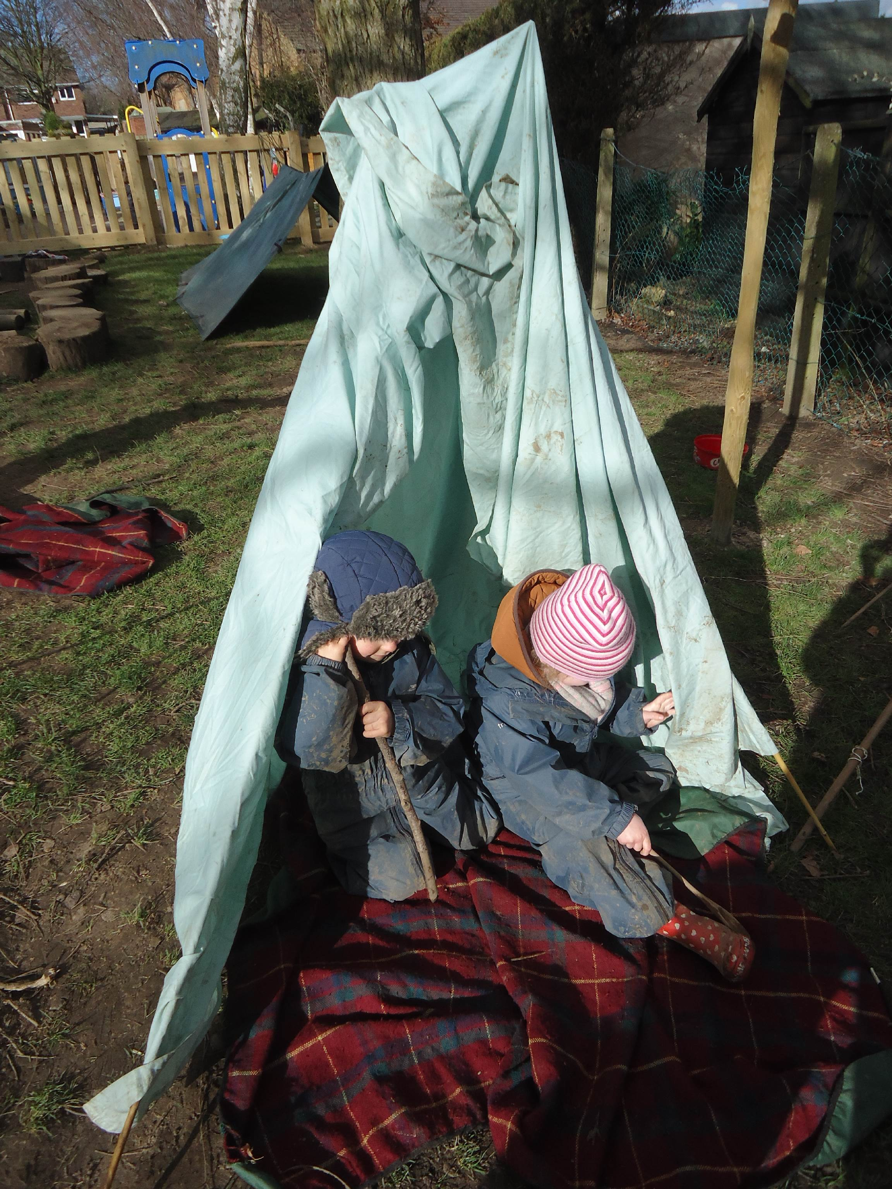
What if it is raining?

We try to go outside whatever the weather but obviously would not lead outdoor sessions in unsafe weather such as storms. Part of our forest school ethos is to respond to the needs of the children so sometimes our sessions are shorter if children are becoming too cold, hot or uncomfortable. We also occasionally offer the option of indoor play alongside the session when the weather is particularly cold or hot. In our experience it is rarely the children who get cold and tired or want to come inside!

What do we need for forest school?

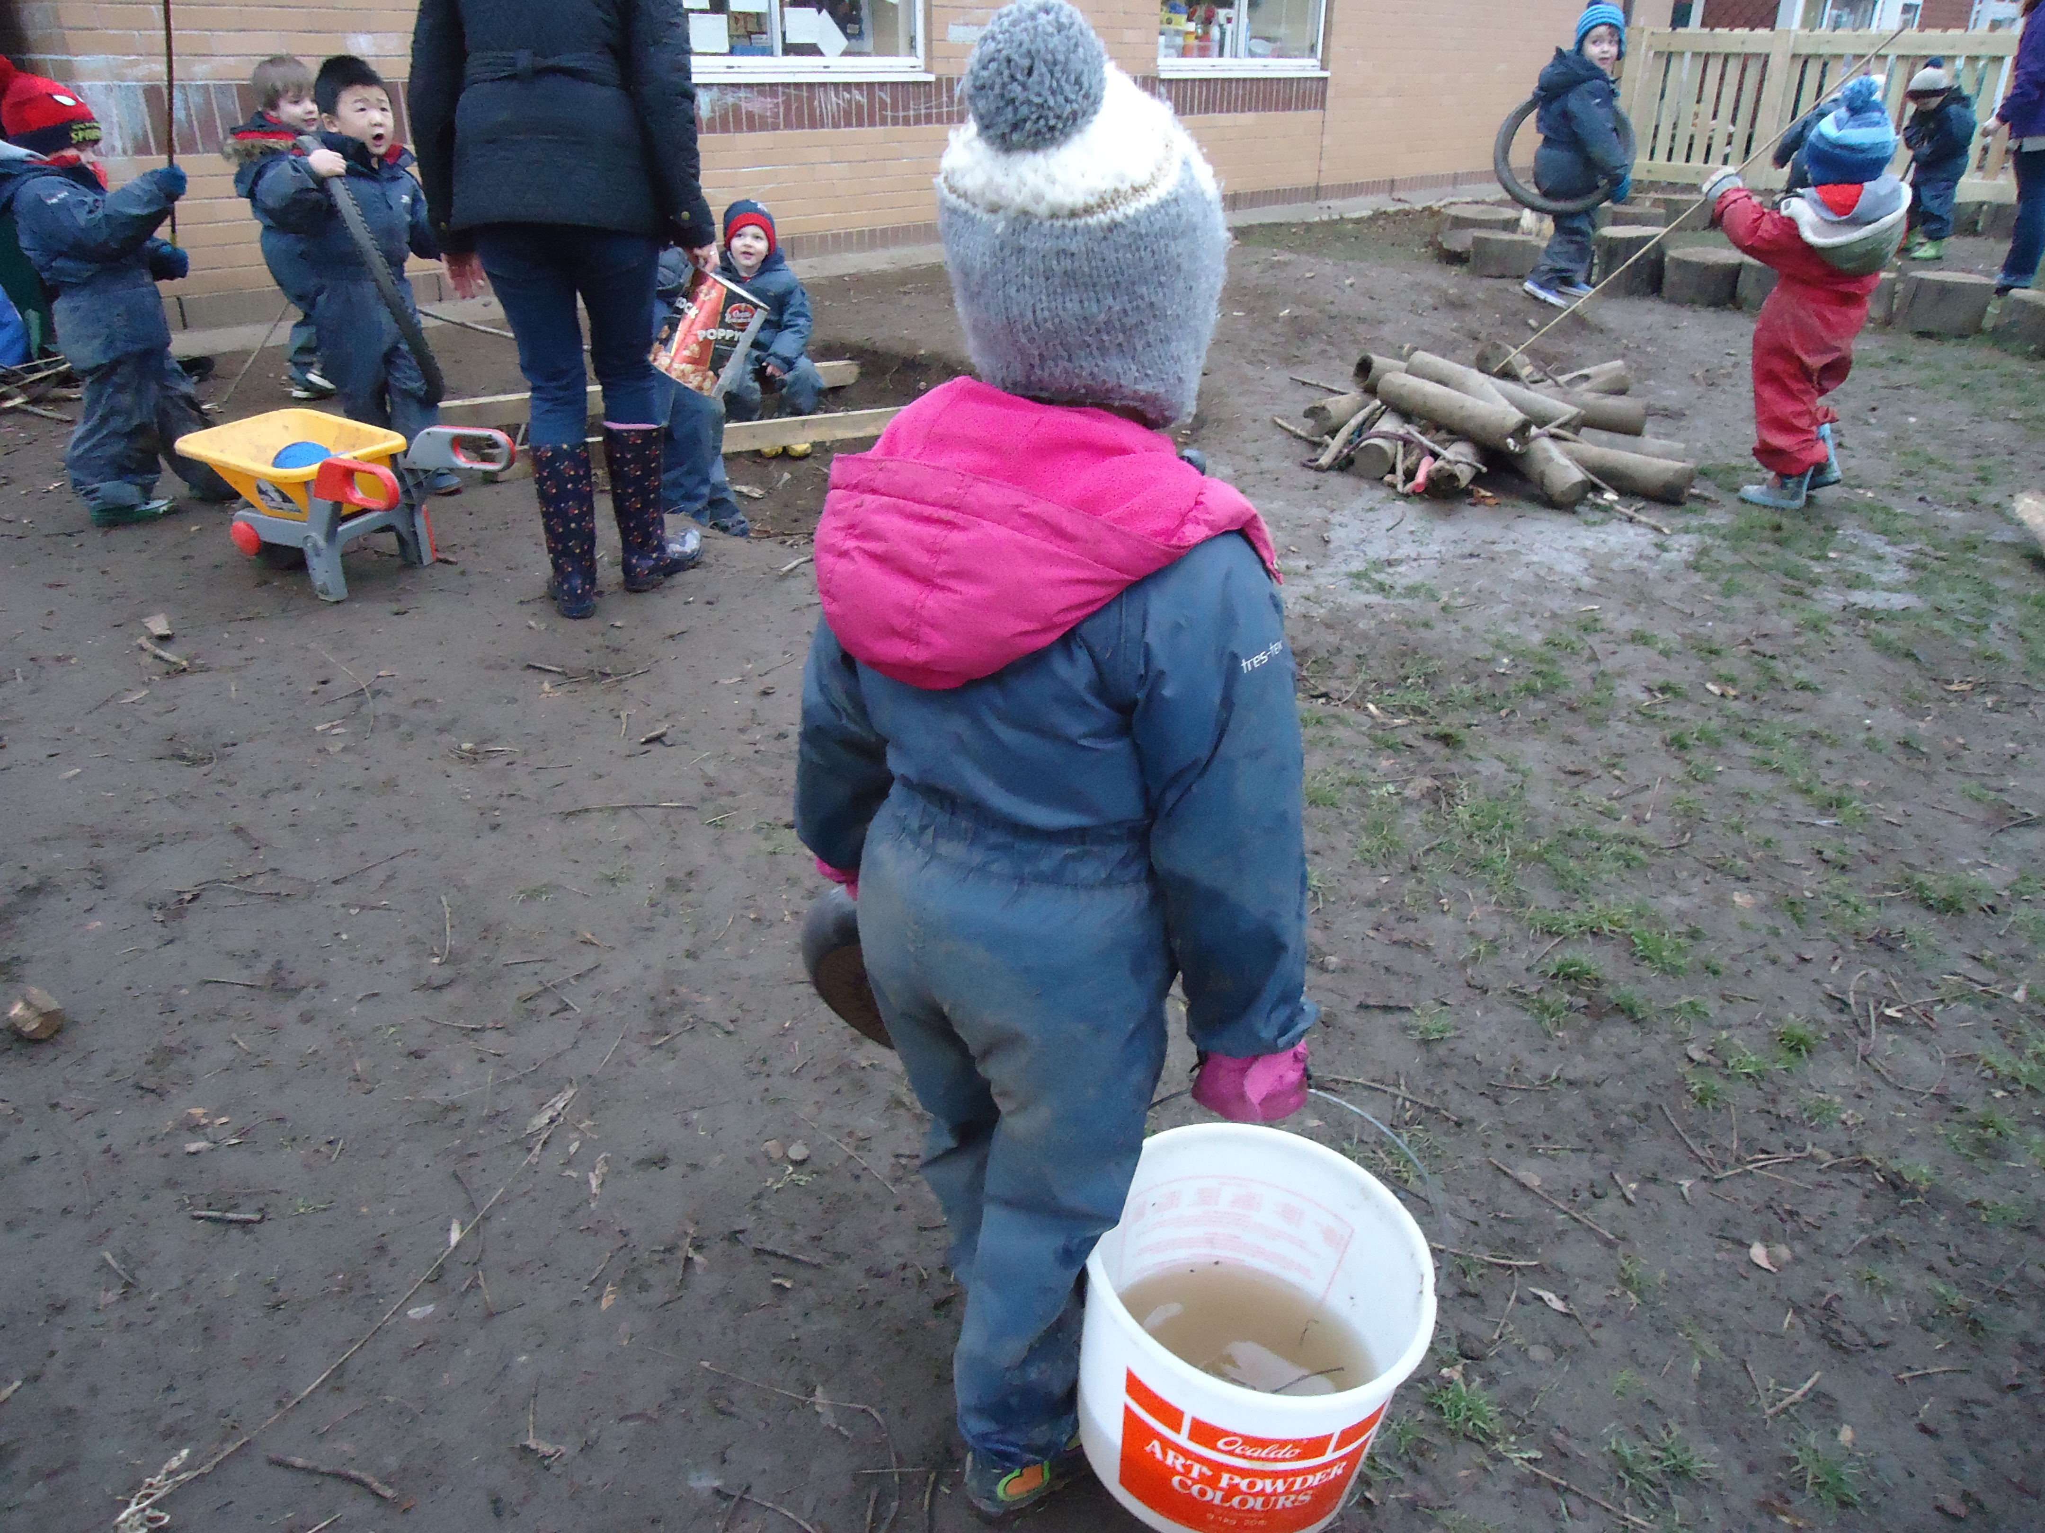
We provide all specialist equipment such as protective clothing and tools and we also have puddle suits for all children which keep them dry. Please note these are not lined so children need to wear lots of layers underneath in the cold weather.

We ask all children to bring a pair of Wellington boots which they keep in school at all times. We wear these and the puddle suits in most weathers.

What do the children do at forest school?

A wide variety of activities! We start with the children’s interests and fascinations and explore these initially through free play and games.

During the course of the year we build up a structure which responds to the needs of the children.

This could incorporate:

- Singing
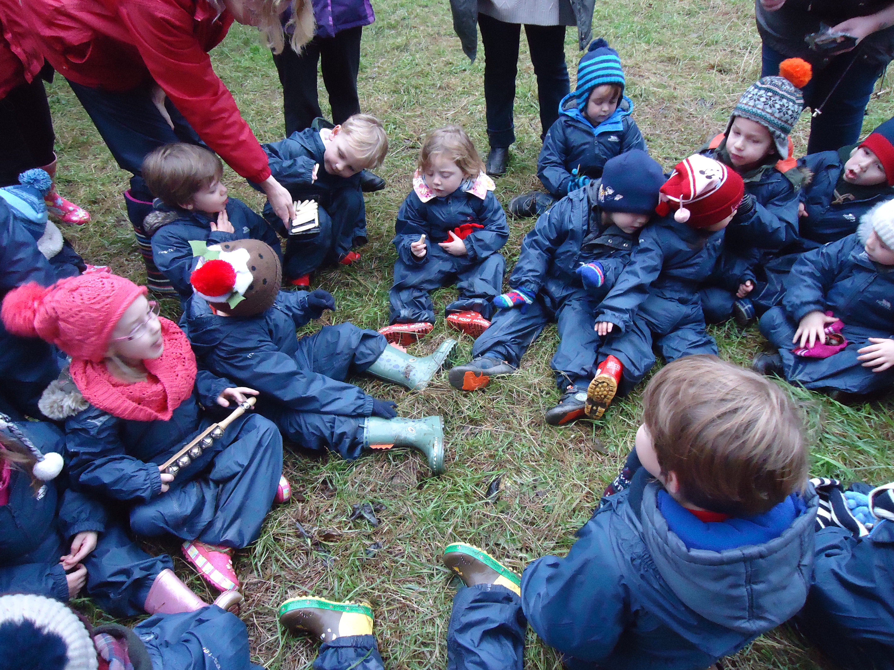
- Collaborative play and games e.g. 123 where are you, what’s the time Mr Wolf
- Story telling
- Imaginative play
- Shelter building
- Ropes and knots
- Making potions and cooking in our mud kitchen
- Using simple tools to whittle wood
- ‘Risky’ play such as balancing over our ‘mud pit’ and climbing trees
- Adding fuel to fires and making hot drinks using ‘Kelly kettles’
- Environmental activities such as building nests, feeding birds, building shelters for woodland animals, mini-beast hunts
- Gardening

Can I come too?
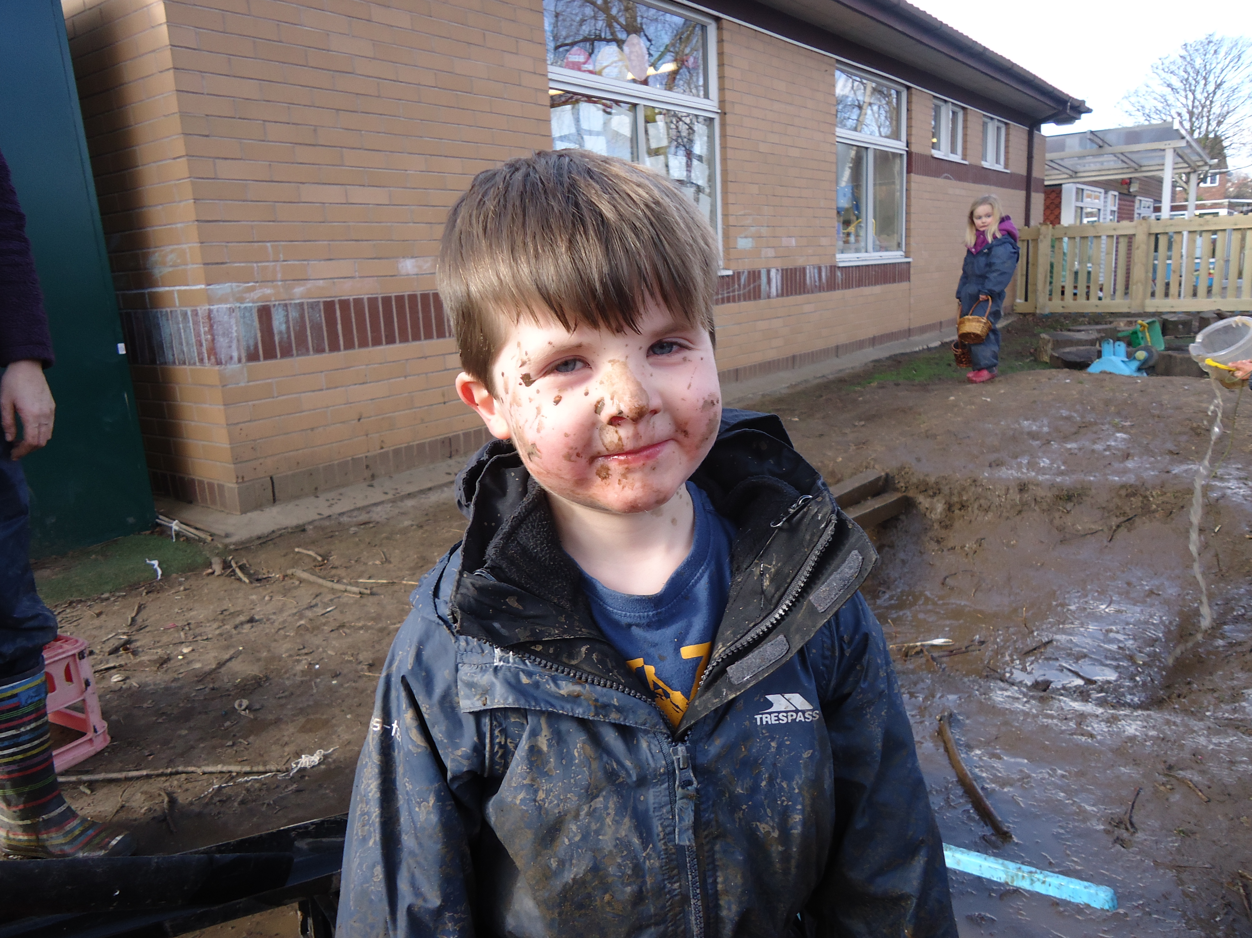
Yes please! In order for forest school to run successfully we desperately need parent helpers preferably on a regular basis. Please speak to the class teacher if you would like to come and help.

Appendix 2

Special Educational Needs at Banks Road

Information for parents & carers

What are Special Educational Needs?

A child is defined under the Children & Families Act 2014 as having a Special Educational Need if they:

- have a significantly greater difficulty in learning than the majority of others their age; or

- have a disability which hinders them from making use of general educational facilities.

At Banks Road we recognise that special needs are vast and wide-ranging. A child could have a very short-term need or challenge with some area of school life or learning. On the other end of the spectrum a child may have a life-long need having great impact on their school and personal life.

Special needs can mean that a child is facing any kind of difficulty at that time. At Banks Road we aim to support the whole child including their academic, emotional, physical, behavioural and social wellbeing.

How will I know if my child is having difficulties?

- As Parents – you may already have passed on your concerns to others who can help i.e. Health Visitor, G.P.

- At Pre-School – Playgroup, Nursery or child-minders, others may have informed you that they had noticed some things were particularly challenging for your child.

- At School – teachers and their assistants may find during their daily working contact that your child may need extra help in certain areas.

- Routine Screening – such as vision and hearing tests can provide important information, as can teacher assessments on the progress your child is making. Hearing and vision tests are no longer provided as a matter of course for all children. If you have any concerns please contact your GP. We recommend that you arrange a hearing test at some point during your child’s Nursery year, just to be on the safe side.

What can you do if you are worried that your child may be having difficulties?

Your child’s early years are a very important time for their physical, emotional, intellectual and social development. When your health visitor or doctor makes a routine check, they might suggest that there could be a problem. But if you have any worries of your own, you should get advice straightaway.

If you think your child may have a special educational need that has not been identified by the school you should talk to your child’s class teacher, to the SENCO (this is the person in the school who has a particular responsibility for co-ordinating help for children with special educational needs), Miss Morris or to the head teacher, Mrs Clemens, straight away.
Children making slower progress or having particular difficulties in one area may be given extra help or different lessons to help them succeed.

So you should not assume, just because your child is making slower progress than you expected or the teachers are providing different support, help or activities in class, that your child has special educational needs.

- It is best to start with your child’s teacher or the SENCO.

- You will be able to talk over your concerns and find out what the school thinks.

- The SENCO will be able to explain what happens next.

- Working together with your child’s teachers will often help to sort out worries and problems.

- The closer you work with your child’s teachers, the more successful any help for your child can be.

Remember – you know your child better than anyone.

In School support

SENCO: Miss Morris (Special Educational Needs Coordinator)
Teaching Assistants
Class teacher

All these staff have a part to play in developing and implementing the Special Needs Programme at Banks Road Infant and Nursery School.

If you are concerned about your child’s progress and their learning needs, please speak to their class teacher in the first instance.

You are welcome to speak to the SENCO who can be contacted easily through the school office.

Mrs Williams is the Governor with responsibility for SEND and can be contacted through the school office.

Tel No. 0115 9179881.

Want to find out more?

For the SEND policy, accessibility plan, local statement and lots more information please refer to the SEN section of the School website: www.banksroadschool.co.uk

For further information on children with special educational needs check out the DfES publication Special Educational Needs – a guide for parents and carers. This, and lots of other information, can be found at the following website:
http://www.education.gov.uk/schools

You can also get help from the Nottinghamshire and Nottingham Parent Partnership Service: www.ppsnotts.org.uk
Appendix 3

Pupil Premium

The school can claim extra funding through Pupil Premium to support children’s development, learning and care.

National data and research tells that children who are from families which have a low income or are claiming certain benefits achieve less than the expected level of development at the end of the early years foundation stage compared to other children. The Pupil Premium provides additional funding to help the school to close this gap.

Pupil Premium provides extra funding to be used specifically for the children who are eligible. We can use the funding in any way we chose to improve the quality of the early year’s education that we provide for your child. This could include for example TA intervention for small group work to support your child with a particular area of learning, or for social and emotional support; alternatively it could be used to support the cost of school trips for your child. It is important to stress however that it is for the benefit of your child.

It is well documented that high quality early education can influence how well a child does at both primary and secondary school, so we do want to make the most of this additional funding.

Children may qualify for pupil premium if the parent/carer receives one of the following benefits:
- Universal Credit with an annual net income of no more than £7,400
- Income support
- Income based Jobseeker’s Allowance
- Support under Part 6 if the Immigration & Asylum Act 1999
- The Guarantee element of State Pension Credit
- Working Tax Credit
- Child Tax Credit

Register on-line by visiting the public website The information needed to register includes:
- Personal details (including national insurance number and date of birth)
- Child’s details in full including their date of birth and school they attend.

If you have any questions, please do not hesitate to contact the school office on 0115 917 9881.
Appendix 4

Anti-Bullying

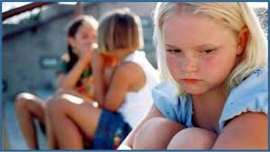

The Definition of Bullying

Bullying occurs where there is a deliberate intention to hurt or humiliate someone. There is a power imbalance and it is usually persistent. Several Times On Purpose (STOP)

What happens if I suspect bullying?

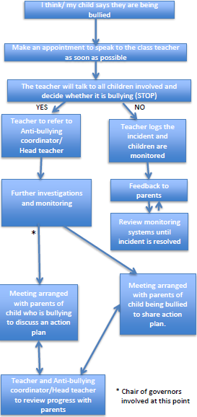

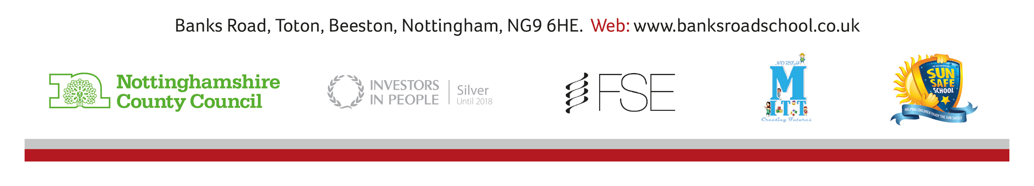
Head Teacher: Carole Clemens
Tel: 0115 917 9881
Email: office@totonbanksroad.notts.sch.uk

