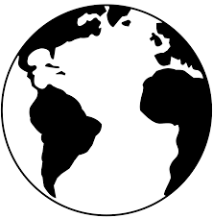
Global Week!

In school each year we have a Global week where each class spends a whole week learning about a different country. This is such a special week as we learn about the country’s culture; its famous landmarks; the food they eat; the clothes they wear etc, the list goes on! We thought that it would be nice for the children to complete some of the activities we would normally experience in school during this week.
We have named this week’s learning a Staycation!
Your child can choose a place that they would like to learn about – maybe it is somewhere they have been on holiday before or somewhere they would love to travel to. With that place in mind, see if they can have a go at the following activities.
Activity Name | What you need to do…
Passport | In order to travel on airplane and to a new country, you need a special document called a passport. You may have seen one of these before, if you haven’t they look a little like the one below.  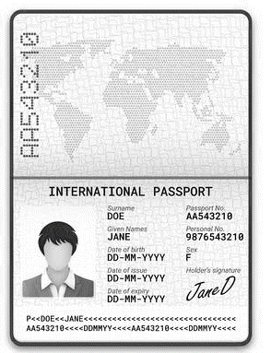  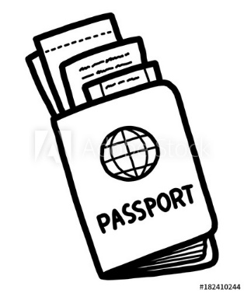  Can you make your very own passport ready for your Staycation!? Remember to add in a self- portrait and your details so you are ready to go! You could draw this on paper or card (make sure to fold in half first!).
Flags | The flag for the United Kingdom is called a Union Jack, can you use books or the internet to find out what the flag looks like for the country you are visiting this week? Can you draw the flag for the country you are pretending to visit?  If you were the king or queen of a new country and you were designing a flag for your country what would it look like? Would it have stripes, stars or spots on it? Would it have any pictures or patterns on it? What colours would you use?
Famous Landmarks | There are lots of famous landmarks around the world, for example in Italy there is the Leaning Tower of Pisa and The Colosseum. Below are the famous landmarks that have been recreated using box modelling resources.  See if you can find out about a famous landmark in the country you have chosen. Can you use box modelling from around your home to make the landmark? Think about the shapes of the boxes and resources.  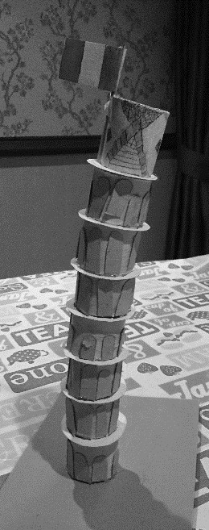  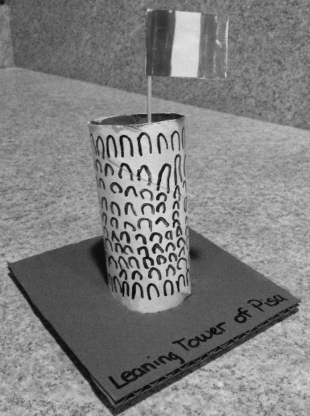  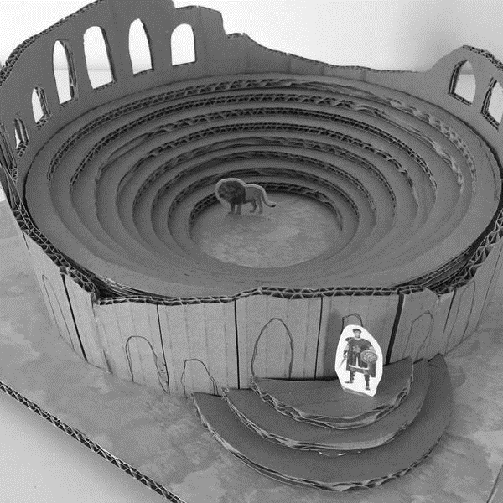
Food | In different parts of the world, people like to eat different types of food. Some food may be similar to what we eat here, and others may be things we haven’t tried before. For example, pasta and pizza is very popular in Italy, paella is well known in Spain, snails are famous in France and Frankfurts (hot dogs) are enjoyed in Germany.  Can you find out about the food that originates in the country you have chosen? You could draw a dinner plate and fill it with the food from that country or if you have a paper plate you could draw the food straight onto there!  If some things are hard to draw, you could also write a label or cut pictures from magazines or newspapers.  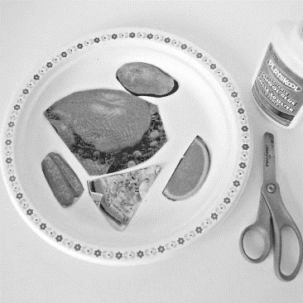  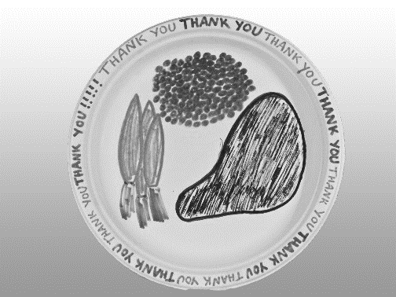
Music | Music is listened to all around the world – the song ‘Shotgun’, which has been one of our favourites at school this year is sung by an English man called George Ezra. BUT! This song has travelled far and wide and it isn’t just known by us at Banks but people miles and miles away in different countries! Wow!  The song ‘Into the Unknown’ from the new Frozen film is sung by a Norwegian lady called Aurora which is very far away from us!  Can you find out about a singer or piece of music from the country you have chosen?  You might also want to find out about the countries more traditional music – it may be their celebration music. Does it sound different to the music we hear on the radio?  You could draw the instruments you think you could hear in the songs/music. You might even want to draw how the music makes you feel when you listen to it.  You might even be able to make the music using some of the things in your house, e.g. if you have a tin or a pan with a wooden spoon you can make the sound of a drum!
Art | Artists are born all over the world and the type of art they create is very different.  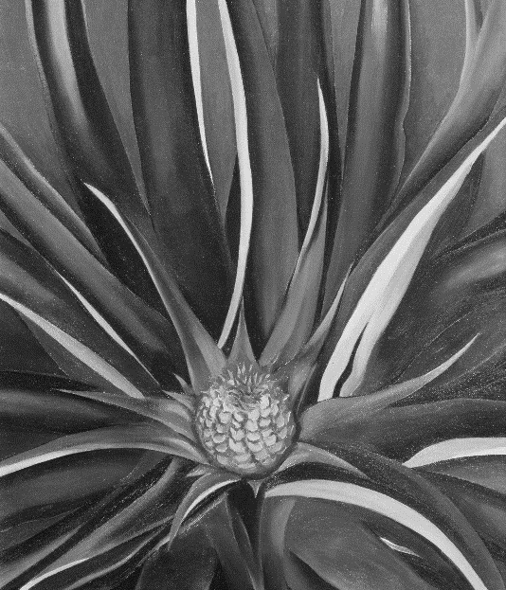  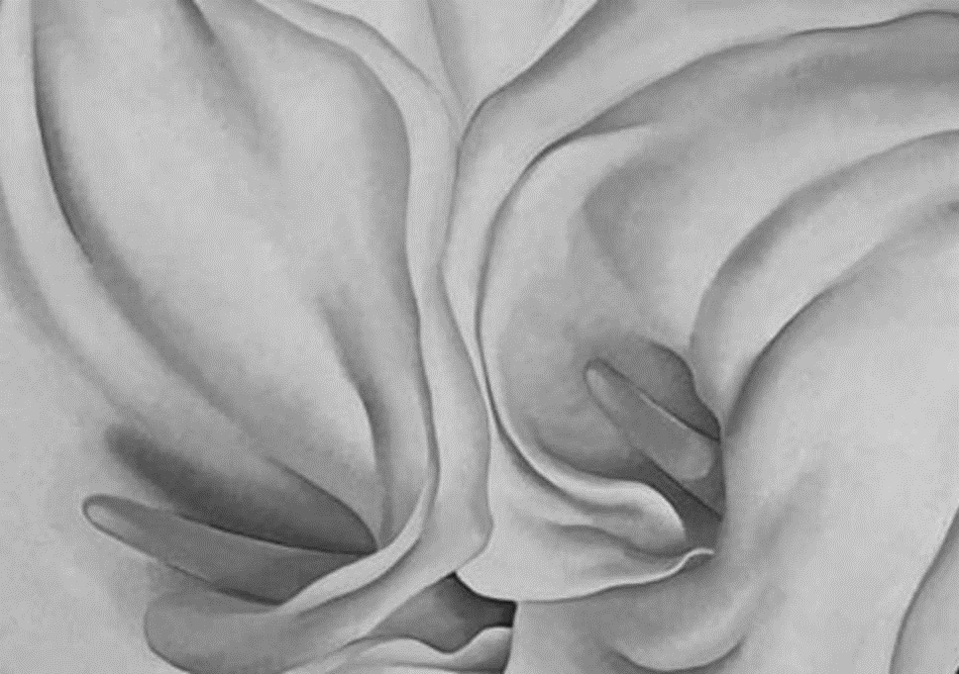  In America, there was an artist called Georgia O’Keefe. She liked to use paints for her art work, they looked like this…  In Britain there was an artist called Andy Goldsworthy who used lots of natural resources to create his art, they looked like this…  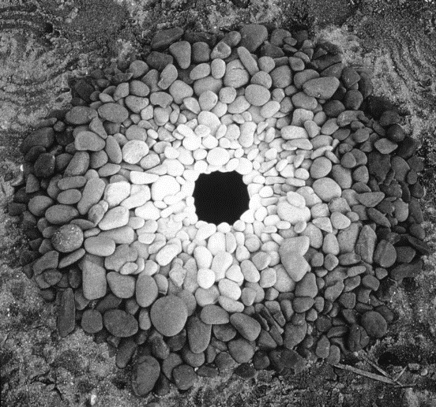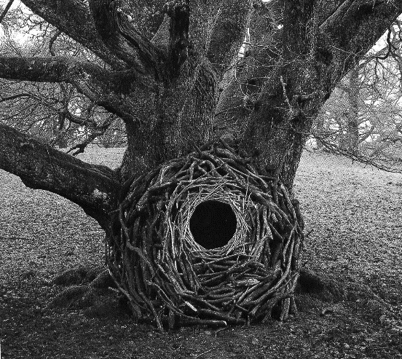  Can you find out about an artist from the country you have chosen to go to? Can you recreate a piece of their art work? We would love to see a photo of your beautiful artwork when it is all finished!
Languages | All over the world people speak different languages, some words sound very similar to English but some sound very different. Can you learn to say hello, please and thank you or my name is… in the language of the country you are visiting?  Some countries use different ways of writing letters and numbers, if you have chosen a country that has a different numeral or alphabet system can you try and write your name and age?  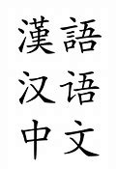
Postcard | Can you create a postcard from your location? Talk about what kind of pictures you would normally find on the front of a postcard, where to write your message and the address. You could create your own stamp.  