Maths Year 1 – week beginning 20.4.2020

Please look at <https://www.whiterosemaths.com/homelearning/> Week 1 – Multiplication. There are online videos to watch and sheets to practice. If you can’t print these try doing the activities below (or have a go at both). You can do them practically using objects you have or use the pictures.

Discuss the groups – are they equal? Can you explain why? How many fish are there altogether?



Beth is making equal groups of 2. Can you make your own equal groups of 2? You can use a book/paper/card to make them. How many objects do you have altogether?



How many wheels are there altogether? How did you count them? Which is the easiest way to count them?

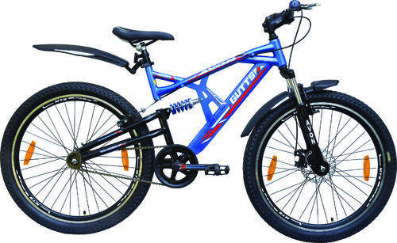

How many counters are in the 10 frames altogether?

[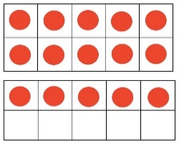](https://www.google.co.uk/url?sa=i&url=https://kgmathminds.com/2015/09/13/1st-grade-ten-frame-number-talk/&psig=AOvVaw1MVCNDDB1EWN3KOtPfhJRA&ust=1585836379193000&source=images&cd=vfe&ved=0CAIQjRxqFwoTCIDl8c6zx-gCFQAAAAAdAAAAABAD) [](https://www.google.co.uk/url?sa=i&url=https://kgmathminds.com/2015/09/13/1st-grade-ten-frame-number-talk/&psig=AOvVaw1MVCNDDB1EWN3KOtPfhJRA&ust=1585836379193000&source=images&cd=vfe&ved=0CAIQjRxqFwoTCIDl8c6zx-gCFQAAAAAdAAAAABAD) [](https://www.google.co.uk/url?sa=i&url=https://kgmathminds.com/2015/09/13/1st-grade-ten-frame-number-talk/&psig=AOvVaw1MVCNDDB1EWN3KOtPfhJRA&ust=1585836379193000&source=images&cd=vfe&ved=0CAIQjRxqFwoTCIDl8c6zx-gCFQAAAAAdAAAAABAD) [](https://www.google.co.uk/url?sa=i&url=https://kgmathminds.com/2015/09/13/1st-grade-ten-frame-number-talk/&psig=AOvVaw1MVCNDDB1EWN3KOtPfhJRA&ust=1585836379193000&source=images&cd=vfe&ved=0CAIQjRxqFwoTCIDl8c6zx-gCFQAAAAAdAAAAABAD)

Counting in multiples makes it easier to count quickly! We can write them down as a repeated addition 2 + 2 + 2 + 2 = Or as a multiplication sentence 4 X 2 = which is like saying 4 lots of 2.

Try counting the coins in your money box in groups of 2, 5 and 10!

Use the 100 square to practise counting in 2’s, 5’s and 10’s!

[https://www.primarygames.co.uk/pg2/splat/splatsq100.html#](https://www.primarygames.co.uk/pg2/splat/splatsq100.html)

You can also practice your counting in multiples along with other Maths skills on ‘Karate Cats Maths’ on bbc bitesize. Try clicking on the ‘Multiplication and division’ section and start on Bronze. See if you can get to the gold level!

Follow the link here to try it!

<https://www.bbc.co.uk/bitesize/topics/zjkphbk/articles/zf4sscw>