Home Learning Pack – The Last Week

Please feel free to do these days in any order.

Day 1 : Reflection and Assessment

Today we would like you to take some time to think about all the things you have achieved this year. You could have a look through your school books at some of the work you did in school or look back on your home learning and talk about what you have learnt or achieved.

There is an end of year reflections sheet so you can draw or write about your favourite things this year and your achievements.

As part of thinking back on the year that has passed you might like to test yourself to find out how much you have learnt. We have included:
A spellings list - test yourself on a few each day to see how many you can spell now.
A times tables test and some activity sheets for practice - 10, 2, 5 and 3 times tables - maybe you have learnt some of your times tables. We practice our 10s, 2s and 5s in Year 2 and the next one you learn in Year 3 is your 3 times table.
A reading booklet – you could have a go at this on your own or with a grown up.

Day 2 : Party Day

Today we would like you to have a party. These might be just with your family to celebrate the end of your time home schooling together or you might like to link up with one of your friends from school and have a two households party.

Things to do at your party :

- Ice biscuits and eat them

- Play a party game - you could try a traditional game like charades, pin the tail on the donkey or pass the parcel. We have also included a few party game ideas with this pack.
- Dance together to your favourite music
- Have a treasure hunt outside. We like a scavenger hunt. Maybe there will be a prize if you find everything!

Day 3 : Tidying Up and Sorting Out

This is the day that we would spend sorting out your school books ready to bring home for the holidays, empty our cupboards and tidy up our resources. We would sharpen our pencils, get rid of old or broken toys and wash lots of our toys so they are nice and clean ready for the next children.

Perhaps you have been using a space in your house for home schooling and it needs a tidy up. You could use today to tackle your bedroom or have a toy sort out and get rid of some old or broken toys.

It is important that you help your grownups today. You can help to tidy up your toys or fold your clothes and put them away. We have included the ‘Tidy Up Song’ that you will have heard many times at tidy up time in school in our pack on the school website.

Day 4: Gratitude and Appreciation

Today we would like you to have a think about just how lucky you are. We have seen and talked to all of you during the time we have been learning at home and we know that you are all such lucky children. Your grownups have worked so hard making your learning fun for you, helping you when you got stuck, being creative and taking good care of you. Lots of your grownups have done this whilst they have been trying to do their job every day. They are amazing.

Today we would like you to say thank you to all the grownups who have helped you with your home schooling. You could:
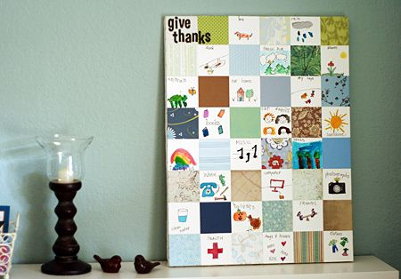
Make a thank you card. You can get creative or colour in and send some of the ones below.

Call or video call a family member who has helped you with your school work to say thank you.

Make a giving thanks paper quilt - cut out squares of card or paper and decorate them with pictures and writing of things you are grateful for. It might be nice to include friends and family. Stick your squares together to form a 'paper quilt'

Day 5 : The Last Day of Term

Today would be the last day of term. You are usually allowed to bring a toy to school to play with and we have part of our day for golden time. Today we would like you to have some 'golden time' at home where you can choose what you play with. Your grownups can have a rest and a cup of tea. Don't forget to play nicely with members of your family and share your toys.

We would usually watch a film together on the last day so we would also like you to snuggle up on the sofa and watch a film. It might be a new one you haven't seen before or just one of your favourites. If you have been good in golden time then your grown up might find you a movie treat such as popcorn to have with your film.

Finally we would usually finish our day with an assembly to remind you to be safe over the holidays. You could talk through the powerpoint included with this pack. We would also take this opportunity to all sing together for the last time (and the grownups might have a little cry). We have included two of our favourite songs from Year 2.

Maybe you would like to perform these to your grownups in your very own leavers assembly. As always we would love to see any work and photographs (or singing videos!) at year2@totonbanksroad.notts.sch.uk. We will treasure all the memories you have sent in over the past few months. They have been truly inspiring.

To all the grownups - It has been known for the teachers to have a bit of a party and 'celebrate' the end of the school year and the start of the summer holidays. We would like to thank all of you for all the hard work you have done educating your children at home this year. This has been so much harder than it is in school and we have been overwhelmed by how positive you have all stayed, how much learning your children have done and the fun they have had. You are all absolutely wonderful so please feel free to 'borrow' our end of term celebration - you have earned it!

