[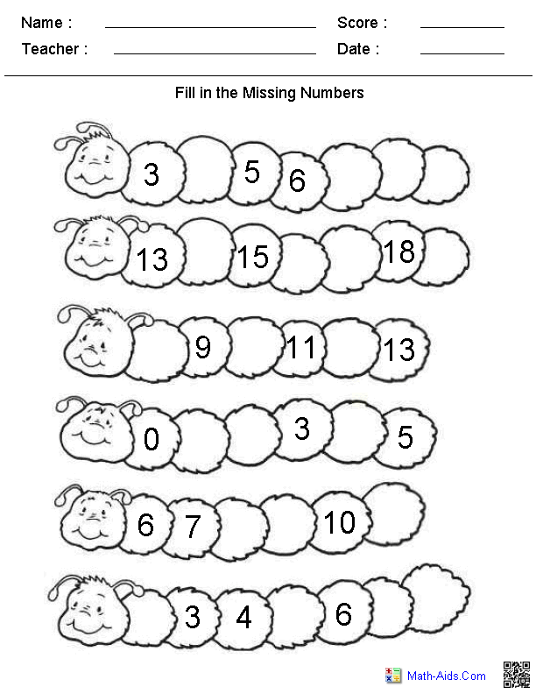](https://www.google.co.uk/url?sa=i&url=https%3A%2F%2Fwww.tes.com%2Flessons%2FgNKd65xY9PjFFw%2Fmissing-numbers&psig=AOvVaw2Yh8lYwwA-QqhA_-AM2uw5&ust=1591532136105000&source=images&cd=vfe&ved=0CAIQjRxqFwoTCKC95ayW7ekCFQAAAAAdAAAAABAg)

[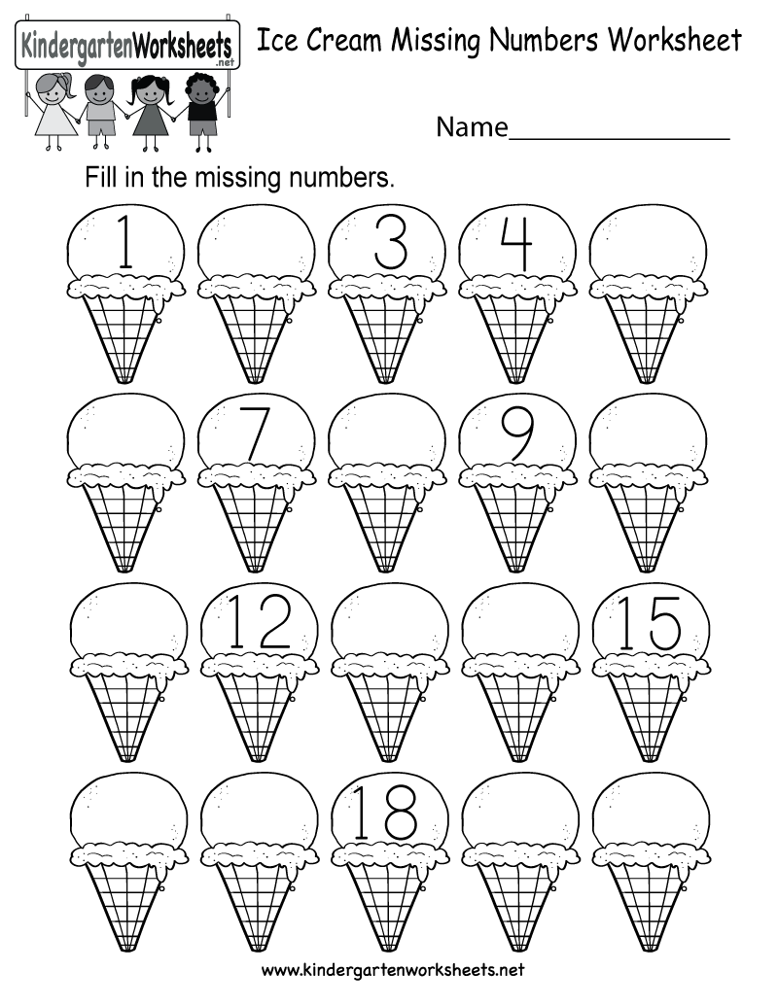](https://www.google.co.uk/url?sa=i&url=https%3A%2F%2Fwww.tes.com%2Flessons%2FR0un9_yKwbIK_Q%2Fmissing-number&psig=AOvVaw2Yh8lYwwA-QqhA_-AM2uw5&ust=1591532136105000&source=images&cd=vfe&ved=0CAIQjRxqFwoTCKC95ayW7ekCFQAAAAAdAAAAABAD)