[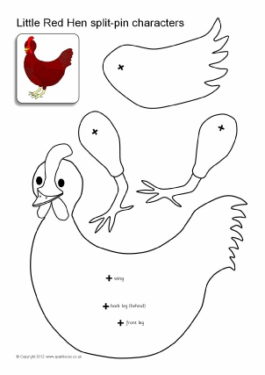](https://www.google.co.uk/url?sa=i&url=https%3A%2F%2Fwww.clipart.email%2Fclipart%2Fthe-little-red-hen-characters-clipart-67173.html&psig=AOvVaw0aGOA50OKaUXJ8Fd0SN2u6&ust=1587303880025000&source=images&cd=vfe&ved=0CAIQjRxqFwoTCMCZ1vmN8ugCFQAAAAAdAAAAABAJ)