Using a calendar

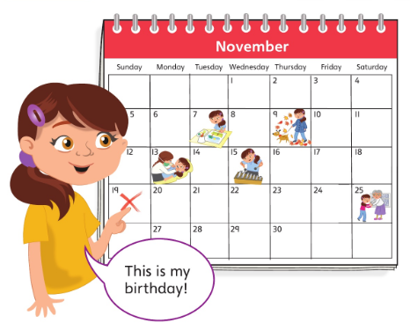
What date is Daisy’s birthday?
When is your birthday? Can you find it on a calendar and see which day it is this year?
Calendars are really useful to plan ahead and remind you of exciting things that are going to happen!
Look at your calendar if you have one and look for important dates! Mark on the calendar the 23rd or 24th July when you are coming to see your teacher for a visit, you could even put the time too!

