Cheeky Monkey has gone for a sleepover at Miss James’ house whilst the nursery has an extra good clean. Look what he has been up to…..

Cheeky Monkey is sleeping in Miss James’ spare bed, he has got the Gruffalo and Fluffy to keep him company. Who do you sleep with at night?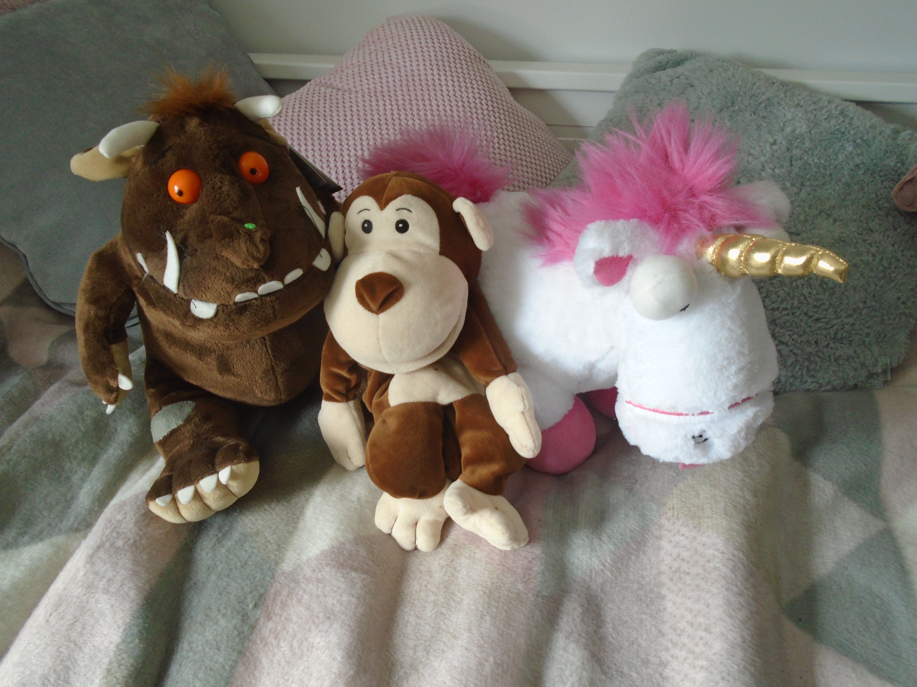

Miss James and Cheeky Monkey have been so inspired by all your photos of you gardening that they decided to have a go. Can you guess what they are growing? Have you grown anything?
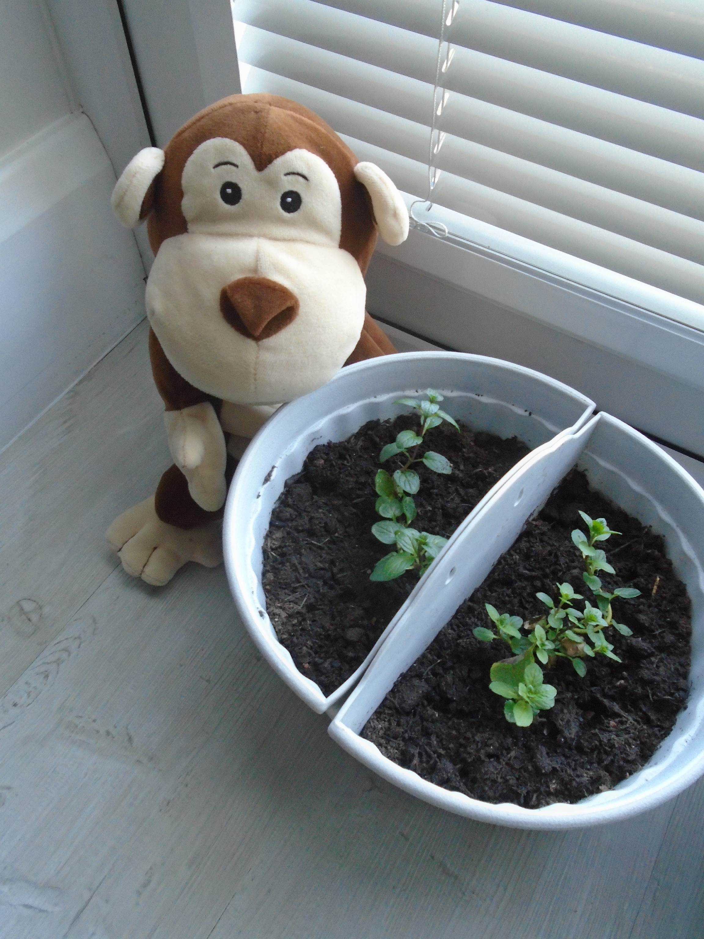

Oh No!! Cheeky Monkey has found Miss James’ crisp drawer, do you think he will eat them all? Do you think Miss James will share?
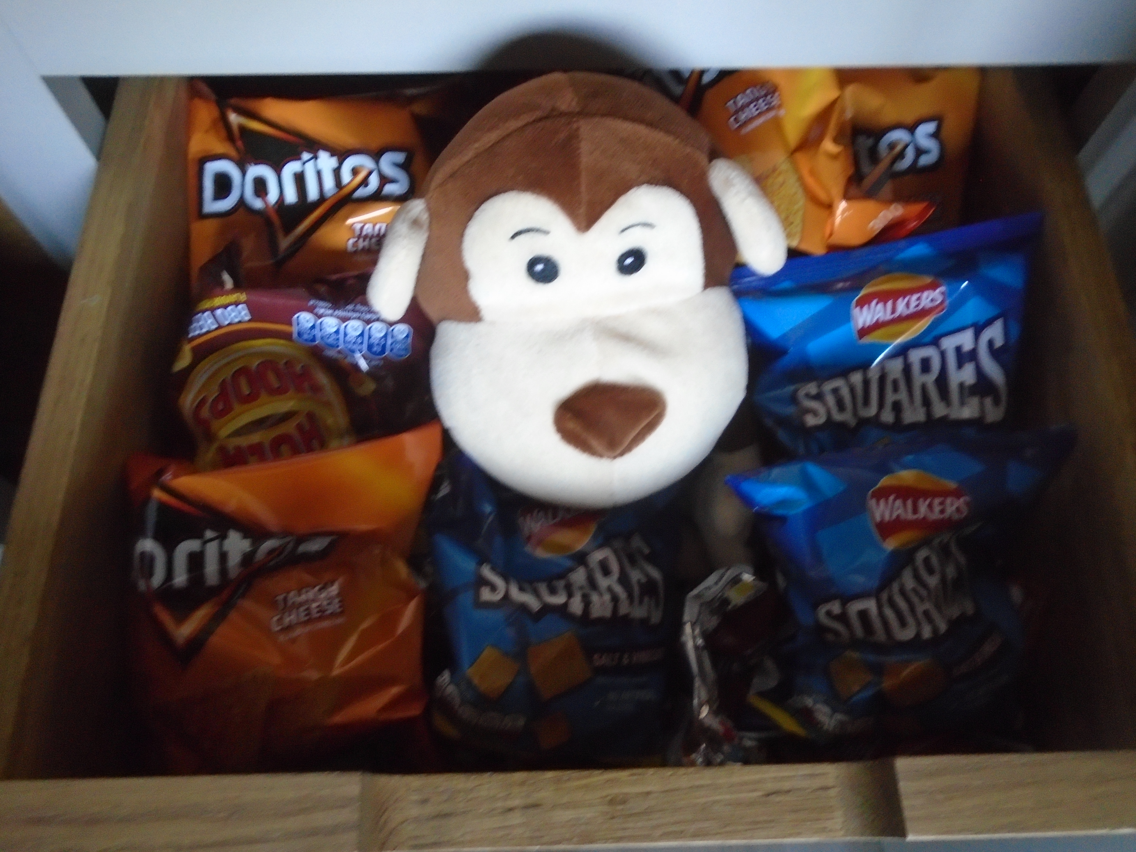
Cheeky Monkey is being very mischievous, Miss James can’t take her eyes off him for a second!! Look she caught him trying to eat all the bananas! No Cheeky Monkey that’s not good sharing.
Miss James has got lots of boring jobs to do on her computer, she lets Cheeky Monkey watch a film in bed. Cheeky Monkey is being very good and knows he has to entertain himself for a little while, otherwise Miss James won’t be able to send any activities to the nursery children. If your Mummies and Daddies have to work from home are you being helpful and keeping yourself busy?
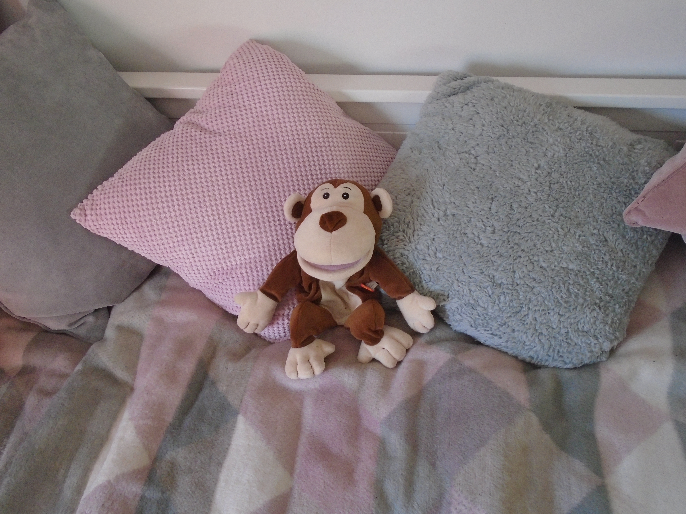

Miss James does an Easter egg hunt for Cheeky Monkey and Mr James. Can you find all 3 eggs?

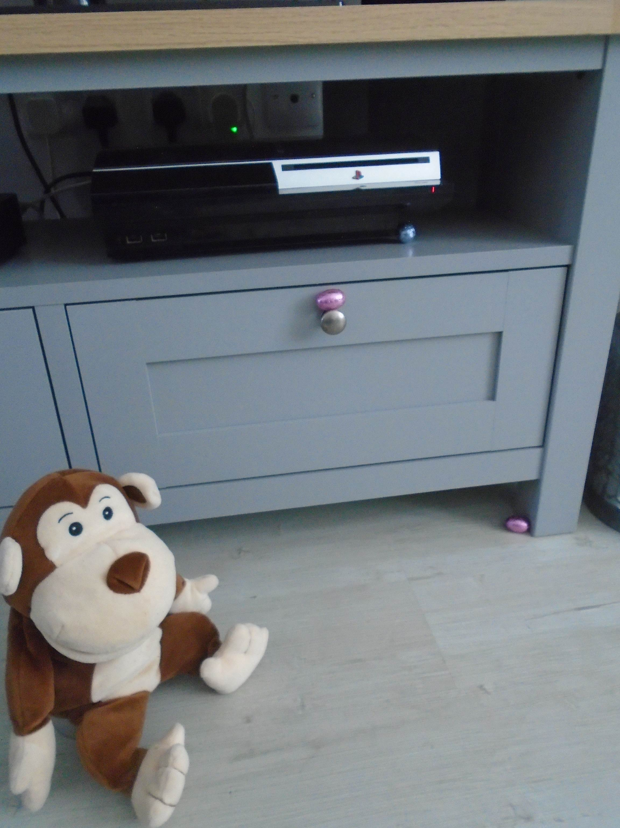

Cheeky Monkey has made some Easter cakes with some of his Easter eggs. Have you done any baking?
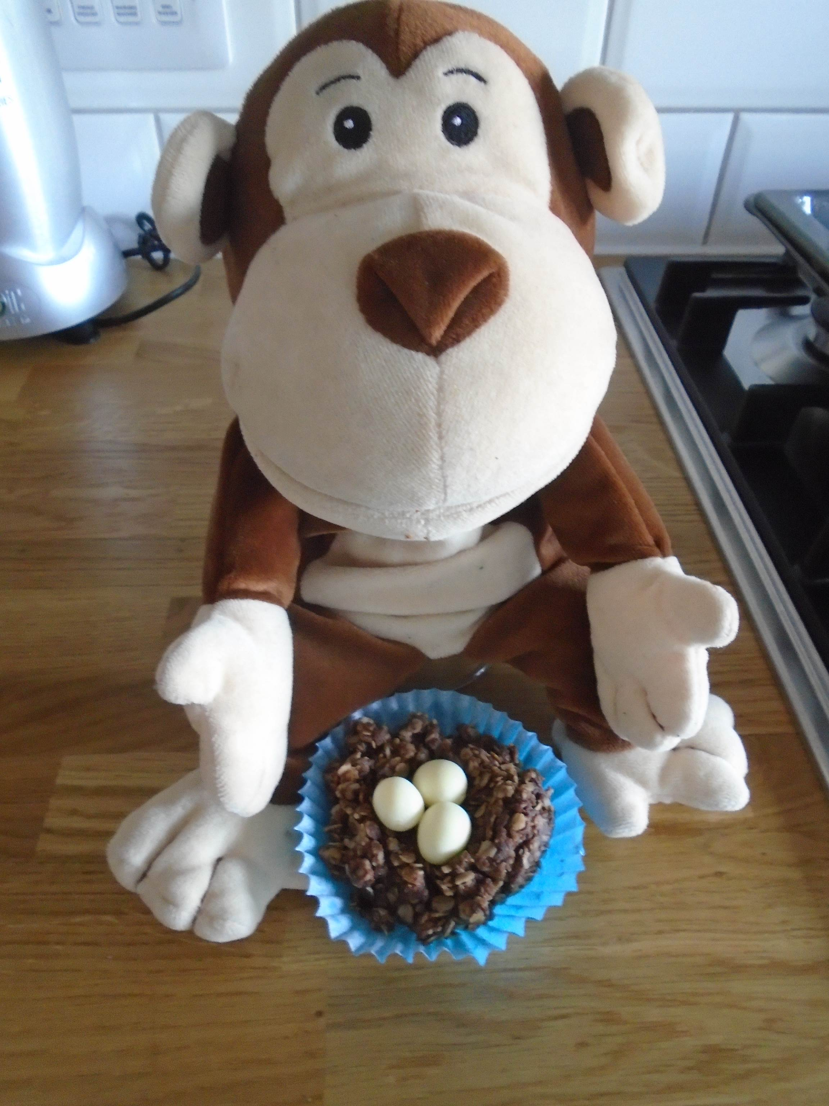

Miss James said Cheeky Monkey could use anything he wanted to start his own rock band….10 minutes later she is beginning to regret it!
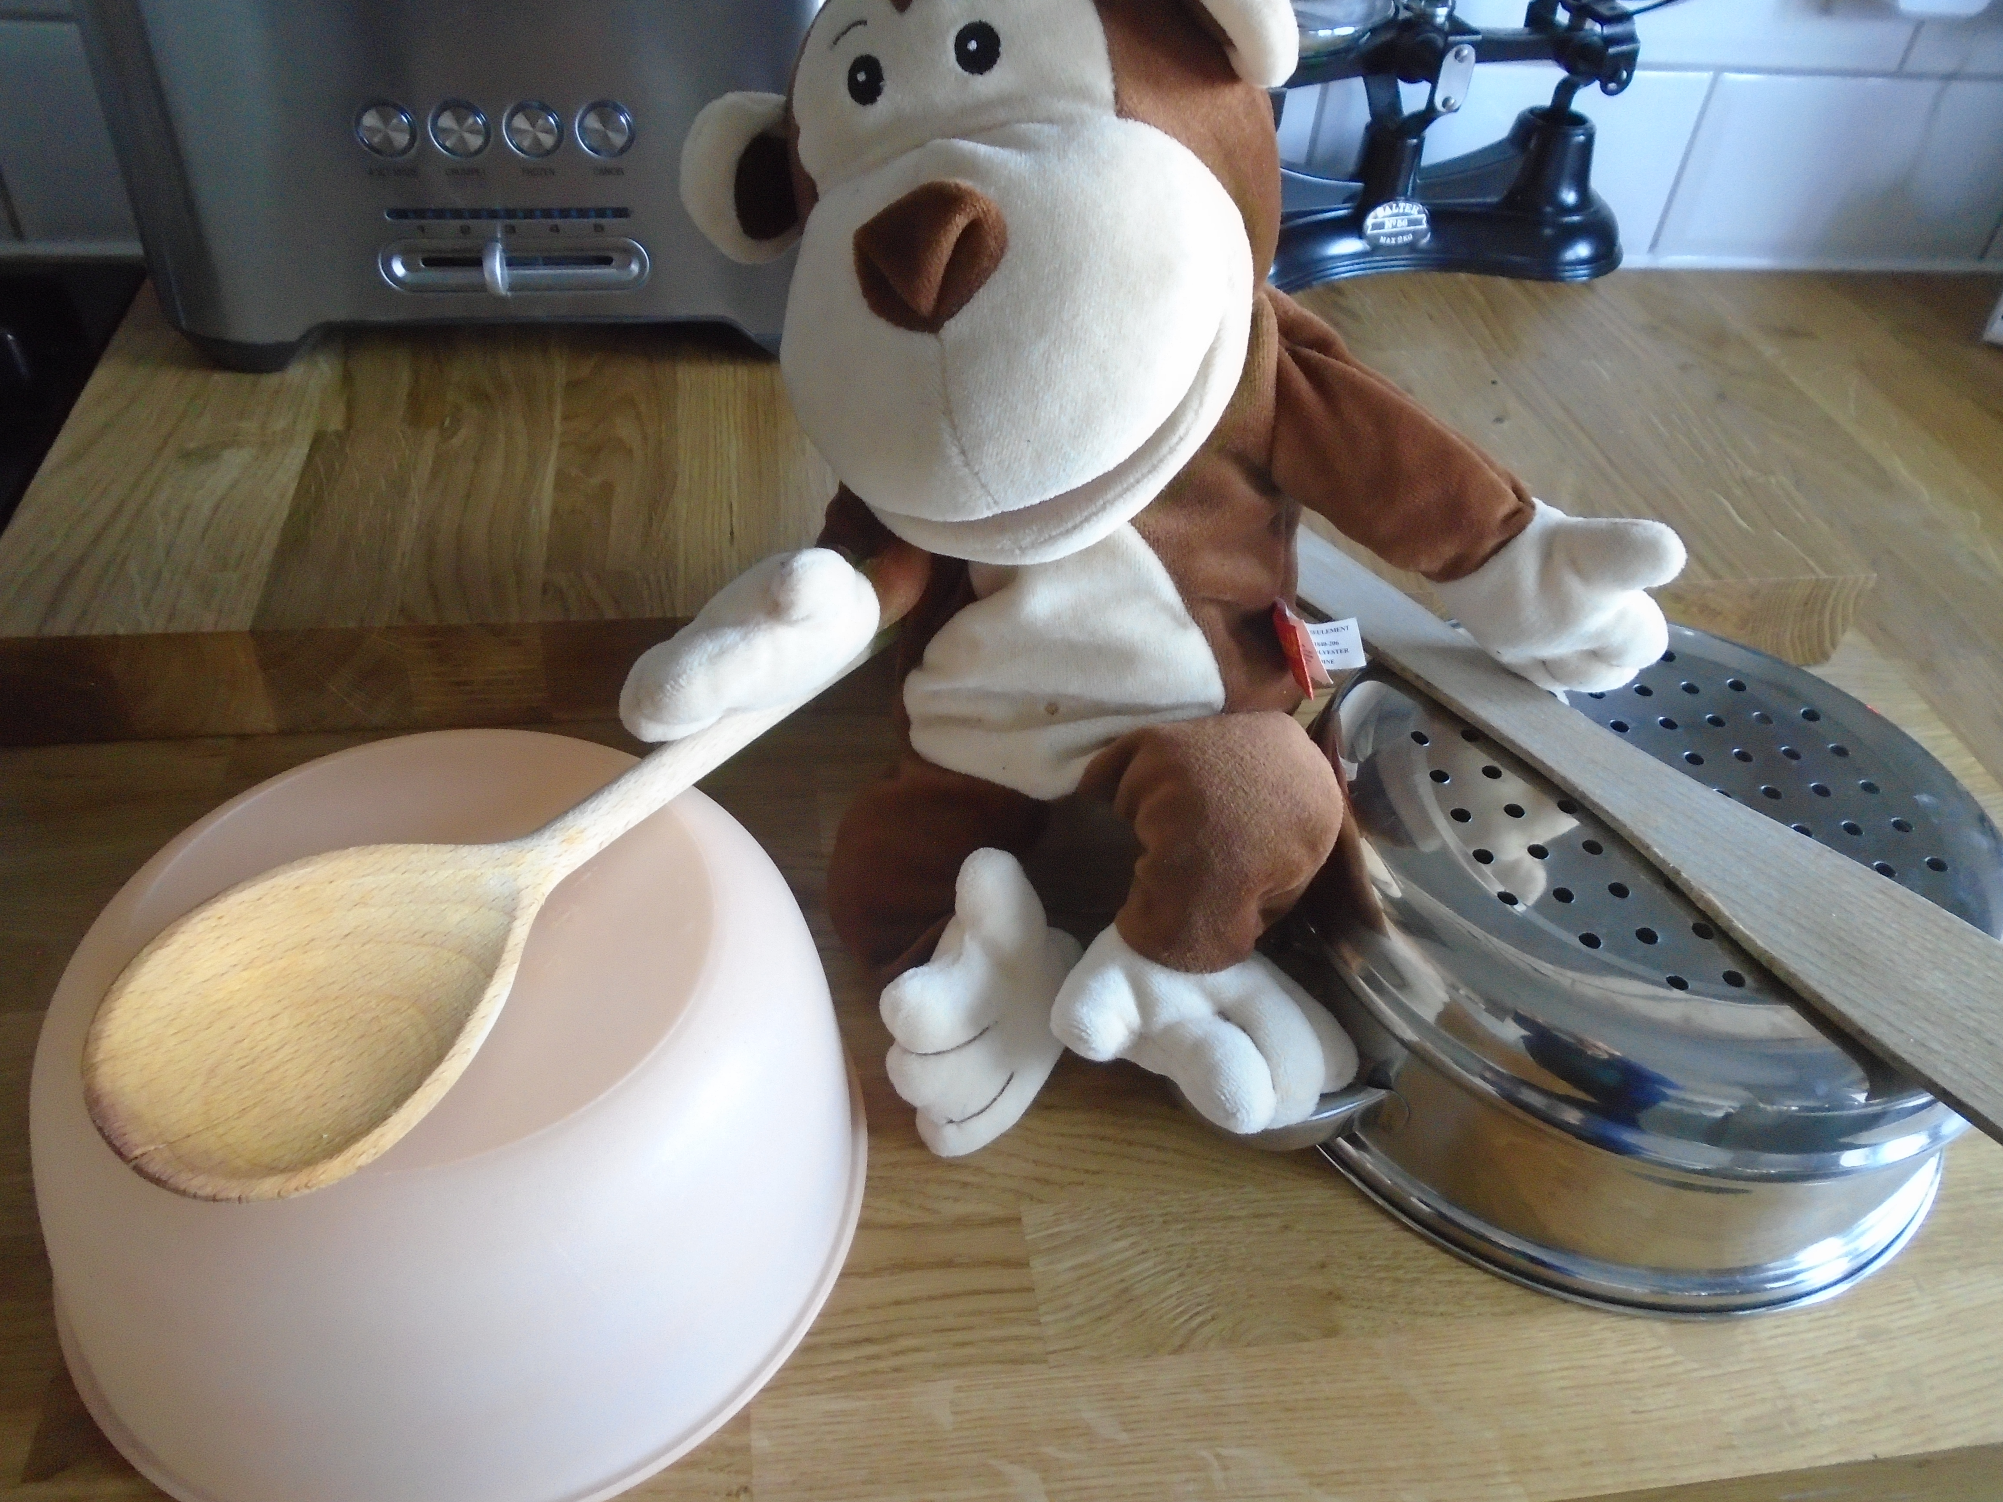

Cheeky monkey is trying to do something kind each day, he is missing how kind the children are to each other at nursery. Today he is helping with the hoovering. Have you done something kind today?
